How to Find a Job at Hello Work
(Explanation materials used at the first orientation meeting for the unemployed)

1. Early Reemployment
Those who return to work early are provided a Job Starter’s Allowance, although there are some conditions to be fulfilled such as the reason for the separation from work.
Almost seventy percent of job seekers find a job within three months after being separated from work. It means that there are more job opportunities available in an early stage.
On the other hand, long-term unemployment has many demerits. If you cannot find a job early, as times go by, the chances to find a job will be decreasing for various reasons.

Encouragement to Early Reemployment
Demerits of long-term unemployment
- Irregular way of life; Prolonged unemployment makes your life mistimed
- Maladjustment to working life; It becomes difficult to adapt to a new working life
- Demotivation; Long-term unemployment diminishes the will to work
- Bad Impression； Long-term unemployment is not welcomed by a prospective employer
- Financial concern; Duration of benefit is limited.

Merits of earlｙ reemployment
- Statistics shows that 70% of job seekers are employed within 3 months
- Employment Promotion Benefit is paid for a qualified unemployment beneficiaries

In Kawasaki district, the ratio of job offers to applicants is 0.51 as of 2010. From the view point by occupation, in the field of administrative/office work, there are more job applicants than job offers, but on the other hand, in the field of specialized technical or skilled work, there are more job offers than job applicants.

When/if you find a good job offer, you should take it without hesitation. Otherwise, other job seekers will get the job. The better the job offers are, the quicker they disappear

Hello Works encourage job seekers to make efforts to find a new job as early as possible.
Hello Works will provide full support for your reemployment.
2. Consultation services
(1) Application for the service
To obtain services such as job placement and vocational consultation at Hello Work, job seekers must have a “Certificate of qualified unemployment beneficiary”.
When job seekers want to consult about job and job placement, they need to apply for the service at the “Vocational Consultation” counter as designated in the certificate. Get a number ticket from the ticketing device at the counter and wait till your number is called.

Remarks;
14. Daily Wage upon Separation total amount of 6 months wage / 180
15. Limitation of Benefits to be filled in case of separation for one’s own reason
16. Date of Job Application date approved as a qualified unemployment beneficiary at Hello Work

(2) Recognition as unemployed
Job seekers have to visit Hello work on “Recognition Day of Unemployment” every month and have to be certified as jobless to receive unemployment benefit.

Beneficiary No.
Name |  |  | Date of Job Application  Date of Issue

Note for Qualified Unemployment Beneficiary for Unemployment Insurance

Date and Time of Initial Orientation  on Employment Insurance | (Date and Time designated)
Items to bring for Orientation on Employment Insurance | - This Note  - Application for Unemployment  - Notice of bank account for payment transfer and a bankbook (restricted to beneficiary’s own account)  - 4 copies of photos ( 3 cm by 2.5 cm )  - ID (Driving license or Resident Register Certificate, Passport etc. and the guidebook  - Tools of writing  - Others ( )
* In case of absence, please be sure to make contact with Hello Work in advance

Please come to Hello Work in time on the day of unemployment recognition
Date of Initial Recognition of Unemployment | (Date and Time)
Date of Recognition | (Type) (Day of week)
Items to bring on the day | Certificate of Qualified Unemployment Beneficiary, Application for Unemployment Recognition, personal seal

Schedule of Unemployment Recognition *Please fill out below to remind yourself
(Date) | (Date) | (Date) | (Date) | (Date) | (Date)
(Date) | (Date) | (Date) | (Date) | (Date) | (Date)

* Service on Employment Insurance is available from 8:30 a.m. to 5:15 p.m. on weekday in Hello Work

3. Steps for finding a job opening
(1) First step to find a job
Job seeking starts from making inventory of yourself such as:
- What you want do
- What you have done
- Your sales point
- What you are not good at

Job seekers have to recognize each step’s image clearly. When you take a positive action to get a job at the each step utilizing the various services that Hello work provides, you will be able to get a job in early time.

(2) Finding job offers by using PC for Job Searching as follows:
- Apply for the use of a PC at reception desk, and then you will be given a plate which indicates PC number for your use.
- The PC machine has an easy-to-use touch panel method. By selecting conditions indicated on the screen such as age, kind of occupation, workplace location and so forth, you can look for job offers which meet your desired requirements.
- PC is available from 8:30 a.m. to 7:00 p.m. on weekdays, 10:00 a.m. to 5:00 p.m. on Saturdays.
- The PC provides various information such as check point of job-offer information, how to write resume and work history, and seminar information.

Steps to get a job

Confirmation !! |  | Choosing job and working conditions
- What you want to do  - What you have done  Consultation and advice given on inventory of work experience,  - Likes and dislikes |  | - Choosing a job with consideration of what you want and what you can do,  - Amount of salary  Consultation and advice on the desired working conditions based on hiring outlook and wages, etc.  - Holidays  - Commuting  - Social Insurances  - Other requirements
Collect Information on jobs
- What kind of job
- What qualification or experiences are needed
Consultation and advice given to view a job opening and confirm the conditions

Looking for a job
- Consultation counter
- Job searching PC machine
- Hell Work Internet Service
- Unable to find a job opening?? -
- Consultation at the counter
You only might have failed to find desired job opening
- Re-think your conditions : Clarify what you can compromise or cannot
Application
- Prepare application forms
- Resume, Work History
Correction of application, guidance, advice on job interview, and mock interview
- Letter of Introduction
- Prepare for job interview
- Information of the company
- Collecting other information
- Screening by application
- Job interview
Hello Work supports you with consultation service at each step as well as with a total support program.

Get a job
It’s a new start!

Employment Support Services
Vocational Consultation & Introduction*1
Consultation services for reemployment are given on various issues such as:
- Characteristics of a job and qualifications required
- Details of job openings and conditions
- Vocational training*²
- How to write resume and work history*³, and how to take job interview
*1Introduction; contact with a company and confirm the date/time of job interview and screening by application documents
*² Vocational training; some courses require an entrance exam or interview, and tuition fees
*³ Work history; recently many companies require its submission

Registration required to receive consultation service at Hello Work
When job seekers want to get consultation services, they need to register as a job seeker at the Hello Work. Then, you will be issued Hello Work Card.
Hello Work Card is available at any Hello Work. But if the card has not been used for more than one year, you need to be
registered again.
Hello Work Card
Name
Counter in charge: Occupation Classification:
Job Seeker No.; (bar-code)

xxxx Hello Work Phone Number xxxxxxxx

Looking for a job
- Searching for desired job openings by a dedicated PC
- Easy to view job openings by touch panel system
- Providing neighboring prefectures’ job opening information as well
- Obtaining job opening information by consultation as well as PC system
- Application for a job requires a letter of introduction. Ask at reception or counter for details.

Individual Employment Support (at Early Employment Support corner)
For those who desire early reemployment, the supporting staff in charge provides individual man-to-man employment support:
- Choosing a desired occupation by vocational aptitude test
- Inventory of work experiences and setting of desired conditions
- Guidance on how to write application documents such as resume and work history
- Guidance on how to take a job interview and practice on mock-interview
- Vocational consultation and introduction
- Follow-up and consultation

Other services to support employment
- Individual Consultation for Career Development; correction of application documents, aptitude test, assistance for making job card
- Individual consultation on welfare and nursing care services
4. Support for early reemployment
Full time staffs in charge of early reemployment and employment support advisers provide jobseekers with man-to-man assistance aiming for reemployment within 3 months after separation from job, including taking inventory of work experiences and mock interview and so on. Prior appointment is required.

5. Guidance on application documents preparation
Hello Work provides guidance on preparation of application documents such as resume and work history which will become effective tools to appeal to a prospective employer.
Also, if job seekers have not yet decided on the kind of occupation for reemployment, Hello Work will assist you to select the kind of occupation suitable for you through vocational aptitude test, and give advice as to how to take job interviews.

6. Public Vocational Training for Job Seekers
For job seekers who intend to improve their vocational abilities or to convert their job, Hello Work provides information and consultation to enroll in vocational training institutions, and application for training is also accepted by Hello Work.
Vocational training provides wide variety of courses such as short term, long term courses by duration, and information technology, machinery, cooking, and nursing care by subjects. Regarding vocational training courses that Hello Work recommends, when job seekers undergo such training at the instruction of the head of a Hello Work, those job seekers can take training while receiving unemployment benefit. In this case, job seekers need to be enrolled in training before they have covered the two third of the benefit period.

To take public vocational training at the instruction of head of Hello Work

Through vocational consultation, in case that a job seeker is judged in need of training to improve vocational ability or qualification in order to get an appropriate job, the Hello Work gives instruction to take public vocational training.
When training is started while receiving basic allowance (unemployment benefit), they are entitled not only to basic allowance, but also to training and commuting allowances.
* Admission period and application method differ depending on subjects and courses.
Ask at consultation counter for details.

Instruction to take vocational training
(1) In the course of vocational consultation, if a job seeker is judged in need of training to improve vocational ability or qualification, the head of Hello Work gives an instruction to take public vocational training.
(2) Intended vocational training courses are limited only to those who start training in early stage of his/her unemployment benefit period. ( before the two thirds of benefit period
is covered)
Duration of Benefit | Criteria for instruction on taking training at early stages
90 days | 90 days (*)
120 days | 120 days (*)
150 days | 120 days (*)
180 days | 120 days
… | …
360 days | 240 days

Instruction for taking vocational training is given only to those who fulfill the following conditions.
- Regularly take vocational consultation at vocational consultation counter
- Attend every Unemployment Recognition day appointed by Hello Work
- Positive job-hunting activities are proved clearly by the contents of Application for Unemployment Recognition.

7. Application and Interview
When a job seeker has found a preferred job offer
- Print out the job-opening information sheet, get a number ticket from ticketing device at the consultation counter and wait till you number is called
- When your number is called, go to the counter with your “Hello Work Card” and the printed sheet. The staff in charge will contact with the company and arrange the date for job interview, and issue a letter of introduction for you to bring to the interview.
* Recently, many companies conduct documents screening prior to interview. Also in such a case, a job seeker is required to submit a letter of introduction.
- In case you take job interview without “the letter of introduction” and be employed, you may not be able to receive Job Starter’s Allowance. It is considered that you have obtained a job on your own account without the introduction of Hello Work.
- You can get assistance and consultation to find a preferred job from the staff at the counter if you cannot find any from job offer information available in PC.
- When you have succeeded in getting a job, you need to notify the benefit payment section in Hello Work.

Application and Interview

When you have decided on the company you want to apply, you have to receive a Letter of Introduction at Hello Work. Hello Work cannot issue a Letter of Introduction after an interview was conducted.

Interview
Job interview is considered most important in recruitment screening process. You are advised to fully prepare yourself in advance, so that you can be at ease during the interview.

Check the followings:
- Information of the company
- Work history and reasons for applying
- Contents of your question
- Clothes and appearance
- Items to take for interview including designated ones
- Date, time, place and transportation
- Frequently asked questions: reasons for applying, reason of separation, questions to the company and self PR
* In case of absence, please make contact with the company and Hello Work

Some tips for a successful interview
- Greet and respond with clear and appropriate language
- Reply in such a manner as to give good impression to interviewers
- Ask questions frankly, if any. Interview is set for mutual confirmation and understanding.

Result of application
- Upon receiving a notification of acceptance, indicate your intention promptly
- Upon the determination of employment, confirm the condition of employment in writing to avoid a trouble in the future.
- In case of declining the offer, explain the reason with sincerity so as not to hurt the employer
- For those who are receiving unemployment benefit, notify the employment to Hello Work

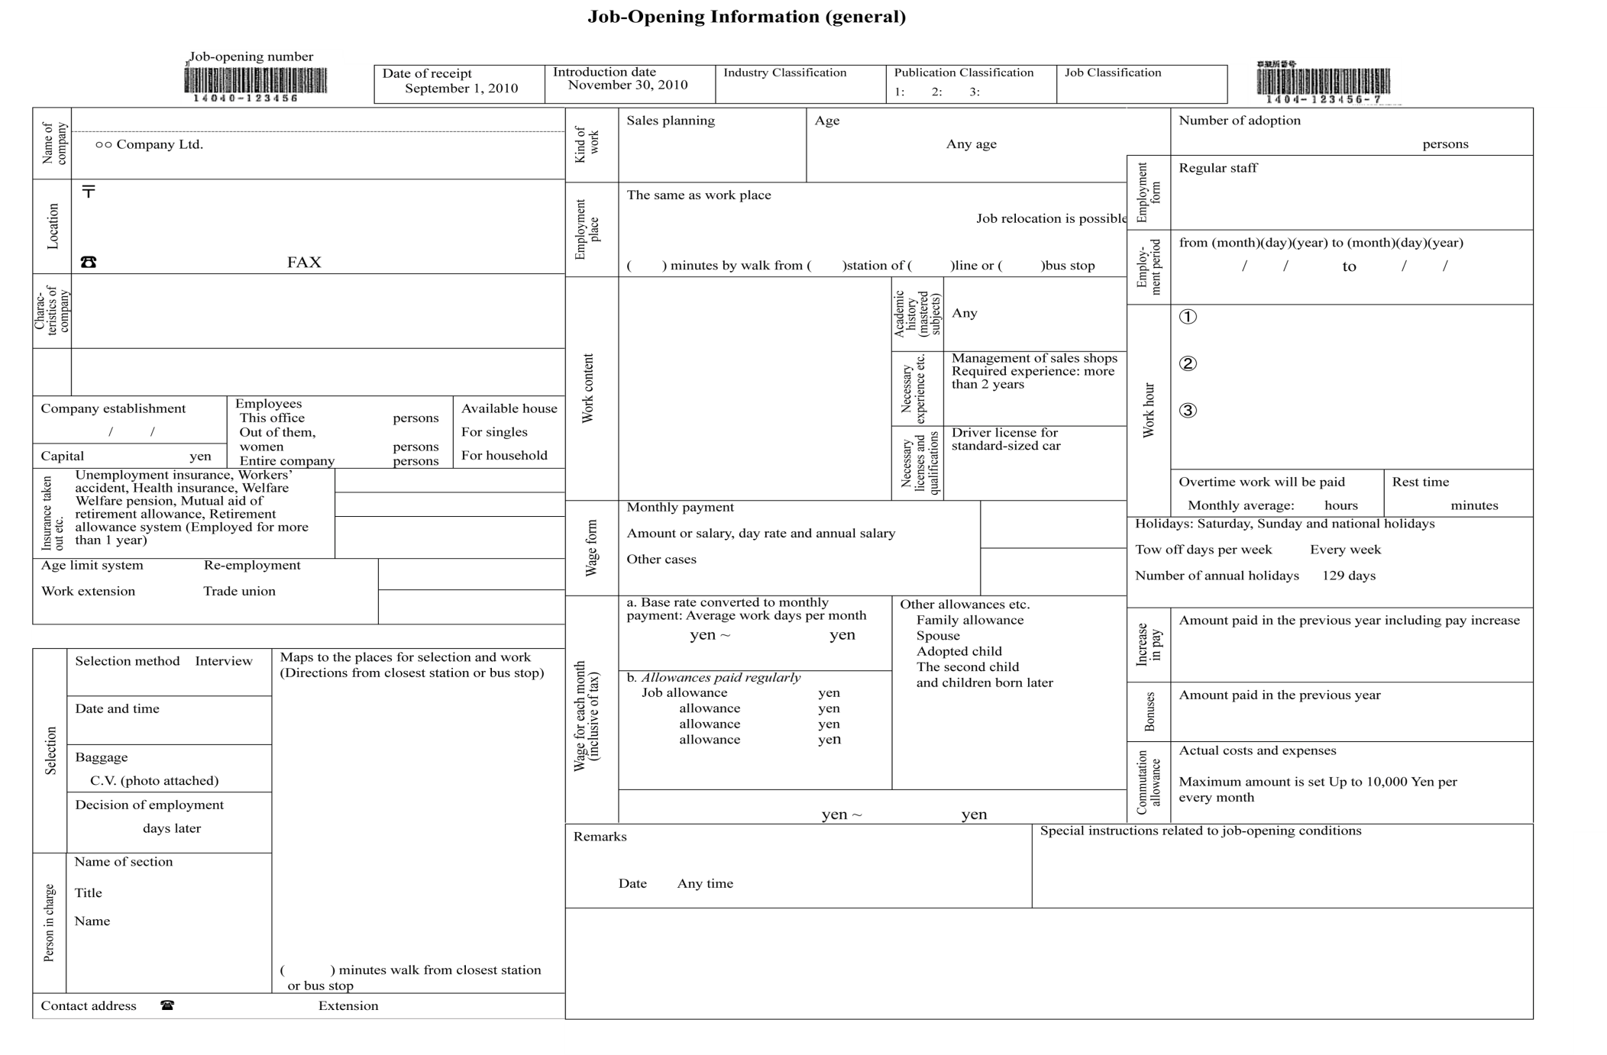
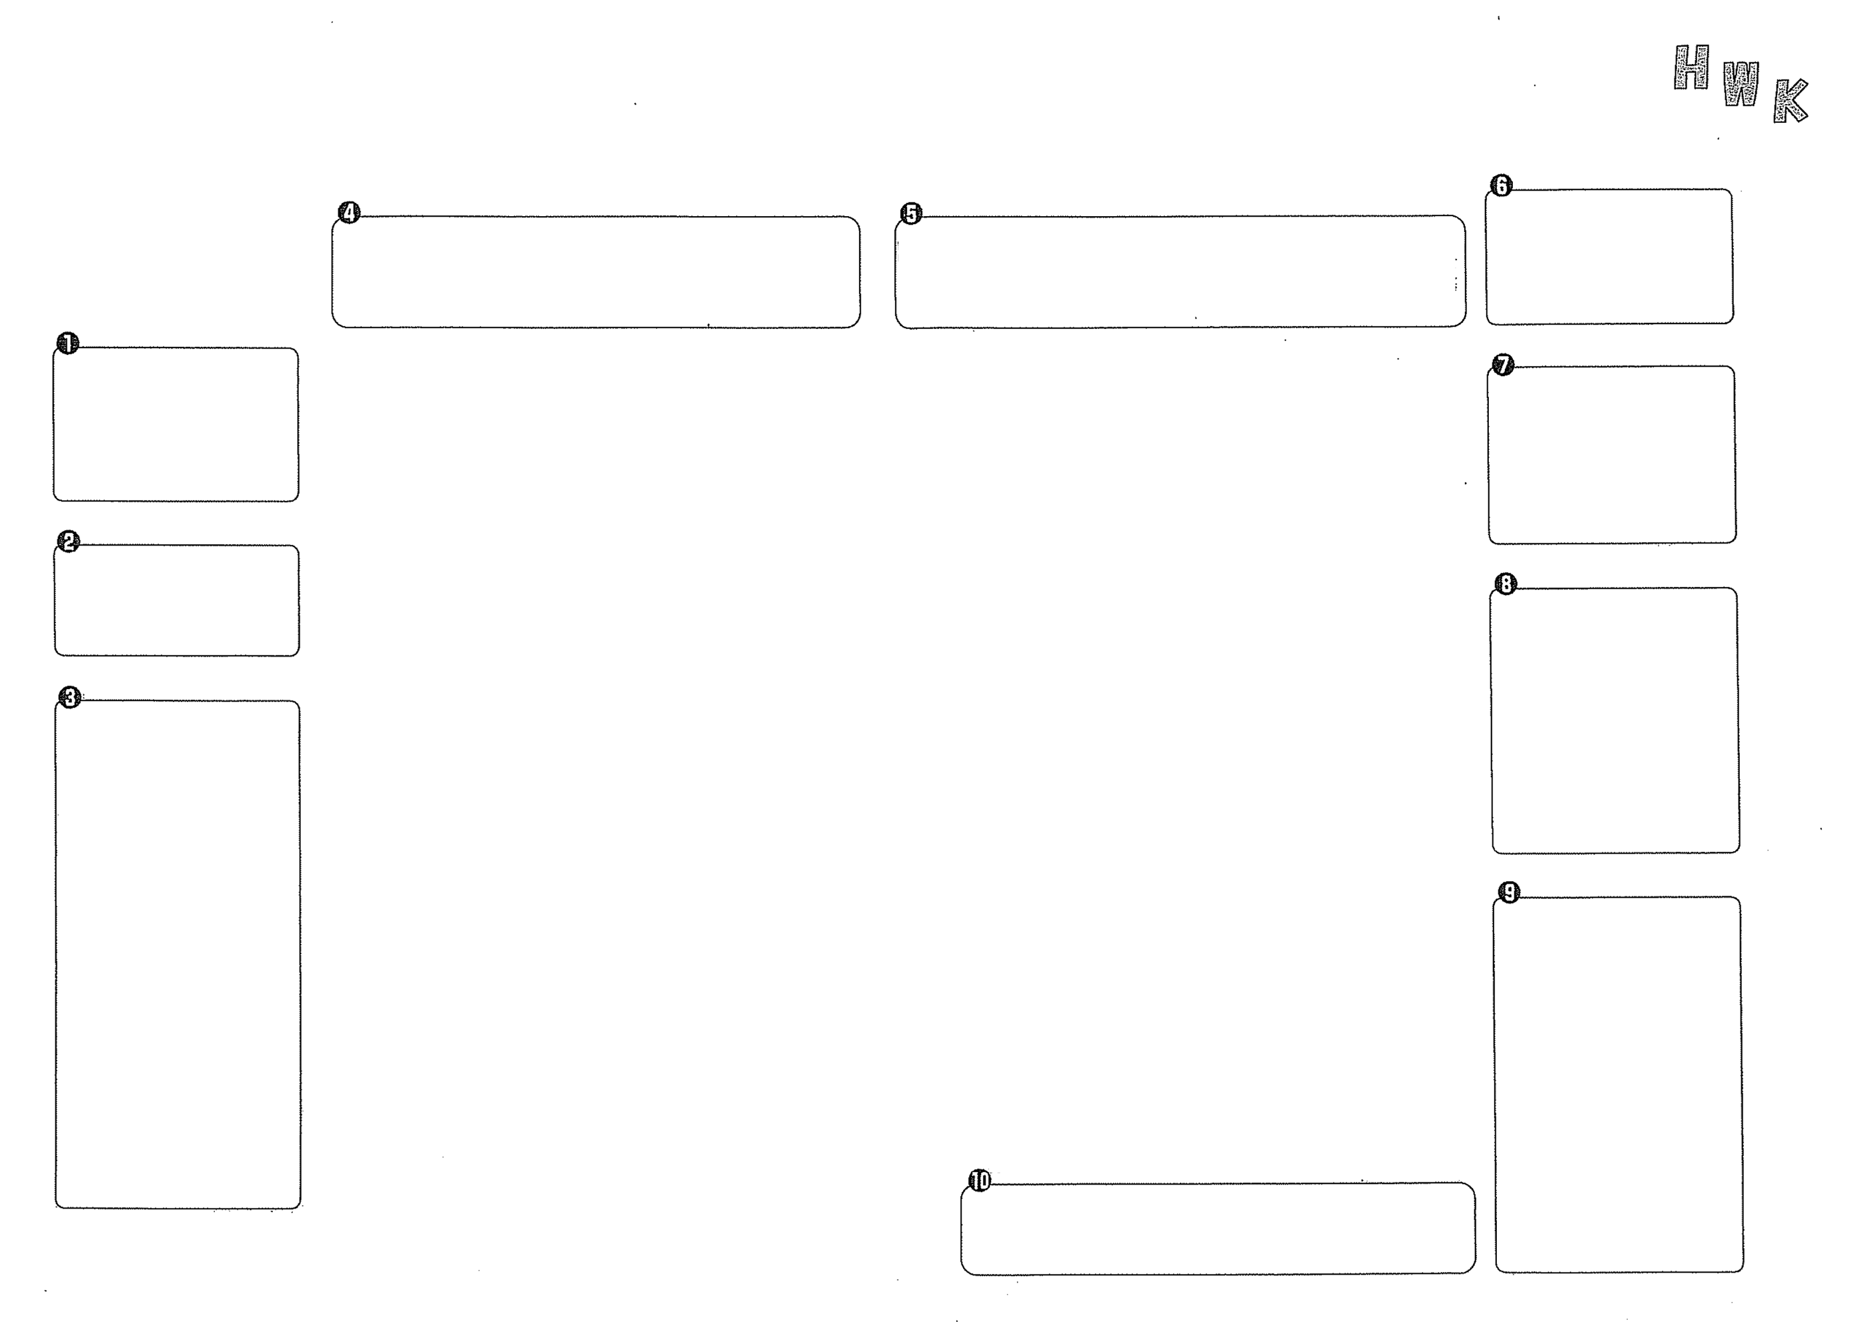
Work Place
This is a place where you will actually work when you are adopted by this job-opening. Be careful that the location of the company and the work place may be different.

Age
There is no age limit in principle. But there are exceptionally cases where age limits are admitted.

Employment Status
The employment status when you are adopted by this job-opening.
・Regular staff
・Non-regular staff
(Contract employee, junior employee, temporary employee etc.)
・Regular type dispatching
・Registration type dispatching
Note)
“Regular type dispatching” means dispatched work when you are employed by a dispatching employer as a worker to be employed for more than a year continuously (or to be likely so).
“Registration type dispatching” means that a person who wants to be employed by dispatching is registered at a dispatching company and when work for dispatching is found such a person is employed by the dispatching employer for a certain period and dispatched and works.

Employment period
There are some job-openings in which employment periods are set beforehand. In such cases, the information of existence or non-existence of contract renewal is written in the remark column, please check well job-opening information.

Necessary experience and necessary licenses and qualifications
This is a part which recruiters consider as the most important. Compare with your experience and qualifications. The part reads “It is better if you are ○○” or “We prefer ○○”. But basically, the recruiters are hoping to employ those who meet these conditions.

Overtime work
Overtime work hours are much or little, depending on seasons. It would be better that you will check what depends on seasons in time of interview.

Holidays and two off-days per week
When the day of the week is fixed as a holiday, the day is displayed. There are holidays according to a company’s own calendar or to rotation. Tow off-days per week are displaying its form.

Wage form
○Monthly payment system shows that you will receive a fixed amount on monthly basis.
○Day rate and monthly payment system shows that you will receive a fixed amount on monthly basis but the wage for days you are absent from work except for annual vacation will be deducted.
○Hourly rate system shows that you will receive the wage for your working hours multiplied by a fixed amount on an hour basis.

Wage for each month (inclusive of tax)
Column a shows the so-called base rate (inclusive of tax). When there is rates zone in this column, the wage will be decided based on the applicant’s experience etc. Please check on the rate in time of interview.
Column b shows allowances that a company will surely pay you.
Column c shows allowances for which payment situation differs according to the conditions of individuals. For example, dependant allowance, percentage pay etc. are included in these allowances.
Commutation allowance is shown in the commutation allowance column. But you are recommended to check it in detail in time of interview.

Remarks and special instructions
There are cases where special things are written that cannot be written specially on periodical basis. Never fail to check here and if you have anything you don’t know, please check with contact person.
❿
❶
❷
❸
❹
❺
❻
❼
❽
❾
8. Job-opening sheet
Please refer the attached about job-opening sheet.
Job offer information that the Hello Work caught is showed to the public as a job-opening sheet

9. Employment Support Seminar
Kanagawa Labor Bureau and Hello Work jointly hold seminars to support job hunting activity on the following subjects:

- How to carry out job-hunting activities
- Self-analysis and career planning
- How to write a resume and work history
- How to undergo a job interview
- Workshop on writing the purpose and reasons for applying to a particular company
- Workshop on writing self PR and taking a job interview

