
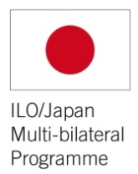

ASEAN-ILO/Japan Project
on Unemployment Insurance and Employment Services in ASEAN

First Year’s Achievements in Viet Nam
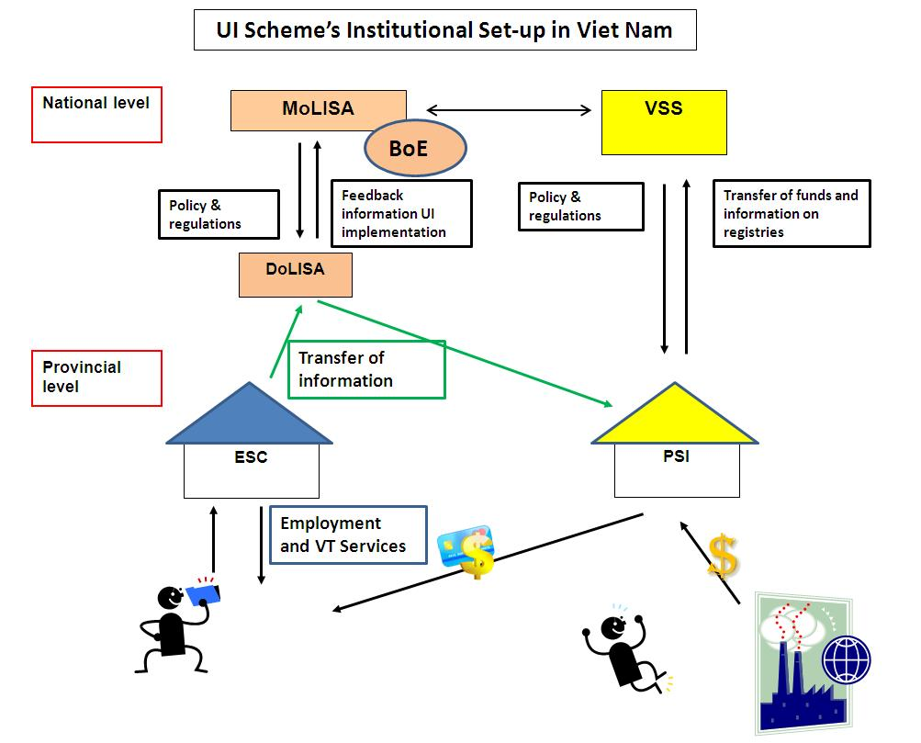

Source: ILO/Japan-ASEAN UI Project, 2011
BOE: Bureau of Employment; DOLISA: Department of Labour, Invalids and Social Affairs (Provincial level); ESC: Employment Service Center; MOLISA: Ministry of Labour, Invalids and Social Affairs; PSI: Provincial Social Insurance; UI: Unemployment Insurance; VSS: Viet Nam Social Security.

- Eighteen months’ review and evaluation of the unemployment insurance scheme:
In 2011, the Project supported eighteen month’s implementation review of the unemployment insurance scheme.
The evaluation mission, which took place in August 2011, conducted bilateral meetings with key stakeholders and discussed preliminary findings during tripartite provincial consultations. On 18 August 2011, a national tripartite workshop refined the findings and drafted the recommendations. The recommendations were finally endorsed by MoLISA and the social partners on 19 October 20121, in Hanoi.
The twelve recommendations encompass four areas for improvement:
- Extension of coverage
- Enterprises with at least one employee
- Short-term contracts (3 months)
- Clarification of the definition of public servants

- Simplification of procedures
- 90 days to register to ESC for UI benefits
- ESC Director approved benefits calculation (currently, DoLISA)
- Employed person = insured person
- One-stop-shop (PSI front desk within ESC)
- More flexibility for monthly reporting
- Improve filing and archiving system (IT)

- Financial sustainability
- Creation of fraud and control mechanisms in ESC/DoLISA
- Increased penalties on delinquent employers

- Improved linkages with ALMPs
- Making VT more attractive for unemployed

Source: ILO/Japan-ASEAN UI Project, 2011

- Support to the revision of legal framework related to UI:
The application of the recommendations of the eighteen months’ implementation review will have implications on the legal framework guiding the UI implementation.
On 19 October 2011, a tripartite national workshop, co-shared with the One UN fund Project, discussed and agreed on the legal amendments recommended by the ILO experts and the subsequent time frame to present these amendments to the National Assembly.

3. UI staff and management training needs assessment:
The surveys and consultations were conducted between August and November 2011. The training needs assessment report brought the following recommendations:
- Need for understanding the broader legal and policy framework related to UI: There is a need to replace the UI policy into a broader legal context, in particular the linkages with the Social Insurance Law and its implication on the implementation of the UI policy. This is particular true in a context where the UI policy is being revisited.

- Need for advanced technical skills to implement the UI policy and procedures: Basic skills are acquired. However, there is a need for improvement of advanced skills to deal with cases which require to seek guidance in policy and procedure documents related to other issues (in particular labour dispute and complaints), beyond the UI policy and procedures guidelines.

- Need for enhanced soft skills to improve client-centred services: Also as important as technical skills, there is no training provided UI staff to improve their soft skills, such as communication, counselling and case management skills, as well as ability to deal with emotional situations, and so on.

- Need to improve informatics skills: Bureau of Employment is introduction a nationally-based IT system to administer to UI claims and payments. In such a context, it is crucial to ensure that UI staff is equipped with necessary informatics skills to fully operate the newly launched IT system.

Based on these recommendations, a complete training plan was designed for implementation in 2012 and 2013 under the ILO/Japan – ASEAN UI Project.

XXXXX

5 May 2012

From 2010 to 2011, MoLISA received the support of the One UN-funded ILO’s project to strengthen mechanisms for the implementation of the Unemployment Insurance Law.

