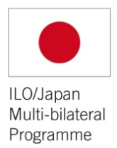

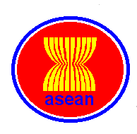
ASEAN-ILO/Japan Project
on Unemployment Insurance and Employment Services in ASEAN

Capacity Building and Knowledge Sharing Activities

1. Study visits to Japan’s Employment Insurance Institutions and Thailand’s Unemployment Insurant Scheme. (Act.3.1.1)
Tokyo, Japan, 7-9 November 2011.
Invited member States: Malaysia, Thailand and Viet Nam
Bangkok, Thailand, tentatively July of 2012.
Invited member States: Brunei Darussalam, Cambodia, Indonesia, Lao PDR, Philippines, Singapore.
Target beneficiaries: Representatives of Bureau of Employment and Social Security Offices, at technical level.
Study visit to Japan
Among the ASEAN member States, Thailand and Viet Nam have already in place an unemployment insurance scheme, while Malaysia is conducting a feasibility study to design an unemployment insurance system (January to September 2012).
Experience gained from Japan, where UI cash benefits and where employment services, such as vacancy information, job matching, vocational training, and other Active Labour Market Policies (ALMP) are provided to the unemployed, shows that this combination is the most efficient way to protect the unemployed against poverty on one hand, and to support them to return to employment on the other hand. This why the integration of both mechanisms and provisions under one Employment Insurance (EI) as a single window service should be reinforced in Viet Nam, Thailand and considered in Malaysia.
Two representatives of the Governments of Thailand, Viet Nam and Malaysia attended the study visit to Japan’s EI institutions which took place on 7 to 9 November 2011.

 Findings and Lessons learnt from Study visit to Japan, 7-9 Nov. 2011:
- It took over 30 years to build the EI system in Japan
- The EI system is based on strong link between UI benefits & ALMPs (Hello Service and Two Services)
- The EI system is doted of a solid control and investigation unit
- The legal framework allows for certain flexibility to adjust the EI parameters to socio-economic indicators.
Source: ILO/Japan-ASEAN UI Project, 2011.
ALMP: Active Labour Market Policies; EI: Employment Insurance; UI: Unemployment Insurance.

Study visit to Thailand
Governments’ representatives from Cambodia, Lao PDR, Philippines, Brunei, Singapore and Indonesia will be invited to visit the Thailand’s institutions involved in the implementation of the UI schemes and policies to support return to employment. The tentative dates for the study visit are July 2012.
 It is expected that participants will learn from the experience of Thailand’s good practice to design and implement an UI scheme in a context of a middle income country.

2. Experts’ Meeting to share preliminary findings of the research on UI and other income security measures for the informal economy workers, as well as ALMP. (Act. 1.2.2 & 1.2.3)
Jakarta, Indonesia: 14 December 2011.
Participating member States: Cambodia, Indonesia, Malaysia, Philippines, and Viet Nam.
Target beneficiaries: UI policy makers and practitioners from government agencies.
Session I: Promotion of Unemployment Insurance
In Indonesia as in other countries in the region such as Malaysia and the Philippines, the rigidity of the labour law (hiring and firing rules) has some adverse effect, for instance the reluctance of enterprises to hire workers on long term contracts and to invest in their employees (in terms of training, career development, etc.). The government of Indonesia is planning a reform of the labour law that will aim at introducing a higher degree of flexibility in the hiring and firing rules. It is acknowledged that these reforms should not be conducted at the expense of the sole workers and that they should be eased by the introduction of unemployment benefits schemes and active labour market policies.
To support this process the ILO is facilitating a feasibility study for the introduction of unemployment insurance scheme for formal sector workers in Indonesia, in 2011-2012. This exercise should take stock of similar experiences in the region, particularly the implementation of the new UI scheme in Viet Nam and the design of a new UI scheme in Malaysia.
Sharing knowledge and experience on the design and implementation of UI schemes in ASEAN – particularly in the context of Labour Law reforms – was extremely useful for Indonesia as well as the Philippines.
One representative of the UI scheme in Viet Nam attended the Meeting and shared the findings of the 18 months review and proposed measures to improve the UI scheme. Similarly, a representative of the Ministry of Labour of Thailand shared the seven years’ experience of implementing the UI scheme. So, Indonesia, the Philippines, and Malaysia at the early stage of the UI system design were able to learn from Viet Nam and Thailand’s experience. Malaysia also provided the lesson learnt on the importance to build a national consensus while introducing UI benefits.
Session II: An integrated approach to provide social security and employment services to the informal economy workers.
The main source of widespread poverty in lower income countries is not temporary but structural. In the informal economy, which represents more than 60% of the work force in the ASEAN, where everybody has to work in order to survive, the very concept of “unemployment” seems to be irrelevant. The main issues are underemployment and the often extremely precarious character of existing employment for those in poverty. The long-term solution relies on sustainable employment-generating policies, but there is still a need for interventions that alleviate the current situation. These should include: income support / income security for the unemployed and underemployed (working poor) in the form of cash transfers, as well as certain forms of basic employment guarantees in the form of public works or similar. Such measures are among the foundations of the Social Protection Floor (SPF) promoted by the ILO and the United Nations since April 2009 as one of the United Nations Chief Executed Board’s measures to face the crisis and accelerate recovery.
Under this policy framework, an integrated delivery mechanism seems to be effectively addressing the needs of vulnerable workers. Successful experiences have been reported in India, Pakistan, Chile, France and so on.
 In the region, countries like Cambodia and Indonesia are developing or willing to develop similar models and it was appreciated to share ideas and experience with ASEAN counterparts.
Cambodia and Philippines’ government representatives presented how they set up an integrated provision of social protection programmes and employment services under respectively the “People Service” in Cambodia and the Public Employment Service Offices (PESOs) in the Philippines.

 Key messages of the Experts’ Meeting (UI, income security, AMPs), Jakarta, 14 Dec. 2011:
- UI might not be the priority in all countries. Need for adapted measures for informal economy workers.
- Those measures should be institutionalized.
- There is a need to address youth unemployment through adapted ALMPs.
- Combination of income replacement and employment support is amongst the most effective mechanisms to protect the unemployed and vulnerable workers.
- Successful implementation of social protection/security laws and strategies could be based on piloting and then replicated at national level.

Source: ILO/Japan – ASEAN UI Project, 2011
ALMP: Active Labour Market Policies; EI: Employment Insurance; UI: Unemployment Insurance.

3. ASEAN Seminar on UI, income security and ALMPs. (act. 1.3.2)
Ho Chi Minh City, Viet Nam, 20-22 March 2012.
Participating member States: Government and social partners’ representatives of ASEAN Member State.
Target beneficiaries: Representatives of the Ministries of Labour, Social Security Offices, Workers’ and Employers’ Organizations
The Seminar aimed to promote further and implement income and employment security measures for the working age population of the ASEAN countries. More specifically the Seminar reaffirmed the commitment to extend social protection in the region, shared experiences and knowledge, contributed to raise awareness, and build synergies between initiatives to promote UI, as well as other income security measures and ALMP for the unemployed and vulnerable workers (youth and informal workers).
Sixty representatives of Ministries of Labour, Social Security Offices, Workers’ and Employers’ organizations, civil society organizations of the ASEAN member States, as well as experts, representatives of the ASEAN Secretariat and ILO Specialists participated in this Seminar.
In line with its objectives, the seminar was organized to disseminate ASEAN and worldwide countries good practices on UI, income security measures and ALMP for formal and informal economy workers. It was also an opportunity to share information and importance of the ratification of two up-to-date ILO conventions related to UI: the Social Security (Minimum Standards) Convention, 1952 (No.102) and the Employment Promotion and Protection against Unemployment Convention, 1988 (No.168). The seminar likewise provided an update of the latest global discussions related to the Social Protection Floor Initiative and also contributed to the creation of an experts’ network in the region.
The Seminar adopted thirteen recommendations to improve income security and the access to decent employment for all workers of the formal and informal economy in the region.
 Ho Chi Minh City Recommendations on UI, income security and ALMPs in ASEAN include:
- The need to develop adapted income security measures and ALMPs to respond to specific needs and constraints of workers according to economic sector, skill levels, age (youth unemployment was highlighted as a major concern), sex, disabilities, and so on;
- The urgent need to extend these measures to the informal economy workers;
- The necessity to work with Workers and Employers’ organizations;
- Proposals to improve the coordination of services and benefits delivered to unemployed and vulnerable workers;
- A request for the ILO and other relevant international organizations to pursue technical and financial assistance in the region towards enhanced social protection for all.

Source: Ho Chi Minh Recommendations on Unemployment Insurance, Income Security and Active Labour Market Policies in ASEAN, 22 March 2012.

The Seminar agreed on the follow-up actions:
- To continue information sharing and exchange of experiences among government officials, non-governmental organizations, international organizations, and other stakeholders in ASEAN member States on social protection with the objective of learning from the good practices and experiences of each other in improving the social protection coverage and delivery of services,
- To explore measures for improved protection against loss of employment including measures for the informal economy workers, through national dialogue with representatives of workers and employers,
- At national level, to start by mapping social protection situation, to identify and propose recommendations to fill the social protection gaps, in particular income security and better employment for vulnerable workers,
- To call for the ILO and other relevant international organizations to provide technical and financial support and disseminate knowledge on how to extend social protection to those who are self‐ or informally employed.

4. Experts’ Meeting to present the findings of the UI/EI comparative analysis and discuss challenges and lessons learnt from the feasibility study for the introduction of UI systems. (Act. 1.1.2 & 1.1.3)
Malaysia: 4 September 2012.
Invited member States: Indonesia, Malaysia, Philippines, Thailand, Viet Nan and any other country considering the introduction of UI.
Target beneficiaries: UI policy makers and practitioners.
Among the ASEAN member States having in place (Thailand, Viet Nam) or considering introducing UI/EI (Malaysia, Indonesia and the Philippines), there is a great interest to learn from experiences of neighbours countries, but also Asian and other countries relating to UI/EI schemes and other measures to support the unemployed of the formal sector.
The Government of Malaysia is considering the introduction of unemployment insurance and has requested the ILO's technical assistance to facilitate and support the design of an UI system. The ILO's Project to Support and Facilitate the Design of an Unemployment Insurance System in Malaysia (funded by the Government of Malaysia) started in January 2012.
Similarly, during the summer, Indonesia will conduct a study to explore the feasibility of introducing measures for a better protection of the unemployed, which could take the form of UI benefits and/or ALMPs. By organizing the UI Expert Meeting in Malaysia, the idea is to reinforce the synergies between the two projects.
The Government of the Philippines is also contemplating the introduction of an UI system in the coming years, and had already conducted preliminary feasibility study in this sense.
The ILo/Japan-ASEAN UI Project proposes to organize an Experts Meeting to share findings and experiences of these on-going processes. It is suggested holding the meeting in Kuala Lumpur, on 4 September 2012, linking with the final phase of the ILO’s UI Project in Malaysia.
 The purpose of this Experts Meeting is to (i) disseminate the findings of the comparative analysis among 14 EI/UI schemes worldwide, and (ii) to share experiences and lessons learnt for the feasibility studies in Malaysia, Indonesia and the Philippines.
UI policy makers and practitioners from Viet Nam and Thailand, as well as researchers, will be conveyed to share their experience with representatives of Malaysia, Indonesia and the Philippines on the design and implementation of their respective UI scheme. In addition, other ASEAN countries also firmly considering the introduction of UI will be invited to join the Experts Meeting.

5. Experts’ Meeting to promote integrated approaches to deliver social security benefits and employment support services. (Act. 3.2.2)
Dates and venue to be decided
Participating member States: Cambodia, Indonesia, Lao PDR, Philippines, Thailand, Viet Nam, and any other country considering the introduction of one-stop-shop services.
Target beneficiaries: UI policy makers and practitioners from government agencies, at central and decentralized levels.
Many developing and middle income countries in Asia and the Pacific are exploring the implementation of a Social Protection Floor (SPF) and have employment generation and decent work at the heart of their development agendas. However existing programmes often face challenges relating to coverage and effectiveness, and the services are not always delivered to the poor and most vulnerable. The institutions in charge of these programmes do not coordinate their interventions sufficiently nor have the necessary information systems to monitor and evaluate policies and programmes. They also need to coordinate more with local governments, because the trend towards decentralization has given these bodies an increasing role in implementing and overseeing social protection and employment programmes at provincial, district and commune levels.
There is also increasing need to provide both a framework and practical solutions that can effectively address the absence of social protection and economic security encountered by informal sector workers and the poor. The integration of social protection and employment services would provide beneficiaries with opportunities to progressively graduate from being mere receivers of basic social protection to finding a decent job and being able to contribute to social security.

Figure 1 - Moving up the staircase: towards higher levels of social protection and sustainable employment
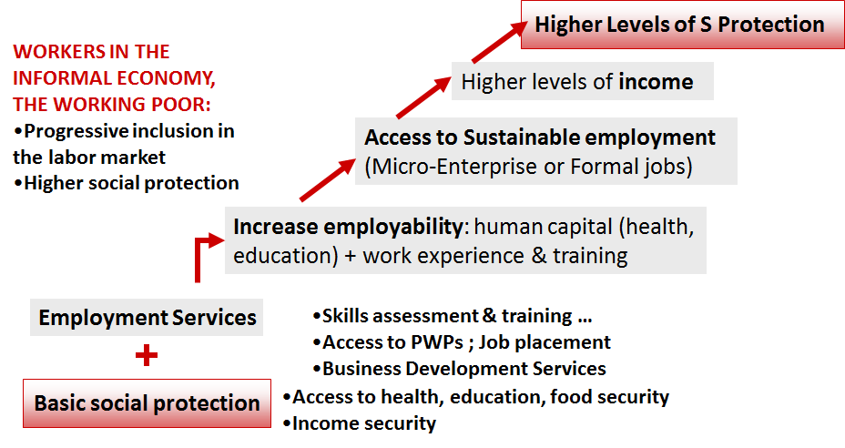
Source: ILO, 2010

In Cambodia and Indonesia, the ILO is piloting an innovative mechanism intended to improve the coordination, monitoring and delivery of integrated social protection and labour market interventions. This is called the People Service in Cambodia or the Single Window Service in Indonesia.
An integrated approach seems to be relevant because:
- it increases access to information on social protection and employment services and contribute to effective delivery of these services;
- it increases coordination at delivery level of institutions and therefore reduce costs by avoiding duplications (e.g. single registration, vulnerability and skills assessments);
- it fosters synergies between local level interventions and therefore increase their impact on poverty reduction and human development (e.g. by linking cash transfers with school attendance and health check-ups, by linking access to PWPs with access to health care);
- it facilitates the collection / update of data, and therefore will feed the central database of labour market information, as well as data on poverty reduction & social protection programs;
- it gives incentives for informal economy workers to use counselling services such as training or microenterprise development, access to micro-credit;
- it carries the potential to create incentives for economically active workers needing temporary support to become self-reliant and gradually benefit from higher levels of protection through contributory or partially contributory systems. With their progressive access to better paid jobs, their capacity to contribute to social security schemes is increased and they progressively have access to higher levels of social security benefits.

 The Experts’ Meeting will offer a platform to share the findings of the piloting in Cambodia and Indonesia, exchange experiences from the ASEAN countries and worldwide and draw recommendations to promote such an integrated approach to implement the social protection floors nationally.

XXXXX
5 May 2012

The feasibility study in Indonesia is supported by the ILO/Korea Bi-Multilateral Programme.
The Project to facilitate and support the design of an UI system in Malaysia is self-funded by the Ministry of Human Resources of Malaysia.

