Vietnam: Strengthening the social safety net to address poverty and vulnerability
A Policy Note - DRAFT

May 2010

Human Development Sector Unit
East Asia and Pacific Region

Document of the World Bank
_

Summary
As it transitions to Middle-Income Country status, Vietnam is considering whether its social protection system is adequate to meet rapidly changing needs associated with strong economic growth, industrialization, urbanization and other economic and societal shifts. With social insurance the primary focus of attention over the last years, the recent economic crisis has raised questions on the effectiveness of Vietnam’s social safety net – programs that address chronic poverty, help the poor in coping with the worst forms of shocks and transient poverty and that promote human capital development for long-term poverty reduction – and whether it stands the test of changing needs. This note highlights two messages: First, it identifies gaps in the current poverty reduction and social protection system – programs that help address urban vulnerability and poverty and that help the poor and vulnerable manage shocks – which could be closed through strengthened and more effective household-targeted social safety net programs. Second, in examining the existing core social safety net programs the note finds that, while targeting is respectable, their primary weakness lies in limited coverage. Based on these findings, this note proposes to strengthen household-targeted social safety net interventions in Vietnam as a complement to geographically-targeted poverty reduction programs and social insurance.
The note is a contribution to the ongoing policy discussion in the context of the preparation of the Vietnam Social Protection Strategy 2011-2020. It was prepared by Christian Bodewig and Emily Farchy with contributions by Daniel Mont and under the overall guidance of Xiaoqing Yu. The authors are grateful for comments by peer reviewers Carolyn Turk and Emil Tesliuc as well as by Paulette Castel, Son Thanh Vo, Sean Bradley and Valerie Kozel.
This note is in draft. Comments are welcome at cbodewig@worldbank.org.

Contents
Summary 3
Introduction 3
Poverty, vulnerability and challenges for the social safety net in Vietnam 3
Vietnam’s social safety net and anti-poverty programs 3
Household-targeted and social assistance programs 3
Geographically targeted anti-poverty and development programs 3
Spending on the social safety net 3
Assessing the effectiveness of the social safety net 3
Coverage 3
Targeting 3
Adequacy 3
Institutional and delivery aspects 3
Targeting methods 3
Benefit administration 3
Objectives and instruments: Anything missing? 3
Summary and Outlook: Possible policy directions for Vietnam’s social safety net 3
References 3

Introduction
As it transitions to Middle-Income Country (MIC) status, Vietnam is considering whether its social protection system is adequate to meet rapidly changing needs associated with strong economic growth, integration of its economy in regional and global markets, industrialization, urbanization and other economic and societal shifts. Efforts are under way to develop Vietnam’s first Social Protection Strategy 2011-2020 which will lay out directions for change over the coming decade. With social insurance and the expansion of coverage of Vietnam’s population the primary focus of policy attention over recent years, the recent economic crisis has raised questions regarding the effectiveness of Vietnam’s social safety net – programs with the following objectives: (i) alleviation of chronic poverty; (ii) help to the poor in coping with the worst forms of shocks and transient poverty; and (iii) promotion of human development for long-term poverty alleviation. This note aims to assess the system of social safety net programs currently in place in Vietnam and to gauge how well it covers the poor and vulnerable populations. It is a contribution to the ongoing policy discussion in the context of the preparation of the Social Protection Strategy. It does not discuss or assess Vietnam’s largely geographically targeted anti-poverty programs but raises the question whether social safety net interventions should become more prominent in Vietnam’s future overall system of social protection and poverty reduction.
What is a social safety net? Social safety nets are typically defined as non-contributory transfer programs targeted to the chronic poor, the transitory poor, vulnerable groups and losers in reform. Social safety net programs are part of the poverty reduction effort, but typically target poor people rather than poor regions and focus on mitigating extreme poverty and shocks and on helping households to make those decisions which will enable them to move out of poverty. They usually include programs such as unconditional or conditional cash transfers, in-kind transfers such as school feeding programs, price subsidies for households such as for energy or food, jobs on labor-intensive public work schemes, or fee waivers for social services such as health or education. In the Vietnamese context, social safety net programs include household-targeted programs such as social assistance under the Decree 67, certain elements of the National Targeted Program for Poverty Reduction (NTP-PR), the one-off cash transfer for poor households at Tet in 2009, subsidized access to health insurance, aid to disaster victims and others. There are also household-targeted social safety net elements within geographically targeted programs such as P 135 and the 61 Districts program.
Why social safety nets? By transferring income to the poorest and most vulnerable, safety nets have an immediate impact on poverty and inequality. In addition to this direct and immediate function, safety nets also make other key contributions to long-term national development policy:
- Safety nets help households manage risk and vulnerability and respond to shocks. At a minimum, safety net programs help households facing hard times to avoid irreversible losses, allowing them to maintain the household and business assets on which their livelihoods are based, and to adequately feed and school their children. Social safety nets can provide an insurance element that allows poor and vulnerable households to make better choices about livelihoods that yield higher earnings.
- Safety nets can encourage households to make better investments in their future by reducing poverty and improving human capital and labor productivity, and promoting an environment favorable to equitable and sustainable economic growth. In this role, safety nets basically act to remedy market failures, allowing households to take up opportunities that they would otherwise miss — both in terms of investment in the human capital of their children and in the livelihoods of the earners.
- Safety nets can directly assist governments in making reforms. Short-term safety net programs can compensate those who are negatively affected by reforms that are necessary for economic development, or who may oppose and stall these reforms.

Poverty, vulnerability and challenges for the social safety net in Vietnam
Vietnam has seen an impressive reduction in poverty since the early 1990s, yet poverty remains high among certain groups. Figure 1 presents poverty rates for Vietnam as a whole as well as for rural and urban areas and by ethnicity. It demonstrates just how successful poverty reduction has been in both urban and rural areas. Yet important challenges remain. First, rural poverty remains high, at close to 20 percent. Second, while poverty reduction among ethnic minority groups has been significant, poverty rates at above 50 percent remain a multiple of those of Kinh/Hoa, and the gap shows no sign of closing. Moreover, poverty among ethnic minorities is considerably deeper than that of other groups. Poverty among ethnic minorities is multi-dimensional and associated with the remoteness of location and limited access to social services. In particular, education outcomes remain significantly poorer for ethnic minority children, translating into the transmission of poverty from one generation to the next: While the primary completion rates among the Kinh/Hoa was close to 90 percent in 2006, it was below 70 percent for ethnic minorities. The difference is even starker for lower secondary education (77 vs. 46 percent in 2006). Gaps also remain in school attendance. This raises the question whether existing instruments remain appropriate or whether alternatives should be considered to promote greater inclusion and life chances for ethnic minorities – and what these alternatives are.
Figure 1 Poverty reduction in Vietnam has been impressive, but the gap between Kinh/Hoa and ethnic minorities remains wide, Poverty rates by geographic and household characteristics
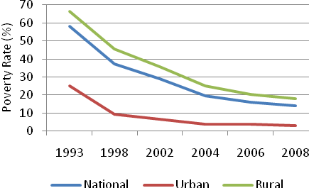 | 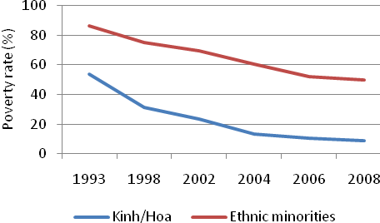
Source: World Bank estimate based on GSO data. Data for 2008 are preliminary

Many households have a tenuous hold on well-being and are vulnerable to shocks that can push them into poverty. Vietnam has a considerable proportion of households (estimated 4-5 percent in 2006 and 2008) that are living within a 10 percent band above the poverty line. Household-level or macroeconomic shocks risk pushing these vulnerable households into poverty. There has been little recent analysis of vulnerability in Vietnam – an important are for further research.
Vietnam’s fast development and transition to middle-income status produces new sources of vulnerability, often in urban settings. Vietnam is urbanizing, and more and more workers are employed in industry and services sectors (see Figure 2). Associated new sources of vulnerability have not yet been well documented in Vietnam, though there are several obvious sources of vulnerability. First, it is worth noting that, although poverty in urban areas is low, there is poverty and disadvantaged people in urban areas. Moreover, while the poverty rates and the depth of poverty in rural and remote areas is higher than in urban areas, poverty density, i.e. the absolute number of poor people, is significantly higher in urban areas. Second, strong internal migration from rural to urban areas, and the associated challenges migrants face in accessing public social services produces new groups of vulnerable people in urban areas. The same is true in terms of households in peri-urban areas who lose access to land due to urbanization and fast expansion of industrial zones and who remain without adequate compensation or new sources of livelihood. Third, industrialization and integration of Vietnam in global markets renders workers vulnerable to economic shocks, such as during the economic crisis of 2009. This is, fourth, particularly true for informally employed workers who are not eligible for unemployment insurance in the event that they lose work. Fifth, climate change risks triggering more frequent and more intense natural disasters. And, given that Vietnam is listed among the 12 most vulnerable countries worldwide on three out of five climate threats, the impact of climate change, already an important source of vulnerability in many parts of the country, is likely to become an increasingly urgent question.
Figure 2: Vietnam is urbanizing, and employment is increasingly in industry and services
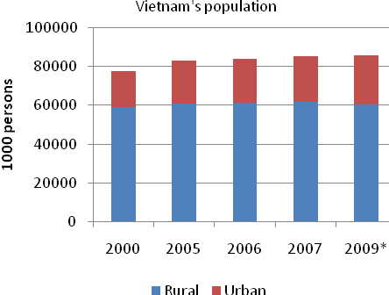 | 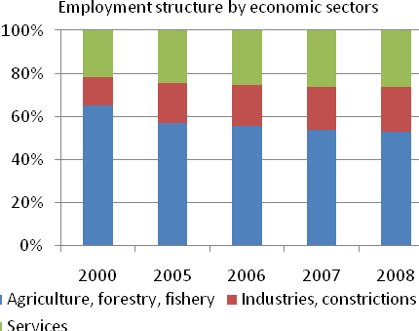
Source: GSO Year Book 2008; * Primary result of GSO population and housing census of 2009

The changing poverty profile, persistent pockets of poverty and new sources of vulnerability and transient poverty suggest that the need for an effective system of social safety nets, targeted at the household level, will increase as a complement both to poverty reduction programs that target poor regions, and to the social insurance system. This raises the question as to what programs are currently in place, how well they perform and how the system could be strengthened to meet the emerging needs. This will be discussed in the subsequent sections.

Vietnam’s social safety net and anti-poverty programs
Social safety net interventions take a small part in Vietnam’s overall social protection and poverty reduction system. The social protection and poverty reduction system in Vietnam is based broadly on three mechanisms: (i) social insurance, with policies to extend access to health and pension insurance for poor and near-poor individuals (see Box 1); (ii) geographically targeted development and anti-poverty programs as well as budget equalization mechanisms to channel resources to poor provinces and poor districts, and (iii) household-targeted anti-poverty and social assistance programs. Safety net programs span elements both of geographically targeted development and anti-poverty programs, and of household-targeted programs such as subsidized access to health insurance for the poor and near-poor. They also include programs and activities at the district and commune levels not covered in national policies (and household surveys).
Box 1: Vietnam’s social insurance programs
Social insurance programs include contributory pension, disability, sickness, health and unemployment insurance managed by the Vietnam Social Security (VSS) agency. Social insurance contributions/coverage are mandatory for most firms/employees of the enterprise sector. However, given the limited share in total employment of the formal sector, the government’s aim is to substantially widen the currently low coverage of old age, unemployment and health insurance through measures to promote voluntary participation, including subsidized access to health insurance for the poor and the near-poor.
In health insurance, the government’s stated goal is to achieve universal health insurance coverage by 2014. VSS ensures coverage of pensioners. The state budget subsidizes access to health insurance for the poor, populations in mountainous areas and children under 6 and covers half of the cost of health insurance cards for the near poor (with income between 100 and 130 percent of the poverty line).
Vietnam runs a largely traditional Pay-As-You-Go (PAYG) pension insurance system that is supported by compulsory contributions of formally employed workers, largely in the public and foreign enterprise sectors and also includes a new voluntary retirement pension, with very low coverage. Other programs, accessible only to contributors in the compulsory scheme, include short-term benefits related to sickness, maternity, and occupational disease and injury. The government also provides considerable budget financing for pension payments for the pre-1995 retirees.
Lastly, Vietnam has introduced a contribution-based unemployment insurance system in January 2009 which provides access to unemployment benefit for workers who have been formally employed for a minimum of 12 months.

Household-targeted and social assistance programs
Household-targeted programs are numerous and consist of preferential access to credit, education and social service subsidies and cash transfers. First, a range of policies and projects to promote access to economic assets and services for poor people are included under the National Targeted Program for Poverty Reduction (NTP-PR, see Table 1) – formerly the Hunger Eradication and Poverty Reduction Program (HEPR) – access to which is based on the Ministry of Labor, Invalids and Social Affairs’ (MOLISA) “poor list” (see below). While the program is managed overall by MOLISA, most funds are channeled through existing programs and mechanisms managed by line Ministries, for example Ministry of Health (MOH) and Ministry of Education and Training (MOET). In addition, there are programs targeted at poor and disadvantaged ethnic minority households living on agriculture and forestry to provide them with land, housing and clean water (P 134). The summary description in Table 1 shows that, while NTP-PR meets some of the typical social safety net objectives, in particular on the promotion of human development through providing access to health insurance and education, it does not provide households with a tool to cope with the effects of shocks.
Table 1: NTP-PR policies and projects and objectives
NTP-PR Project or Policy |  | Objective
Group of policies and projects facilitating production development and increased income for poor people
1 | Policy on preferential credit for poor households | Enhancing poor people’s financial capital in order to make investments that will increase cash income
2 | Policy on provision of productive land for poor ethnic households | Providing poor ethnic minorities with a principal asset, land, through which to increase food security and income earning potential
3 | Project on agricultural-forestry-fishery extension and support for development of production and occupation | Increasing the human capital base of poor people, to enable them to make commercially oriented decisions that maximize the use of household’s available assets
4 | Project on development of necessary infrastructure for communes with special difficulties in coastline and island areas | Strengthening the enabling environment in poor communes, to enable poor households to access markets and income earning opportunities, and to stimulate commercial activity in poor areas
5 | Project on vocational training for poor people | Strengthening the human capital of poor people, equipping them with knowledge and skills to access employment or market opportunities
6 | Project on replication of good practices on poverty reduction | Model development and experience sharing to ensure production models are transmitted from successful areas
Group of policies facilitating poor people’s access to social services:
7 | Policy on health care for poor people | Enabling poor people to access state health services free of charge, in order to enjoy better health as an end in itself, and also to be more productive
8 | Policy on education for poor people | Enabling poor students who would otherwise be unable to attend school, to participate in education, strengthening their human capital, future employment and income earning prospects, and the long term economic prospects of their households
9 | Policy on housing and clean water supply | Improving the environmental sanitation conditions in poor communes to improve communal health and the productivity of villagers, who would be less prone to disease
10 | Policy on legal support for poor people | Enabling poor people to access information and support in pursuance of their rights to access state services
Group of projects on capacity-building and awareness-raising
11 | Project on enhancement of poverty reduction capacity
12 | Monitoring and evaluation
Source: NTP-PR Mid-Term Review
In addition, Vietnam provides non-contributory social assistance cash transfers to different categories of the population. Social assistance cash transfers are available under “Decree 67” to orphans, children and adolescents deprived of parental care, elderly living alone, people above the age of 85 without a pension, severely disabled unable to work, mentally disabled and poor single parents (see see Box 2). This program aims to tackle chronic poverty and vulnerability among people who are unable to provide themselves through gainful employment. It is not designed to serve as a tool to cope with income shocks, as its eligibility criteria exclude households that fall into poverty, without any of the above mentioned categories of individuals. Decree 67 was introduced in 2007 and merged several separate programs into one. Vietnam also provides cash support to households affected by natural disasters. Moreover, there is a plethora of programs outside the NTP-PR for a range of beneficiary types including poor households, laid-off workers, ethnic minorities and others to (i) promote access to credit, (ii) encourage labor export, (iii) enhance access to housing and land, and (iv) promote access to education and training. Lastly, people with national merit also have the right to non-contributory benefits (see below), though strictly speaking this program should not be classified as social assistance.
Box 2: Social assistance under Decree 67
In introducing Decree 67 in 2007 the Government decided to recast the basic targeted social assistance benefit program and to increase its importance within the overall social protection system. Decree 67 consolidated several social assistance benefits under several separate decrees, widened eligibility criteria and raised benefit levels. According to Decree 76, the following groups are entitled to monthly social assistance benefits:
- Children and young people: Eligible groups include orphans, abandoned children (and minors aged between 16 and 18 years who are in general education or vocational training) or, those who have nobody to rely on, and HIV/AIDS- infected children in poor households. It also includes families and individuals who adopt orphans or abandoned children.
- The elderly: Eligible groups include lonely elderly people in poor households or elderly people in poor households who have no spouse or other relative to rely on. The same holds for people aged 85 or older without pension or social insurance income.
- People with special needs or health challenges: This includes seriously disabled persons who are unable to work. It also includes people with a non-treatable mental disability. Also eligible are HIV/AIDS-infected persons in poor households who are unable to work and households with two or more seriously disabled persons.
- Poor single parents or guardians: Single persons in poor households who are raising children under 16 years of age (or under 18 years if their children are in general education or vocational training) are eligible.
The widening of eligibility criteria has led to a considerable increase in the number of beneficiaries from 416,000 in 2005 to about one million in 2008, accounting for around 1.2 percent of the population. This is still low in an international comparison. For example, Bulgaria’s Guaranteed Minimum Income program, itself considered a small program, covered close to 4 percent of the Bulgarian population in 2007. According to the Bureau of Social Protection of MOLISA, old people (aged 85 and above) without pension accounted for 43 per cent of Decree 67 social assistance beneficiaries, people with disabilities for 25 per cent, the lonely elderly for close to 10 per cent, people with mental disability for close to 9 percent, single parents raising children accounted for close to 8 percent, with around 5 per cent other beneficiaries.
The adoption of Decree 67 in 2007 and an amendment in early 2010 considerably raised benefit levels which now vary between VND 180,000 and 540,000 per month depending on eligibility criteria. It also introduced one-time emergency assistance in case of shocks such as death of family member, natural disasters or other impoverishing shocks. Some Decree 67 benefits are targeted to the poor based on the MOLISA poor list, while others are categorical. In fact, the amendments of early 2010 strengthened the categorical nature of the benefit by removing the requirements of being on the poor list for people unable to work.
The widening of eligibility criteria and increase in benefit levels raised budget allocations for social assistance programs under Decree 67 to around 0.15 percent of GDP in 2008, up from 0.05 percent in 2007 and previous years, and covering 1.5m beneficiaries (above 1.5 percent of the total population). Decree 67 stipulates that the program is funded from local budgets, though the Government can release funds from the central budget in case of significant funding shortfalls.
The draft Social Protection Strategy 2011-2020 proposes to develop the program into a guaranteed minimum income program.

Geographically targeted anti-poverty and development programs
Geographically targeted development programs are not specifically targeted to poor people, but address poverty through general socio-economic development. They include national targeted programs, budget reallocation mechanisms and targeted anti-poverty programs. National targeted programs consist of a wide range of programs – e.g. immunization, general education, electrification, etc. – which combat poverty indirectly through general economic development. The programs set targets which the provincial governments are obliged to meet. Provincial governments draw up plans based on their perceived needs and submit them to the central government for approval. Funds are then distributed based on those plans.
Vietnam also has several geographically targeted anti-poverty programs aimed at addressing structural sources of poverty in remote regions, often with a high share of ethnic minorities. The longest-standing and most prominent is the P 135 program. Started in 1998 and now in its second phase running until the end of 2010, the P 135 program in its second phase is funded jointly by the government and donors and managed by the Committee for Ethnic Minority Affairs (CEMA), which targets resources, mainly for infrastructure projects, to geographic regions with high concentrations of ethnic minority populations and with the poorest villages. It aims to increase the production knowledge and promote a shift towards profitable commodities and to improve socio-cultural life and narrow the gaps among regions and ethnic groups. Provinces are allocated resources based on how many of their communes qualify for assistance, according to the following targeting criteria: (i) a lack of four out of seven essential infrastructure facilities (transport, water, power, schools, clinics and markets), (ii) social factors, e.g. high rates of ethnic minorities, difficulties with communication, education gaps, (iii) production, e.g. a lack of cultivation or low rates of sedentary farming, and (iv) living conditions including poverty and housing conditions. P 135 is largely an investment program with the majority of expenditures going to infrastructure development, and reviews of the program have found that there are limitations to integrated planning and coordination with other household or geographically targeted programs. While it does entail social safety net elements such as a monthly subsistence benefit for children in primary education (VND 140,000 per month) and preschool education (VND 70,000 per month), it does not have tools to help people cope with the effect of shocks (see also Box 3). In addition to P 135, there are several other area-based programs in different parts of the country (in the northern mountains, central highlands, Mekong delta and other areas (see Annex).
A new geographically-targeted program for the poorest 63 Districts was launched in 2009 as part of the stimulus package (Decision 30A). This program, run in districts with a poverty rate of above 50 percent, covers activities in support of agricultural production, job creation and income generation, including preparing for labor export, programs to enhance education and training, measures to promote greater rotation of public officials to bring more and better–trained officials to poor areas, and policies and programs for infrastructure investments including in disaster-prone regions. It includes as diverse measures as access to credit, fees for maintenance of forests and in-kind transfers. This program also does not classify as a social safety net program, and like P 135, is focused on poor areas and not per se on poor households.
Box 3: Adjustments to the social safety net in response to the 2009 economic slow-down
The global economic crisis led to a significant slow-down in economic growth in Vietnam, though not to a recession, and GDP grew at above 5 percent in 2009. However, sharply reduced international demand for Vietnamese manufacturing products resulted in lost jobs, increased underemployment, lower wages and lower incomes among formally employed, informal and migrant workers, those providing services in industrial parks and others. What was the social protection response to the slow-down?
Existing largely geographically targeted anti-poverty programs were not adjusted and expanded in response to the crisis. Due to administrative complexity amongst other reasons, such geographically targeted programs appear not to have served the purpose of a safety net for people affected by the economic crisis in 2009. This is most evident in the example of returning migrant workers: Research suggests that anti-poverty programs have not been utilized to help absorb migrant workers who, as a result of losing employment in urban areas returned to their rural homes. And, while the return of migrant workers appears to have been limited, those migrants who did return to underdeveloped rural areas appear to have found little employment opportunities there, despite the existing geographically-targeted anti-poverty programs.
The government instead introduced new programs as part of the stimulus package adopted around the Tet New Year in February 2009 which included social safety net measures. The stimulus package included three social impact mitigation interventions: First, the main immediate social safety net response was through a one-off targeted cash transfer at the Tet New Year holiday (VND 200,000 per poor person, up to VND 1,000,000 per poor household, adding up to VND 1.7 trillion overall) based on the MOLISA “poor list” which contains approximately 2.3m households with 9.2m individuals and which allowed a rapid identification of beneficiaries for the cash transfer. Second, a new regionally-targeted program for the poorest 63 Districts was launched (see above). Third, a program of increased housing support for the poor was put forward for around half a million rural households residing in substandard, dilapidated or temporary housing on the MOLISA poverty list to receive subsidies or loans of VND 6 and 8 million each respectively, adding up to VND 3.6 trillion, in a program to be completed by 2012.
Source: World Bank (2009c), ASEAN Assessment on the Social Impacts of the Global Financial Crisis, Vietnam Background Report

In addition to national targeted programs, the central government makes budget allocations for direct use by the provinces in carrying out their own investment plans. These allocations make up about half of all public expenditures and are distributed progressively so that poorer provinces receive disproportionately high allocations. In fact, there is evidence that relatively more net transfers have reached relatively poorer regions over time. The distribution formulas are transparent, and rely on population, level of development, geographic conditions and the organization of the local governments. Some provinces receive more than half of their GDP in these equalization grants, and a strong emphasis is placed on the spending of the resources according to regional and local economic development plans. However, there is little systematic evidence on how these funds are actually spent at provincial or district levels and how they reach the poor.
Looking at the system of social safety net and anti-poverty programs, it is obvious that Vietnam’s poverty reduction effort through designated programs has so far largely focused on poor and remote areas, and less on poor and vulnerable households regardless where they reside. The system of household-targeted programs is considerably less developed than that of area-based programs. Moreover, within the system of area-based programs, there is little focus on urban or peri-urban areas where the majority of the poor and vulnerable reside. While the approach so far has been associated with spectacular poverty reduction in rural areas over the last two decades, it may be worth considering the question whether a shift in focus may be necessary to deal with new challenges.

Spending on the social safety net
Vietnam’s main expenditures on non-contributory social protection programs are in pension payments to pre-1995 retirees and benefits for individuals with national merit – and considerably larger than anti-poverty programs. Consistent data on social protection spending in Vietnam across all levels of government is hard to obtain. Table 2 presents an estimate of budgeted expenditures on different social protection programs for 2008 and 2009. It does not capture executed expenditures. The estimations suggest that Vietnam may be spending in the vicinity of 4 percent of GDP on social assistance, pensions for the pre-1995 retirees, access to health insurance for the poor and near-poor, education fee waivers and poverty reduction programs. In 2009 Vietnam allocated budgetary resources worth above 2 percent of GDP for non-contributory programs, fee-waivers and anti-poverty programs. Specifically, in addition to close to 0.6 percent of GDP for poverty reduction programs, Vietnam in 2009 budgeted to spend around 0.6 percent of GDP on social assistance cash transfers, including social assistance payments under Decree 67 and disaster relief, as well as 0.9 percent on benefits for individuals with national merit and their families. An additional 0.35 percent was allocated for subsidizing access to health insurance for the poor, near-poor and children below the age of 6. The estimations suggest that additionally introduced programs in 2009 in the wake of the anti-crisis stimulus package represented around 0.4 percent of GDP (see and Box 3).
Table 2 Social safety net spending in Vietnam is considerable, though not on basic social assistance
Vietnam’s non-contributory social protection budget 2008 and 2009 – estimates
 | 2008 |  | 2009
 | VND billion | % GDP | VND billion | %GDP
Social assistance | 8,099 | 0.55 | 9,958 | 0.59
allowances under Decree 67 | 2,036 | 0.14 | 2,036 | 0.12
Tet 2009 cash transfer |  |  | 1,700 | 0.1
aid to natural disaster victims | 4,762 | 0.32 | 4,879 | 0.29
social services | 1,301 | 0.09 | 1,343 | 0.08
Benefits to people with national merit | 13,613 | 0.92 | 13,691 | 0.82
Social insurance | 23,044 | 1.56 | 23,044 | 1.56
state budget transfer for pre-95 retirees | 23,044 | 1.56 | 23,044 | 1.49
severance pay 2009, 200 000 workers |  |  |  | 0.06
Health insurance | 2,217 | 0.15 | 6,051 | 0.36
state budget transfer for the poor | 2,217 | 0.15 | 3,726 | 0.22
children under 6 |  |  | 2,013 | 0.12
near poor |  |  | 241 | 0.01
Education subsidies | 1,432 | 0.1 | 1,432 | 0.1
Bonus to low income civil servants |  |  | 360 | 0.02
Labor market policies | 1,327 | 0.09 | 1,342 | 0.08
Poverty reduction program | 4,564 | 0.31 | 9,689 | 0.58
NTP-PR and P 135 2006-2010 | 4,564 | 0.31 | 4,564 | 0.27
Poorest 61 districts |  |  | 1,525 | 0.09
Housing additional aid |  |  | 3,600 | 0.22
Total | 54,295 | 3.67 | 68,402 | 4.11
Source: Castel (2010)

At the same time, budget allocations for the main last resort social assistance cash transfer program under Decree 67 are low compared to that in other countries, reflecting relatively tighter eligibility criteria. According to Table 2, budget allocations for Decree 67 programs were below 0.2 percent in 2008 and 2009. In comparison, social assistance cash transfer programs such as the flagship conditional cash transfer (CCT) programs in Mexico and Brazil have an annual cost of 0.3-0.5 percent of GDP. Public spending on last resort social assistance programs in most countries in Eastern Europe accounts for between 0.3-0.5 percent of GDP. These differences can be explained by the fact that eligibility criteria for social assistance under Decree 67 is much narrower – and coverage therefore lower – than most last resort guaranteed minimum income programs or CCT programs worldwide which typically have no age limitations.

Assessing the effectiveness of the social safety net
The effectiveness of the social safety net can be assessed by looking at (i) coverage – the share of poor households who receive the benefit, (ii) targeting – the share of overall benefit spending that accrues to the poor, and (iii) adequacy – the share of recipients household consumption that the benefit represents. The unit of analysis for this is typically the poorest 20 percent of households. This is done based on household survey data such as the Vietnam Household Living Standard Survey (VHLSS).
The analysis of the effectiveness of the social safety net in Vietnam is constrained by limitations in available household survey data. The analysis in this section is based on the 2006 VHLSS which includes questions on a few social safety net programs, though not all. The survey captures (i) income from social insurance programs (pensions, sickness and job loss benefits and the lump-sum retirement allowance), (ii) income from social assistance programs (social welfare allowances, the precursor to Decree 67; allowance for recovery from disaster and fire); income from social welfare allowance for invalids and relatives of revolutionary martyrs; and income and support from charity organizations, associations or firms); and (iii) whether households benefit from any programs under the NTP-PR. Other social safety net programs that are often implemented and financed at local levels are not included in the VHLSS. Also, the VHLSS does not capture geographic targeted anti-poverty programs such as P 135. The survey measures actual benefit amounts received for social insurance and social assistance, but does not quantify the monetary value of the NTP-PR programs. Moreover, the 2006 VHLSSS did not ask all survey respondents whether they benefited from any program under the NTP-PR, but only those that stated that they were registered on the MOLISA poor list. This makes the analysis and results problematic both because it may lead to an underestimation of the real coverage of the NTP-PR, and because results may be unreliable due to uncertainty of respondents whether or not they are on the poor list. The analysis of the NTP-PR program incidence in this section must, therefore, be treated with caution.
Most importantly, available VHLSS data does not allow analysis of social assistance benefits following Decree 67. The VHLSS 2006 captured information about the social welfare allowances prior to the Decree 67 which was launched in 2007. These benefits, under several separate decrees, provided for social assistance cash transfers for poor individuals unable to work. Decree 67 merged these separate decrees into a single program (see Box 2 above). However, unfortunately the VHLSS 2008 does not cover social assistance allowances following Decree 67 because it does not include a separate question on whether or not households receive this benefit. It will be critical to ensure that the VHLSS 2010 includes this program, and other relevant social protection programs, to ensure policymakers can benefit from benefit and program incidence analysis. The analysis put forward in this note, therefore, reflects the pre-Decree 67 social welfare allowance.

Coverage
The coverage of poor households of targeted cash transfer programs is limited. Whilst most of those households that receive cash-transfer programs are in the bottom expenditure quintile, coverage remains severely limited. The only cash transfer program explicitly targeted to the poor, the social welfare allowance, covered only 1.3 percent of the poorest quintile in 2006. However, this is likely to have increased since 2007 with the introduction of Decree 67 which saw a widening of the eligibility criteria. The program that covered the biggest share of those households in the bottom expenditure quintile, at 17 percent in 2006, is the allowance for invalids and families of martyrs of war which by design is not poverty-targeted and not a social assistance benefit. Close to 10 percent of the bottom quintile households received donations from charity in 2006, while less than 3 percent benefited from disaster relief programs. At such levels, the coverage of Vietnamese programs is low also by international standards (see Figure 3). This low coverage is suggestive of how little these social assistance programs act as a social safety net.
Figure 3: Vietnam’s social safety net cash transfer coverage is low
Vietnam social safety net coverage, % of bottom and top quintile households receiving benefit
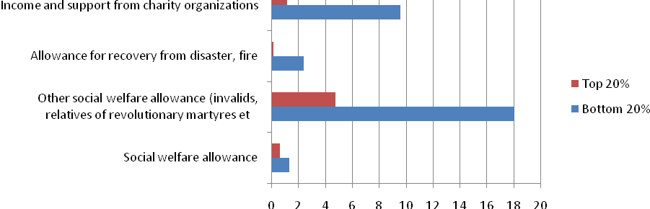

Social assistance coverage worldwide, % of bottom quintile households receiving benefit
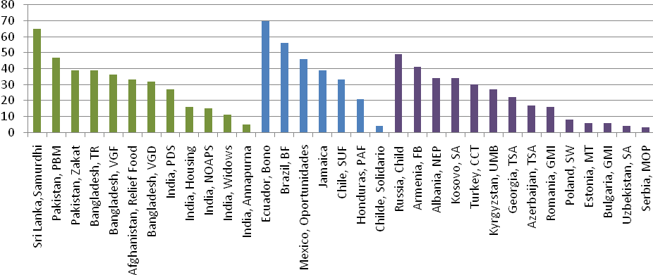
Source: Authors’ calculations on VHLSS 2006 (top panel), Ferre and Rashid (2010, bottom panel). Note: Coverage is calculated using household consumption net of each transfer

By contrast, coverage rates of eligible households under in-kind programs as part of the National Targeted Program for Poverty Reduction (NTP-PR) appear to be high. In 2006, close to 90 percent of eligible households – those on the MOLISA poor list – benefited from at least one NTP-PR intervention. This result is driven primarily by free health insurance (introduced in 2003 under Decision 139 for those who are classified as poor, ethnic minorities and people living in poor communes), education tuition exemption, and preferential access to credit for individuals on the poor list. However, because the VHLSS only puts questions on NTP-PR programs to those households who report being on the poverty list, this analysis has to be treated with caution. The VHLSS does ask separately and all households about access to free health insurance and to complete or partial fee waivers – the two most important elements of the NTP-PR. This allows a more reliable analysis which is less prone to exclusion. Households can be eligible to free health insurance because they are on the poor list, they are near-poor or because they have children below the age of 6. Eligibility for fee waivers are not just for households on the poor list, but also available for children in ethnic minority households, children of individuals with national merit, and children in households in difficulty.

Figure 4: Coverage of NTP-PR programs of households on MOLISA poor list
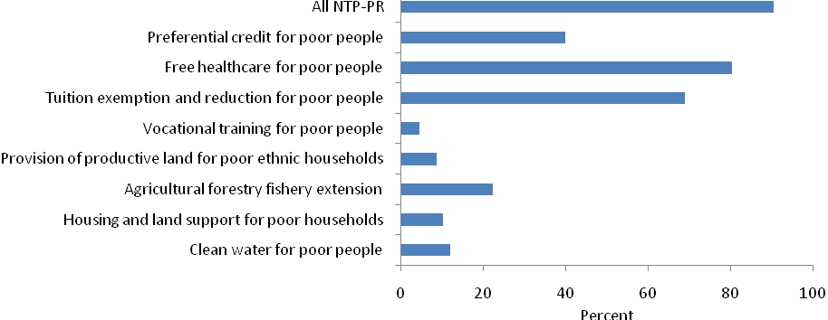
Source: Authors’ calculations based on VHLSS 2006. Note: the denominator is households on MOLISA’s poor list, except: Denominator for tuition exemption is households on poor list with children in school age and for provision of productive land for poor ethnic households is ethnic minority households on poor list.

Coverage of free health insurance and school fee waivers for the poor is particularly impressive, also for the poorest 20 percent of households. The VHLSS also allows measuring the coverage of free health insurance of the poor and partial or full school fee waivers for the entire population and not just that on the poor list, as part of the NTP-PR. More than 90 percent of children from bottom quintile households in primary school were either fully or partially exempt from fees in 2006 and more than 45 percent of children in lower secondary school. The main reason for primary fee exemption was that primary education is free, while lower secondary exemption is driven largely by poverty status and by residence in poor and remote regions. Likewise, health insurance coverage of the bottom quintile is considerable: Over 60 percent of the least well-off 20 percent of the population were covered by either health insurance or a health card in 2006. However, there are equally considerable variations between regions, and the poor tended to access health services less than the non-poor.

Targeting
Vietnam’s social assistance programs perform better on targeting efficiency than on coverage, though not as well as many programs across the world. With 48 percent of total spending on the social welfare allowance accruing to households in the bottom quintile, its targeting performance ranks higher than that of most South Asian programs but lower compared to Latin American and Eastern European countries. The strong targeting of allowance for recovery from disaster and fire may result not from sound targeting methods per se but from self-targeting, as the small size of the benefit (see below) may lead to application only from the very needy. Support for invalids and relatives of revolutionary martyrs, whilst not a targeted social assistance program, is also progressive, with over 40 percent of benefits accruing to the poorest 20 percent of households.

Figure 6 Some of Vietnam’s social safety net programs are progressive in reaching the poorest households, Targeting of programs (2006)
Vietnam social safety net incidence, %of total spending going to the poorest and richest quintile households
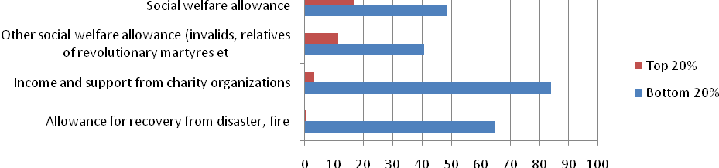
Social assistance targeting worldwide, % of total benefit spending going to poorest quintile households
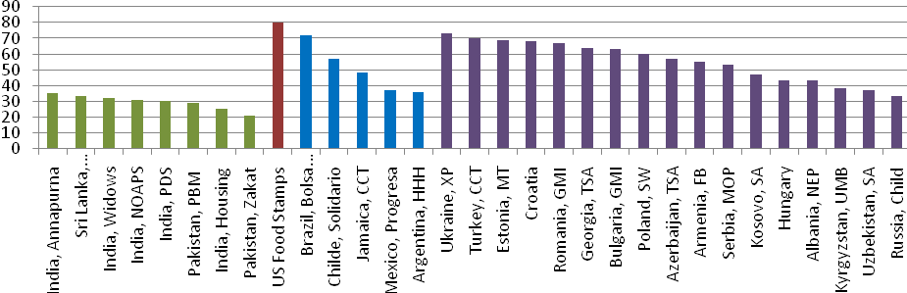
Source: Authors’ calculations on VHLSS 2006 (top panel), Ferre and Rashid (2010, bottom panel). Note: Targeting effectiveness is calculated using household consumption net of each transfer.

Adequacy
Existing social safety net benefits – in particular the social welfare allowance – matter a lot to those poor households who receive them. Benefit adequacy of the social welfare allowance which makes up 49 percent of expenditure of households in the poorest quintile is strikingly high. The message is that, though the social welfare allowance covers few households, for those who receive these benefits they are an important source of income.

Figure 7: Safety net programs take a significant share of expenditure of recipient households, Adequacy of programs, net of each benefit (2006) 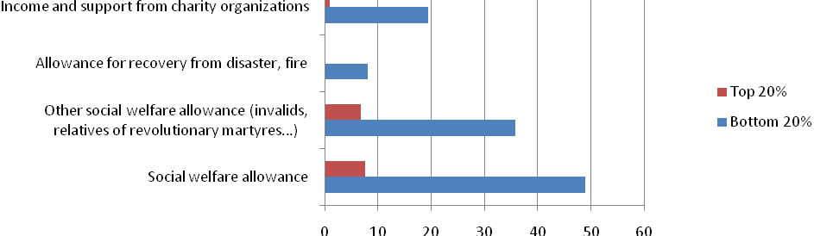
Source: Authors’ calculations on VHLSS 2006. Note: Adequacy defined as the mean value of the share transfer amount received by all beneficiaries in a group as a share of total household expenditure of the beneficiaries in that group. Adequacy is calculated using household consumption net of each transfer

The benefit incidence analysis presented in this note suggests that Vietnam’s social safety net has strengths as well as limitations. While existing benefit programs are largely progressive, their main limitation lies in the fact that they cover so few needy households. This is not a coincidence but a result of policy design which, in the case of the social assistance under Decree 67, maintains a fairly tight restriction on eligible beneficiaries. There are several key messages from this analysis:
- Vietnam’s main social assistance benefit program, the social welfare allowances, covered few people in 2006, but were rather well targeted and meant a lot to those who receive them. This message applies, however, only to the social welfare allowances prior to their merger under Decree 67 in 2007. Unfortunately, the program under the Decree 67 is not captured in VHLSS 2008. The expanded eligibility criteria set forth in Decree 67 have triggered a doubling of overall beneficiary numbers since 2006, but lacking survey data mean that the coverage of allowances under Decree 67 of the bottom 20 percent of the population cannot be established. This is why the only analysis thus far of Decree 67 benefits has been a simulation, rather than actual incidence analysis (see Box 4).
- The other important public cash transfer program – benefits for people with national merit and their families – is an important source of income for many poor households, even though by design it is not a targeted social assistance benefit.
- Allowances for recovery from disasters and fire cover few households and provide very little cash support, though the resources go predominantly to poor households.
- Coverage of poor households of donations from charitable organizations is significantly larger than public social assistance. Donations go almost exclusively to the poor, but tend to be small in value.
- Several programs under the NTP-PR cover most households on the MOLISA poor list, but do not provide support to many poor households that are not on the poor list. However, free health insurance and school fee waivers have considerable coverage of low-income households.
Box 4: Effectiveness of social assistance under Decree 67 – results of a simulation exercise
With Decree 67 allowances not covered in the VHLSS 2008, efforts have been made to at least simulate the incidence of the program by projecting eligibility criteria onto the data from the VHLSSS 2006. Put differently, the question was posed who in the VHLSS 2006 would have received the benefit program in 206, had the program existed then. The analysis conducted as part of the preparation of a poverty assessment by the Vietnam Academy of Social Sciences (VASS) reveals that the impact of the program on poverty reduction is likely rather small, owing to the fact that eligibility criteria exclude important groups such as the working poor and poor households with many children. In fact, while poverty is part of the eligibility criteria for some categories, the primary eligibility criteria are inability to work and family characteristics (see Box 2). The results show that less than 30 percent of the poor are eligible. Likewise, the program awards benefits to certain categories irrespective of whether they are poor – estimated at above 65 percent of potential beneficiaries in 2006. As a result, about half of the expected spending would go to the non-poor. Moreover, according to the analysis, benefit levels are insufficient to help the majority of the poor escape extreme poverty.
The findings suggest that if the program were to become an anti-poverty benefit program to ensure basic protection to all the extreme poor in Vietnam, it would require adjustments. It would require a widening of the eligibility criteria to include the working poor or low income earners as well as families with children. Concerns about benefit dependency or work disincentives could be addressed by making the benefit time-bound and linking it with active efforts to get out of poverty. Likewise, concerns about adverse demographic incentives of a benefit for families with children could be addressed by capping the benefit at a given number of children, say 3.
These findings are the result of a simulation and not the analysis of actual incidence of the program, based on the assumptions of no budget constraints and no targeting challenges. If the VHLSS 2010 includes a question on the social assistance under Decree 67, this would allow conducting actual incidence analysis.
Source: Pham Anh Tuyet and Paulette Castel (2009)

Institutional and delivery aspects

Targeting methods
Social assistance under Decree 67 and the NTP-PR target households using an identification mechanism defined by MOLISA. Poor households are formally identified annually by the Commune People’s Committees on the basis of an official poverty line, defined currently as VND 200,000 per person per month in rural areas and VND 260,000 in urban areas. It was set in 2005 and has not been changed since, despite considerable inflation. MOLISA and the General Statistics Office (GSO) are currently working on identifying a new poverty line which will be in effect in 2010.
The poverty list has been subject to considerable inclusion and exclusion errors in the past. Whether household income is above or below such threshold is decided through a combination of surveys and community discussions, and anecdotal evidence suggests considerable churning of households onto and off the poverty list. Analysis reveals discrepancies between the results of the identification of the poor list and that using household survey data. For example, using the VHLSS 2006, 49 percent of the population of the Northwest region is below the poverty line, while according to the poor list only 22 percent of the population is officially classified as poor. Similarly large discrepancies exist for ethnic minorities. While the current listing procedures at commune level appears to do a reasonable job of ranking people by income status within communes, doubts remain about the consistency of the effective poverty line across communes. The poverty list targeting mechanism relying on local administration and knowledge has thus become a respected tool; however it is subject to ongoing improvements, including introducing proxy-means elements more closely oriented at survey-based poverty correlates.
Targeting reform is under way. The government is raising the poverty line substantially in 2010 and conducting a complete re-determination of the poverty list. One methodology under discussion aims at providing cross-regional consistency in how poverty rates are determined while preserving local determination of the actual poverty lists. Under this procedure, the GSO would use data from the VHLSS and the Population Census to estimate provincial poverty rates. Then, each province would implement a census using a brief poverty scorecard to determine which families are poor. The weights on the scorecard will be determined by statistical analysis using the VHLSS in order to have them scientifically rooted, but the questions on the scorecard could theoretically differ across provinces. That way, indicators that are highly correlated with poverty in some areas but not others (e.g., land holdings) could be used where appropriate.

Benefit administration
The communes play an important role in the targeting and delivering of social safety net programs, under the authority of provincial authorities. While social assistance under Decree 67 is funded from the local budgets (whose size is dependent, inter alia, on the provincial poverty rate), communes also handle targeting (see above) and payment of benefits and maintain the beneficiary lists which are reported to the provincial departments of labor, invalids and social affairs (DOLISA). While there has been no comprehensive and rigorous assessment of benefit administration and service delivery capacities at commune and district levels so far, such an assessment will be necessary if the use of social safety net instruments is to be expanded.

Objectives and instruments: Anything missing?
A close examination of Vietnam’s social safety net reveals important gaps and policy issues which will need attention as Vietnam becomes a middle-income country. Vietnam is urbanizing, and the economy is undergoing a shift towards greater employment in industry and services sector. This is accompanied by greater mobility of workers and greater exposure of the population to economic shocks. Poverty and vulnerability will be increasingly driven by household characteristics than geographic characteristics, even though poverty in rural and remote regions, in particular among ethnic minorities, are likely to remain an important feature. The demand for social safety net programs in response to both chronic and transient poverty will rise. But is the current system geared to responding to these needs? As mentioned above, social safety nets typically follow three objectives, (i) alleviation of chronic poverty; (ii) help to the poor in coping with the worst forms of shocks and transient poverty; and (iii) promotion of human development for long-term poverty alleviation. Table 3 presents a simple taxonomy of the three objectives, design features of interventions and examples of interventions in Vietnam.
Table 3 Anything missing? Objectives of social safety net programs and examples in Vietnam
Objective | Design features of interventions | Examples in Vietnam | Gaps
Alleviation of chronic poverty | Targeted (to household or region), medium- to long-term assistance to address chronic poverty | Social safety net:  - Some elements of NTP-PR  - Regular social assistance under Decree 67  - Decision 102  Poverty reduction programs:  - NTP-PR  - P-135  - 61 Districts program  - Northern Mountains and other geographic anti-poverty programs | - Working poor  - Urban poor
Help to the poor in coping with the worst forms of shocks | Guarantee minimum income or last report irrespective of category; Link assistance to the source of vulnerability | - Free health insurance for the poor and near-poor  - Disaster relief  - One-time social assistance under Decree 67 | - Working poor and vulnerable in urban and rural areas
Promotion of human development for long-term poverty alleviation | Link assistance with ways to improve investment in human capital | - NTP-PR tuition exemption  - Free health insurance for the poor and near-poor | - Working poor and vulnerable
Source: Authors’ compilation
Alleviating chronic poverty: Targeting poor regions or also poor people? The existing mostly geographically targeted anti-poverty programs tackle structural poverty in poor and disadvantaged areas. This has been appropriate in addressing chronic poverty in rural areas, particularly areas with a high share of ethnic minorities, and has been associated with considerable reductions in rural poverty. However, as shown above, discrepancies in poverty rates remain considerable and persistent, with ethnic minorities continuing to be significantly poorer than other groups and, for example, rural averages. This raises the question whether, in isolation, geographically targeted poverty reduction programs remain the sole right approach to tackle persistent pockets of poverty or whether they need to be complemented by a modernized system of household-targeted social safety net programs targeted to the extreme poor that address both chronic and transient poverty that is driven, at least to some degree, by household characteristics and not just by geographical characteristics. Vietnam’s social assistance benefit under Decree 67 targets poor households with members who are not able to work to earn income. However, this excludes certain disadvantaged groups and sources of vulnerability, e.g. the working poor and vulnerable and households with large numbers of children. China has developed a system where regional anti-poverty and investment programs are complemented by cash-based social assistance (“Di Bao”) in rural and urban areas (see Box 5).
Box 5: China’s urban and rural Di Bao social assistance programs
In China, as in Vietnam, the emphasis of the safety net system has been largely focused on “self-reliance,” with the state providing educational and employment opportunities to the best of its ability, while issues of welfare have been left largely to the family. However, underemployment and lack of opportunity in rural areas have spurred massive migrations to urban areas as people search for employment. Many of these migrants lose their community ties and support networks, thus provision of an adequate safety net for these new urban poor is an increasingly urgent question.
Although poverty is characteristically smaller as a proportion of the population in urban areas than it is in rural areas, it tends to assume distinctive forms in an urban setting. These are to be found in inadequate and volatile employment opportunities, inadequate access to credit, and a lack of the necessary capital, both physical and social, to deal with personal or economic shocks. China’s response to increasing urban vulnerability was the rapid transformation of its social safety net system, from what was essentially a system of guaranteed employment, to the current “Minimum Livelihood Guarantee Scheme” (popularly known as the urban Di Bao). The urban Di Bao started in Shanghai in 1993, becoming a national policy in 1999 and expanded rapidly until participation leveled off in 2003 with 22 million beneficiaries - representing 6 percent of urban residents, at a cost of about 0.1 percent of GDP.
The urban Di Bao has an excellent targeting performance compared to international standards with 83.3 percent of all beneficiaries in the lowest income quintile. In addition to cash and in kind benefits the program allows for preferential treatment of beneficiaries for certain social services. Coverage, however, remains more limited; whilst nearly 8 percent of the urban population is eligible for the benefit, only 5.22 percent currently receive it. Furthermore as an urban program, coverage is limited to those with an urban residential permit (‘hukou’), a feature which limits its ability to cover the increasing number of rural-urban migrants.
By its very nature as a minimum income guarantee program aiming to bring everyone’s income up to the Di Bao line, the program implies a 100% marginal tax rate on incomes that fall below this line, leading to potential labor market distortions. However, whilst there is no limit in principle on how long a household may receive Di Bao benefits, in practice, only those who are unable to work are likely to be provided with long-term assistance. Others are provided short-term benefits for three months subject to regular review. Those who are able to work must register at employment agencies for jobs and retraining.
In 2007 China rolled out the rural Di Bao on a national basis in 2007, covering 35 million beneficiaries and two-thirds of the rural poor in all 31 provinces by 2007. Funded from local budgets and with central support, the rural Di Bao became the single most important social assistance program in rural areas. The rural Di Bao is modeled after the urban Di Bao, with the main criterion for eligibility being the household per capita income below the administratively set Di Bao threshold. However, thresholds vary across the country, largely driven by differing fiscal space for the program.
Despite the success of the urban Di Bao, the problems of urban poverty cannot be divorced from the conditions of rural poverty, for reducing the one without addressing the other will merely speed the flow of migrants to urban areas, displacing the poor from rural areas to urban ones. In China the urban and rural Di Bao programs are increasingly viewed as part of an integrated system from policy, administrative and in some cases fiscal viewpoints. Nanjing from May 2004 provides an example of a provincial Di Bao regulation which integrates urban and rural Di Bao policies including common eligibility determination rules and broadly common policy on non-cash benefits. While at one level simply formalizing existing practice, these reforms mark an important step towards an integrated nationwide social assistance program that could breach the gaps in social protection between urban and rural areas. Such an integrated system would have a particularly positive impact on migrant workers, who currently ‘fall between the cracks’ of urban and rural systems.
Source: (O’Keefe 2004, 2007), World Bank (2009a), Ravallion et al (2006)

Helping the poor cope with shocks and transient poverty: New instruments needed? Vietnam’s health insurance subsidy to the poor is an instrument that protects the poor against one of the most costly idiosyncratic shocks. However, there are gaps in terms of instruments that deal with shocks related to a sudden loss of income. Although Vietnam now has an unemployment insurance system for formal sector employees to adjust to job loss, there is no protection for informal and mobile workers. The Decree 67 introduced a one-time emergency social assistance cash benefit to deal with a number of defined shocks. However, as a one-off benefit, this cannot provide assistance where the effect of a shock is sustained for a longer period of time. The monthly social assistance benefit under Decree 67 is limited to certain categories of individuals who are not able to work and is not available to anyone who, as a result of a shock, falls below a certain income threshold – in particular it excludes the working poor. Moreover, Vietnam has a well-functioning mechanism to identify the poor through its annually updated “poor list”. Despite identified weaknesses, it is an asset to build on, with a refinement of its methodology and utilization, and can serve as the basis for modernizing the system of household-targeted, cash transfer-based safety net instruments in the future.
Promoting human development for long-term poverty alleviation: How to use safety net programs to provide a way out of poverty? Considerable attention has also been given to interventions that promote human development with the aim of providing a way out of poverty, for example through providing targeted subsidies to poor households so that they can participate in the same health and education services as the non-poor. Vietnam is investing in expanding and improving the supply of schools and kindergartens in underserved areas through anti-poverty programs and national targeted programs. However, it is not certain that these programs reach the poor, and not predominantly the non-poor, in poor areas. Moreover, there are poverty-related barriers on the demand side as well. Already, the NTP-PR allows children from poor households to go to school without paying tuition or paying less, but there are additional barriers to going to school related to poverty and the inability to afford text books, school material, clothes or the transport to school. Moreover, there are opportunity costs of child labor, especially when children grow older. Complementing supply-side investments, providing cash support to poor households may enable them to send their children to school. Increasingly, countries around the world adopt conditional cash transfers (CCTs) which combine a cash transfer with the requirement for children of recipient households to attend school, as well as other requirements related to health and nutrition. These programs are typically associated with sustained outreach efforts to support parents in making sound decisions for their children.
Many middle-income countries choose cash transfers as a key social safety net mechanism, while limiting the risk of triggering welfare dependency and passivity of the beneficiary. In its efforts to reduce poverty Vietnam has so far relied less on cash transfers than on in kind benefits or indirect investments in production and local infrastructure. Indeed, eligibility for cash transfers under Decree 67 so far has been limited to those who cannot be expected to earn an income through gainful employment, for example the lone elderly or people with severe disability. This reflects a concern that the availability of cash transfers trigger passivity and welfare dependency among beneficiaries. However, vulnerability to shocks can be independent of work ability, and there are instances when those who are able to work fail to earn enough to support their families, at least temporarily – the so-called working poor. Experience from around the world suggests that cash transfer programs can be designed in such a way as to avoid work disincentives while providing much needed support to the poor and vulnerable (see Box 6). In reviewing policy options, Vietnam can benefit from this rich body of research.
Box 6: Subsidy or self-reliance: Avoiding benefit dependency and promoting work incentives in the social safety net
Vietnam’s main social safety net program, social assistance under Decree 67, avoids work disincentives by limiting eligibility to those who are not able to work. This approach is similar to that in many developing countries, but results in only a partial safety net and one which does not fully respond to changing needs of a middle income country where economic shocks are becoming increasingly common. International experience shows that cash transfers do not necessarily trigger benefit dependency and work disincentives if well designed. This box summarizes a number of possible design elements:
First, benefit dependency can be avoided by setting defined time limits for benefits or reduce their value over time. Both these features are incorporated, for example, in Chile’s Chile Solidario and Mexico’s Oportunidades program. Serbia’s social assistance benefit MOP is available only for nine out of twelve months, and not over the summer period. Time limits can be particularly useful if the cash transfer program has a dual objective of responding to temporary economic shocks affecting households with able-bodied members and providing relief to the chronic poor who are unable to work. Time limits can be relaxed for those unable to work but maintained for those who are able to work. This may be a useful model for Vietnam in further developing social assistance under Decree 67.
Second, some cash transfer programs include a workfare program for those who are able-bodied. For example, Ethiopia’s Productive Safety Net Program covers all the extremely poor and combines a workfare program serving those who can work with cash transfers for households without labor resources. Others condition benefits for able-bodied beneficiaries on evidence of active search for work. This is in particular the case in both Western and Eastern Europe where social assistance benefits are increasingly integrated with employment activation programs to help beneficiaries re-enter the labor market. Transfers are linked to activities such as job training or placement, education, or social support services intended to help households move out of assistance and toward independence. However, these may be administratively demanding.
Third, some programs, such as Albania’s Ndihme Ekonomika (Economic Assistance) program and Romania’s and Bulgaria’s Guaranteed Minimum income (GMI) program require able-bodied beneficiaries to work a certain number of days per month in exchange for benefits (one day per week in Albania and one week per month in Romania). Refusal to work results in stopped payments. Combining last resort social assistance programs with a work test allows setting benefit levels based on poverty reduction criteria without the threat of work disincentives.
Fourth, benefits can be set at levels lower than adults can earn by working. Most programs in developing countries have extremely low benefits, often substantially below the poverty line. In many countries social assistance benefits are rarely enough to ensure survival by themselves, but rather are a supplement that can help achieve a minimum standard of living. Alternatively, eligibility for cash transfers can follow a benefit formula that reduces benefits on a sliding scale of less than one currency unit in benefit reduction for each currency unit of increased earnings. This can be found in several middle and high income countries. This means that additional work effort will raise incomes.
Source: Grosh et al (2009)

Summary and Outlook: Possible policy directions for Vietnam’s social safety net
Social safety nets can play an important role in Vietnam’s future development, but need redesign and expansion if they are to do so. Vietnam’s economy is changing fast, with greater shares of the population residing in urban areas and finding employment in industry and services sector. Greater mobility of workers and greater exposure of the population to economic shocks are important dimensions of this change. The analysis in this note points towards three messages: First, while overall poverty continues to fall, important pockets of chronic poverty remain among certain groups (in urban, peri-urban and rural areas). In particular, poverty among ethnic minorities is chronic and remains stubbornly high and associated with poor education outcomes among children. A new approach to tackle this may be necessary. Moreover, economic and societal shifts trigger new forms of vulnerability and openness to shocks (often in urban areas). Both chronic and transient poverty require new instruments, including through strengthened cash transfers based on household targeting. Second, the note identifies specific gaps in the current poverty reduction and social protection system – programs that help address urban vulnerability and poverty and that help the poor and vulnerable manage shocks. Third, in examining the existing social safety net programs, this note finds that while targeting of the main programs is respectable, their main limitation lies in limited coverage. Though data limitations apply, this is in particular true for basic social assistance benefits under Decree 67 which, due to its limited eligibility, also receives less funding than core social assistance programs elsewhere in the world. This suggests that Vietnam may want to consider modernizing and strengthening its household-targeted social safety net interventions as a complement to geographically-targeted poverty reduction programs and social insurance.
Building an effective social safety net for a middle-income Vietnam could involve the following policy directions:
- Creating a basic, non-contributory social assistance program that can help households affected by shocks in both rural and urban areas by relaxing eligibility constraints and widening coverage. It could either be based on Decree 67 or designed in addition;
- Piloting a CCT element in regions with large ethnic minority population shares and poor education outcomes, possibly as part of a basic social assistance scheme, to target income poverty among certain groups and promote the right investments in nutrition and education, complementing supply-side investments in education;
- Improving the monitoring and evaluation of social protection programs. This should include reflecting programs in the VHLSS to allow for regular and expanded benefit incidence analysis along the lines as presented in this note as well as the collection of consistent disaggregated administrative data associated with disaggregated data on expenditures on programs;
- Continuing efforts to improve the targeting methodology used to determine the poor list. At the same time, developing grievance and redress systems to allow citizens to complain if they do not receive benefits despite being eligible;
- Further developing social insurance and expanding coverage of the poor and near-poor as well as non-formally employed in social and health insurance.

References

Castel (2010), Fiscal space social protection policies in Viet Nam, in Bauer and Thant (2010), Poverty and Sustainable Development in Asia: Impacts and Responses to the Global Economic Crisis, Asian Development Bank
CEM and UN (2009), Reviewing the Past – Responding to New Challenges: Mid-Term Review of Porgramme P 135-II, 2006-2008
Grosh et al. (2009), For Protection and Promotion: The Design and Implementation of Effective Safety Nets, World Bank
IPSARD (2009), Impact of economic slow-down on laborers, employment and life of rural people, Reference Report no. 1, 06/05/2009
Jones et al. (2009), A Mapping Exercise – Poverty Reduction Programs and Policies in Vietnam, UNDP Vietnam
Lieberman and Wagstaff (2009), Health Financing and Delivery: Looking Forward, Health Nutrition and Population Series, World Bank
MOLISA and UNDP (2009), Mid-term Review of NTP-PR, 2006-2008
Mont (2009), An Overview of Social Development Programs in Vietnam, processed
Nguyen and Rama (2007), A comparison of quantitative and qualitative poverty targeting methods in Vietnam, Q-Squared Working Paper no. 32, February 2007
Nguyen and Kozel (2010), Poverty by GSO-WB poverty line and poverty classification by commune authorities in Vietnam, p[rocessed draft
O’Keefe, Philip (2007), “Urban Di Bao in China: Building on Success” mimeo, World Bank
O’Keefe, Philip (2004), “Social Assistance in China: An Evolving System,” mimeo, World Bank
Pham Anh Tuyet and Paulette Castel (2009), Social assistance: Cash transfers: Potential impact of Decision 67, Background paper for the Vietnamese Academy of Social Sciences, Centre for Analysis and Forecasting Poverty Assessment, forthcoming. Presented in the Workshop Social Protection and Policy Implications, Vietnamese Academy of Social Sciences, Hanoi, 12 June 2009.
Ravallion et al. (2006), “Di Bao : a guaranteed minimum income in urban China?” World Bank Policy Research Working Paper 3805
World Bank (2008), Vietnam Development Report: Social Protection, Hanoi: World Bank
World Bank (2009a), China, from Poor Areas to Poor People: China’s Evolving Poverty Reduction Agenda, Poverty Assessment
World Bank (2009b), Convenient Solutions to an Inconvenient Truth: Ecosystem-based Approaches to Climate Change
World Bank (2009c), ASEAN Assessment on the Social Impacts of the Global Financial Crisis, Vietnam Background Report
World Bank (2009d), Country Social Analysis: Ethnicity and Development in Vietnam, World Bank.

Grosh et al. (2008)
World Bank (2009d)
VHLSS 2004 Poverty maps
World Bank (2009b)
Vietnam Social Protection Strategy, 8th draft
This note does not discuss the effectiveness of P-135 or other area-based poverty reduction programs. For more see CEM and UN (2009) and MOLISA and UNDP (2009).
IPSARD (2009)
World Bank (2008)
Unfortunately, the 2006 survey lumps these three very different programs into one question which does not allow any meaningful analysis. In contrast, the 2008 VHLSS treats these programs separately.
World Bank (2008) and Lieberman and Wagstaff (2009)
World Bank (2008)
Nguyen Viet Cuong and Valerie Kozel (2010)
Nguyen and Rama (2007)
Recent assessments have confirmed that the system of geographically and household targeted anti-poverty programs are fragmented and uncoordinated and with gaps in coverage. A recent mapping exercise found that, though poverty reduction programs showed plenty of overlap in their design, there is little overlap in practice. However, at the same time there is also little coordination between programs (see Jones et al (2009)). A mid-term review of the NTP-PR concluded that although NTP-PR programs and policies were closely aligned with priorities under the Socio-Economic Development Plan, there was a lack of coordination among them and with other programs such as P 135. Programs tend to overlap, and policies and procedures are difficult to interpret, while the vertical and horizontal information flow is limited. Moreover, due to a multitude of funding sources, it is difficult to monitor resource spending and availability (see MOLISA and UNDP (2009)).

