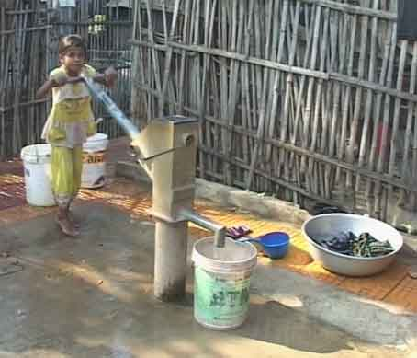
A Public Works Programme as part of the National Social Protection Strategy

Guidelines

for
Implementation
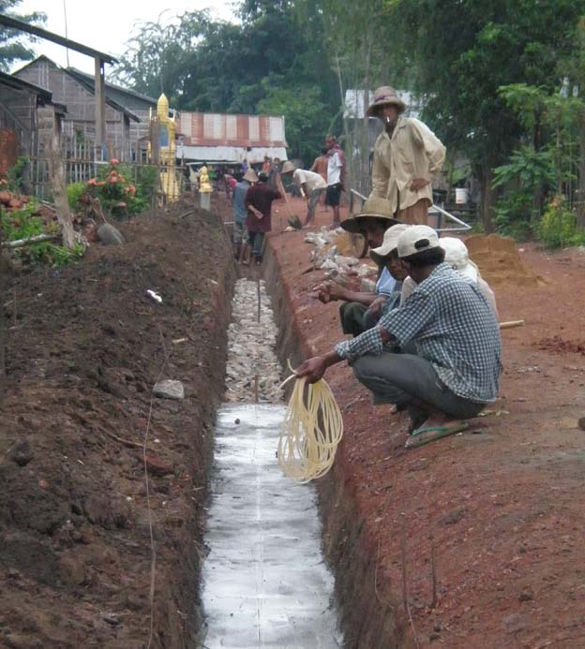
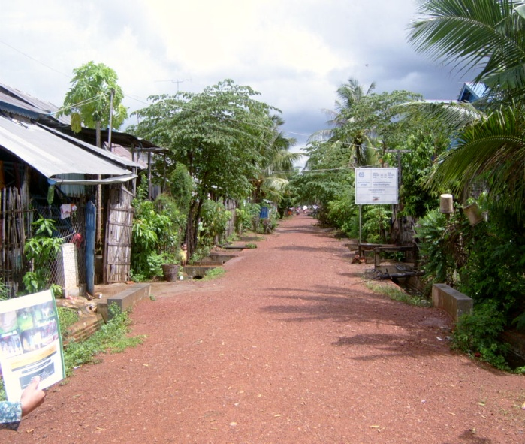
Prepared by the ILO and the Council for Agriculture and Rural Development
Phnom Penh. December 2012

Table of Contents

1. Introduction 1

2. Management and Coordination 1

3. Responsibilities 2

4. Description and Design of approved works 6

5. Project Cycle 8

6. Terms and Conditions of Employment 9

7. Maintenance 10

8. Implementation 10

9 Completion 13

10. Cash Request and Payment Procedure 13

11. Monitoring and Reporting 17

12 Training and Orientation 17

Annex 1. Number of participants required
Annex 2 Tertiary Roads Maintenance
Annex 3 Monitoring Indicators
Annex 4 Measurement Procedures
Annex 5 Flow chart of activities

Abbreviations

ADB | Asian Development Bank
CARD | Council for Agriculture and Rural Development
CC | Commune Council
CDP | Commune Development Plan
CIP | Commune Investment Plan
DIW | District Integration Workshop
PWP | Public Works Programme
FSP | Financial Service Provider
GIZ | Gesellschaft fur Internationale Zusammenarbeit
ILO | International Labour Organisation
KfW | Kreditanstalt fur Wiederaufbau
NCDD | National Council for Democracy and Development
NGO | Non Government Organisation
NSPS | National Social Protection Strategy
PMC | Project Management Committee
PID | Planning and Investment Division (provincial)
UXO | Unexploded Ordnance
VDP | Village Development Plan
WB | World Bank
WFP | World Food Programme

Introduction

The Public Works Programme has been designed as the instrument to achieve the objectives of component 3 of the National Social Protection Strategy (NSPS). This document provides Operational Guidelines for the coordination, planning and implementation of the PWP and will be used by involved stakeholders.

The PWP programme is focused on the development of sustained, predictable and integrated livelihoods promoted by asset creation interventions through the sub national government agencies. The PWP programme will provide employment opportunities for poor and vulnerable, insecure households to participate in creating community assets. Through a participatory process, and working with the commune councils, communities will select assets that contribute to higher agricultural productivity, increased access to markets and social infrastructure, and improved resilience to climate shocks.

PWP will be managed by commune councils and integrated within the new government structure at the sub national level. PWP design and processes are part of the National Social Protection Strategy.

PWP will be more than a relief and recovery programme. It aspires to be a livelihood development programme and its design reflects that objective. Key elements of the PWP are:

- the integration of the programme with the sub national governance systems and procedures
- the transfer of responsibilities to the Commune Councils and the District councils
- geographic focus and sustained, predictable engagement in the selected communes allowing for predictable employment opportunities
- year round provision of employment
- provision of lighter works to vulnerable households
- a payment approach allowing for regular payments
- a wage rate reflecting current rural unskilled wage rates
- improved targeting (focusing uniquely on IDPoor households)
- infrastructure built to a standard which is maintainable and sustainable
- greater collaboration with related livelihood programmes supporting vulnerable Sections.

Where these guidelines are in conflict with the Project Implementation Manual (PIM) of the NCDD, these guidelines will prevail. However, where possible these guidelines should be modified in cases where such modification does not conflict with the overall policy and objectives of the PWP

Management and Coordination

The following institutional arrangements will be put in place for the management and coordination of the PWP programme.

National Level

- The National Committee for sub-national Democratic Development (NCDD), in collaboration with the Council for Agriculture and Rural Development (CARD), will coordinate the planning and implementation of the PWP.
Provincial Level
- The Provincial Governments through the Planning and Investment Division and the District Commune Technical Support Officer will provide technical support on all technical issues and detailed monitoring of the implementation of the PWP programme. Sufficient staff will be provided for this purpose.
- Key responsibilities of involved stakeholders and nominated staff for established positions are defined in Section 3
District Level

- The Commune Technical Support Officer will provide support to the implementation of the programme and monitor the progress of the works

Commune Level

- The commune council will be responsible for the implementation of the programme of works identified under the PWP.
- The PWP programme will be implemented through a Project Management Committee set up for the purpose. The PMC will comprise of the Commune Chief and one additional council member and representatives from each of the villages where PWP projects are being implemented. The role and functions of the PMC are defined in Section 3 below.
- To the extent possible the Commune Council (CC) will allocate counterpart resources to the yearly plan. For example, the budget for maintenance in the C/S fund could be allocated to roads constructed or rehabilitated under the PWP programme.
- The village members of the committee will also be responsible for monitoring and coordinating the implementation of the projects in their respective villages. One member of the commune council will be identified as being responsible for the day to day support to the PWP programme in the commune.

Project/Village Level

- Under the auspices of the PWP PMC, three village members of the committee will be responsible for the implementation of the project in their village. Inter alia they will be responsible for the selection of IDPoor households, providing technical monitoring of the work on the site on a daily basis, recording the attendance on the site, advising the provincial technical agency of any irregularities or necessary changes to the work plan and providing detailed records of the progress of the work to the PMC.
- PWP Projects follow a series of steps or activities from start to finish of project. The sequence of steps in a PWP Project is shown in the Flow Chart of Activities (See Annex 5)

Responsibilities

Responsibilities of the NCDD

- Sign an LoA with CARD and the respective Provinces

- Establish a designated fund at commune level, in parallel to the C/S fund for the implementation of the PWP

- Be the coordinating agency for the monitoring and coordination of the overall PWP programme and participate in the regular sub-national coordination meetings.

- Prepare yearly programme evaluation reports

- Co-Chair, with CARD, the PWP oversight committee

- Facilitate the overall implementation of the PWP programme

- Support the individual communes through the sub national agencies for the implementation of the PWP programme

Responsibilities of Provincial Government

- The Planning and Investment Division (PID) of the Provincial Government will provide support on all aspects of the implementation of the PWP

- Consolidate monthly work lists, draft the agenda for the monthly sub-national coordination meeting and chair the monthly sub-national coordination meeting

- Prepare brief monthly reports consolidating the reports from the Districts on progress and key activities in the project communes

Responsibilities of the District

- The District will support the communes in the implementation of their yearly programme of PWP supported projects.

- Prepare monthly reports of the progress of PWP activities in the communes in the District

- The District will attend the village initial public meeting and support the Commune Councils, in establishing the PMC for the PWP programme

- Participate in monthly sub-national coordination meetings

Responsibilities of the Commune Council

Project Identification

- Select projects for the PWP allocation from the priority investment projects selected at the DIW

- With the Village Chief assist the provincial technical agencies to conduct pre-assessment

- With the Village Chief assist the provincial technical agencies to conduct pre work measurement

- Prepare the PWP project proposal and submit it to the provincial technical agencies for validation

- Identify any funds to be budgeted by the CC as counterpart to the PWP contribution. This will include funds for the maintenance of major works such as roads or canals. Allocate C/S funds as counterpart to the PWP funds where feasible

Project Implementation

- In collaboration with the provincial technical agencies co-chair the initial public meeting and establish the PWP PMC

Various aspects of the implementation will be delegated to the PMC. These are:

- Receive training from the provincial technical agencies on project planning, implementation and supervision.

- Identify and select the IDPoor 1 and 2 beneficiaries who will work on the projects and ensure that Section leaders are elected by the groups for each section

- Allocate sections to groups of participants according to volume of works and the number of participating households

- Provide basic orientation to the Section Leaders and assist them in explaining to their section participants the PWP process and payment procedures

- Supervise the work on a daily basis and record progress of works i.e. attendance, earthworks, compaction in the Site book.

- Ensure that, through the site supervisor, the attendance sheet is consistently completed on a daily basis

- Assist and support the provincial technical agencies as necessary in work measurements and co-sign measurement and/or output sheets

- With support from the provincial technical agencies identify the payment to be made to each participating household based on the attendance sheet and work progress and, for the final payment, on the measured output

- Request the release of cash by submitting a request, endorsed by the provincial technical agencies, to the Provincial Treasury

- Convene and chair pre-distribution public meetings to advise participants of the distribution procedure for cash payments

- Issue a Family Recording Sheet (FRS) for each participating household and give the FRS to household representatives before submission of the cash request.

- Organize and preside over cash distributions

- Make and keep copies of records, including the original site book and ensure that the daily activities of PMC members are recorded in the daily monitoring book.

- Conduct monthly PMC meetings with the District and the provincial agencies at commune level and submit a note for the record (NFR) to PID.

Responsibilities of the provincial technical agencies

Project Feasibility

- Assist the CC to conduct pre-assessment of the proposed works

- Assist CC and village in developing the project proposal outline

- Conduct pre work measurement

- Assist the PMC to determine the required number of participants

Project Implementation

- Participate in the initial Village public meeting

- Participate in the setting up of the PMC

- Organise and execute training sessions on project implementation for the personnel of the PMC and the section leaders

- Set out the sections of the works according to the volume of earthworks and the intended number of participants

- Assist the PMC in allocating participants to the sections

- Verify work output, as well as check output against reported attendance for interim payments

- Conduct pre and post work measurements and sign measurement sheets

- Verify work output, as well as check output against reported attendance for the final payment

- Supervise the works implementation through at least 3 site visits per month and prepare a monitoring plan and check list

- Participate in monthly sub-national coordination meetings

- Visits to the site will be necessary on several occasions. These visits will be for the constitution of the PMC, pre assessment, pre work measurement, selection of participants, providing 2 day training to the PMC on PWP, setting out the sections, checking output and working days for interim payments, post measurement and final reconciliation for days worked and for cash payment to participants.

- In addition during these visits the agency representative will assess the quality of the road maintenance works being carried in the commune. A brief report should be provided to the District Commune Technical Officer every 2 months on the quality and progress of the road maintenance works.

Cash Payment

- Check attendance sheets against the measured output

- Assist the CC in preparing the request for cash from the Provincial Treasury and endorse it

- Work together with the PMC to prepare Family Recording Sheets and finalise the Attendance sheet

Reporting

- Consolidate updated work lists from all communes and submit to the PID

In addition, the provincial technical agency will assist the PMC and/or CC to:

- Provide Family Recording Sheets (FRS) to all participating households before submission of the request for cash, and guarantee all FRS are accepted and agreed by participants before submitting the CRF, to avoid cash return;

- For each of the interim payments, check if there is a greater than 10% difference between the planned and actual numbers of days worked on each of the sections of the works

- Attend pre-distribution public meetings convened by the PMC

- Advise the CC on the allocation of resources for the maintenance of the infrastructure to be constructed

- Ensure there is no duplication with other infrastructure projects in the commune and look for synergies with C/S funded infrastructure projects

- Monitor the distribution of the cash according to the agreed value and individuals

The CC is responsible for Full Cost Recovery in the event of cash loss caused by theft, malfeasance, or negligence on the part of staff allocated to the management of the PWP programme. Full-cost recovery can be defined as the complete retrieval of cash and associated costs concerning the implementation of PWP projects.

Description and Design of approved works

  - Types of Work in a PWP Programme

The following types of work form a non exclusive selection of the works that could be undertaken under a PWP Programme.

- Road and Dike (Dams) - (Re)Construction:

The construction and reconstruction / upgrading / alignment / maintenance of tertiary roads and dikes must be in line with the design specifications in respect to width, height and slope. Only a tertiary road with a proposed design top width of a between 4.5 and 5.4 metres; a road surface width of between 4.1 and 5 metres; and height of more than 0.5 metres above the flood level will be considered. Grassing on the slopes is required after the completion of the road and dike construction.

- Grassing

Grassing will be carried out as a separate exercise on roads and dykes constructed under the PWP programme. The reason for providing grass on the side slopes of the road or dyke is to reduce the effect of water runoff on the side slopes. Excessive runoff causes scouring which, in turn, provides an entry point for water into the body of the road damaging the structure of the road or dyke.. Grassing is most effectively carried out in May or June just prior to the onset of the rainy season. This allows the grass to effectively take root.

- Road Laterite Surfacing:

Spreading laterite on (re)constructed roads will be supported to increase their durability and adequacy for all weather traffic. Spreading of laterite on the surface of roads constructed under the PWAP will be given priority. The thickness of the laterite should conform to the technical specifications of 10 centimetres thickness and a road surface width of between 4.1 and 5 metres. Procurement of laterite, excavation/loading; transport/unloading and compaction, should be done with appropriate technical support from the provincial technical agencies. The work organisation will be carried out in a similar manner to that for road earthworks.

- Tertiary Road Maintenance

Roads constructed under the PWP programme will be village to village roads. Previously these were classified as sub tertiary 3. MRD has now reclassified these as class 4 Tertiary (or Rural) roads. Whilst MRD has overall responsibility for all tertiary roads, maintenance of these class 4 roads is the responsibility of the communes. Routine maintenance refers to preventive maintenance aimed to ensure the proper functioning of the different road elements, especially the drainage system, thus avoiding or reducing damage to the roads. The key activities are general inspection and removing obstructions, clean culvert inlets and outfalls, clear side drains and mitre drains, side slope repair, shoulder repair, grass cutting, patch potholes in the carriageway, filing ruts in carriageway and bush clearing. This activity is subject to agreement with the CC on maintenance planning and funding. Manual and guidelines on the routine maintenance of sub tertiary roads have been developed with support from the ILO and these have been reproduced in Annex 2.

- Irrigation canals (Raised and Dug) and Drainage Canals:

Excavation/re-excavation of both irrigation and drainage canals built to design specifications based on water availability and an overall water management plan for the catchment area will be considered. Re-excavation of both irrigation and drainage canals should preferably be part of the nation-wide irrigation plan. Reconstruction/rehabilitation of irrigation canals should be part of the approved irrigation system in the area provided they are tertiary or lower order canals. New irrigation canal projects will also be considered.

- Other Types of Work:

Other works may also be considered for PWP on a case-by-case basis

  - Design

The design specifications for each type of PWP major works project are as follows:

Roads and Dikes (Dams):

- Roads should have a minimum number of culverts that will allow flood and cross drainage. These culverts are to be provided during construction of the road. PWP will finance these culverts and an appropriate procurement process will be used.

- Borrow pits for earth should not exceed one meter depth and should be at least 1 meter from the foot of the planned road embankment or from foundation of houses. Excavating earth from within one meter of the foot of the road embankment (on either side) or house foundations is strictly forbidden. Where the potential area for borrow pits is restricted, material may be imported. However this can be done only with simple means of transport available in the village, such as ox carts or wheelbarrows. Daily payment for the transport of soil will be made to the owner of the means of transport who will be responsible for the transport of the soil from the borrow site to the road works. Excavation of the borrow pit will be carried out and paid for in the normal manner. In general, the haul distance should be limited to 100 metres.

- During the pre-assessment, standard embankment width, road width, height of embankment above the existing flood level are defined by the provincial technical agency. The agreement of the villagers that land will be available for both the road and earthworks must be obtained prior to signing of Agreements and commencement of construction.

Irrigation and Drainage Canals (Raised and Dug):

- Canals should have a minimum number of bridges and culverts that will allow access across the canal. These bridges and culverts are to be provided, if possible, during construction of the canal.
- Canals will be designed with appropriate slopes to allow irrigation and drainage flow.
- Landowners must agree to the canal and raised dike construction at the selected location and provide the necessary land for the canals and drains.

Village Ponds:

- Ponds should not normally be larger than 50m (length) x 30m (width) and the depth should not be less than 3 meters.
- A strip of land of 5 meters wide is required around the edge on all four sides of the pond for depositing the excavated soil.
- Soil from the top meter of excavation should be carried farthest from the pond; at least 10 meters away from the edge of the pond. Soil from the bottom meter should be carried at least two meters away from the edge of the pond.(See Annex

Timetable for Projects:

    - The PWP major infrastructure projects must start within 2 weeks of the signing of the Agreement and must be completed within 45 days after the start of the project.
    - Grassing should be started after completion of the earthwork preferably at the end of the dry season (May - June).
    - Spreading of laterite should be started one year after completion of the road to allow the road earthworks to settle and compact first.
    - Routine maintenance will be carried out over the whole year according to a timetable agreed between the provincial technical agencies and the PMC

- Project Cycle

PWP projects follow a project cycle from start to finish of the project. The project goes through stages or phases which can be monitored to check the progress of the project. The project cycle includes:

    - Project Identification
    - Pre-Work measurement
    - Project Agreement
    - Participant Selection
    - Project Implementation
    - Post-Work measurement
    - Cash Distribution
    - Reporting.

Commune and Project Identification

    - It is essential for all those working with the PWP programme in mine/unexploded ordinance (UXO) affected areas to take the threat of these weapons into consideration when planning PWP projects. PWP projects will not be implemented in the UXO contaminated areas unless the appropriate de-mining authorities can ensure that the area of the works is safe from mines and UXOs.

    - In general, communes need to have at least 500 IDPoor Households to be eligible for PWP road and canal projects. However communes with less than 500 will be considered for smaller projects such as road maintenance.

    - The PWP programme will target only IDPoor 1 and 2 households (including from neighbouring villages if needed).

    - A list of potential projects should be selected from the priority project list submitted by the CC to the District Integration Workshop. Each proposed project should conform to the two criteria that they are i) included in the Commune Development Plan and the Commune Investment Plan and ii) Identified in the list of appropriate projects

    - Projects should have a long-term impact on the community. Therefore, all PWP projects should be approved at the District Integration Workshop (DIW).

    - Projects that have co-financing partners, e.g. ADB, WFP, GIZ, KfW, WB, NGOs having a plan to ensure the sustainability of the project will receive priority.

5.2 Pre-assessment

The pre-assessment includes a set of specific criteria related to each project these are

- Assessment of the village situation
- Identified project benefits.
- Sustainability of the project
- Potential level of participation

5.2.1 Pre-assessment Checklist is required to be done by the provincial technical agencies and the Commune Council through discussion with the Village Chief/Deputy and villagers prior to project pre-work measurement. The checklist consists of information on the village, project information, environmental impact, village food gap and project benefits. This assessment is required at the very beginning of the project during the project identification stage. The provincial technical agencies will provide a recommendation whether the project should be constructed or not. This will be based on the information on the level of benefits to the poorest households, sufficient project participation from IDPoor households and support to the community livelihood.

5.2.2 In the selection process recognition should be made that some works can be classified as major works such as roads and canals and some as minor works such as road maintenance or tree planting. The major works will be confined to the period between January and June whilst the minor works could take place throughout the year. Minor works may be suitable for those who are unable to participate in heavy earthworks activities.

- Terms and conditions of employment

  - Participants in the PWP projects will be selected from IDPoor Households who are willing to work on the projects.

  - Participants will be formed into Sections and will work together to complete the sections allotted to them by the provincial technical agency representative.

  - A start date will be provided to the Sections by the provincial technical agencies representative

  - The sections will be organized so that no section will require more than 45 days of work for the Section.

  - The estimated time for completion of the work is based on the work norm of 1.5 cu.m of earthworks per day and 8 Sq.m of grassing per day

  - Participants are expected to work together for 6 hours, five days a week not including Saturdays and Sundays

  - Instruction on working procedures will be provided to the Section by the Section leader.

  - The Project Management Committee will provide one person full time every day on the site to supervise the works. This will include completing the attendance sheet on a daily basis.

  - Section participants will be paid 13,500 riel per working day. The Section Leader will receive 14,500 riel per day.

  - It is intended that payment will be made every 2 weeks, details of how the payment will be made will be provided before the start of the work

- Maintenance

7.1 An extra maintenance payment of 10% of the earthworks cost will be piloted on approved projects for maintaining, repairing or reshaping PWP projects during a 12 month period following project completion. It is intended that the funding of routine maintenance will be jointly funded from the PWP allocation and the C/S Fund. Details of the procedures for routine road maintenance are set out in Annex xxx. These works will be carried over the whole year. The work would be suitable for IDPoor 1 households and those not able to involve themselves in the heavier earthworks activities

- Implementation

  - Formation of the Project Management Committee (PMC)

    - A Project Management Committee (PMC) will be formed at the commune level to implement the PWP programme in the commune.

    - The PMC will comprise of 2 members from the Commune Council, including the commune chief, and three members from each village where the PWP programme will be implemented. The Commune Chief will be the Chairperson of the PWP PMC. Participation of 50% women on the PMC is preferable and will at least meet its minimum target of 30%. The Commune Chief should encourage women to be on the PMC at the public assembly.

    - The Chairperson or his local delegate will be responsible for the record keeping of the project

    - The Chairperson will send the names and composition of the PMC to the province and the District. If there are no women on the PMC, the CC should advise the District why there were no women members, how many candidates were women, and how were the PMCs members selected.

    - Persons who have been sentenced to prison, charged with misappropriation, have cases pending in Court, or have failed to submit accounts of previous year's FFA projects are not qualified to be members of a PMC.

    - The CC may remove or replace non-active PMC members if reports are received from the Village Chief, PMC or participants about non-performing PMC members.

    - Should a PMC be dissolved by the CC, they will establish a new PMC, as soon as possible, following the same procedure described above. The dissolution of a PMC should not have any negative impact on the implementation of the project. In such cases, the dissolved PMC will hand over all project documents to the new Project Management Committee.

  - Allocation of Work and Measurement

    - The provincial technical agency with the support of the PMC will determine the number of participants required for each project. This will be based on the volume of earthworks involved and a maximum input of 45 days for each section. In general participation will involve some 100 to 110 households. (See Annex I for the calculation of participants required)

    - Other lighter year round works will be provided to specific IDPoor households who are unable to participate in the major works of roads or canals

8.2.3 Allocation of work will be based on the PMC assigning sections of work to a group of IDPoor 1 & 2 households. One individual from each of the selected households will be eligible for work and will be the sole representative of the household. If however s/he is sick or unable to work he may be temporarily replaced by another member of the household after confirming the change with the representative of the PMC.

    - One member of the group will be selected by the group to be the section leader. He will be responsible for the work of the group and will work closely with the PMC supervisor. He will be provided with a daily supplement to his daily wage for this work

    - The CC will organise a public meeting at the start of the project. At this meeting it is intended to select PWP participants ONLY from the identified IDPoor Households and ensure that the sections are assigned fairly among these households. However, households should not be allocated sections requiring more than 45 days input. The PMC will ensure that there are enough participants to complete the project in time.

    - Each group will be advised of the length of time (work days) it is expected that they will require to complete their work section. In addition they will be advised by when their section should be completed

    - Measurements will be taken for each section before the start of work. The actual length of completed section should be recorded in a site book. The division of sections should be between and within the provincial technical agency’s measured cross sections and should not cross over into other cross sections.

    - Each household must be issued a “Family Recording Sheet” detailing the days or portions of days worked. These will be used as a cross check of the daily attendance sheets prepared by the PMC The PMC will record all cash payments made to the participants in a payment ledger.

    - For the interim payments, the provincial technical agency will assess whether the volume of work executed is correctly reflected in the number of days worked. The provincial technical agency representative will take note for his/her monthly report of his/her conclusions. He/she will note any reason for the variation such as hard rock in the excavation or damage to the works from severe weather. If he/she finds significantly less work carried out than was estimated for the number of day worked he will advise the PMC of this. The PMC must make it clear to the section participants that they will not receive their full number of days wages at the final payment if the final volume of work actually completed is more than 10% less than the estimate.

    - For the overall payment, the PWP participants will be paid according to the number of days worked provided that the volume of earthworks completed is within 10% of the estimate made for the section at the pre work measurement.

    - The PMC and the provincial technical agency will use the measurement sheet to record the Pre and Post-Work measurements. The Chairperson of the PMC will countersign the measurement sheet. .

  - Site Supervision

    - The PMC is responsible for project implementation. The PMC and the section leaders will receive two days’ training from the provincial technical agency to introduce the technical issues involved in the project.

    - One of the three village members of the PMC will be responsible for site supervision. H/She will be responsible for monitoring attendance by noting on the attendance sheet the names of the participants who are present throughout the day. A working day is assumed as 6 hours. The attendance sheet should be filled in every morning and checked again in the afternoon. H/She will ensure that the work is progressing in a proper fashion. H/She will assist the PROVINCIAL TECHNICAL AGENCY in their work on the site. This member of the PMC will be paid a daily wage slightly above the wage rate paid to the participants.

    - A site book is provided to the member of the Project Management Committee (PMC) who is responsible for supervising the PWP project in their village. One person from the PMC will be responsible for keeping and maintaining the records in the site book. It is the responsibility of the PMC to keep all records in the site book up to date .The purpose of the site book is to ensure transparency and help the provincial technical agency staff monitor, assess and evaluate the project. All records in the site book must be clear and accurate. They should be taken to the project site regularly during project construction, so that participants can see the amount of work which is being recorded for them by the PMC. If any participant requests to see the site book, the PMC should immediately provide it.

    - One other village member of the PMC will be designated as Secretary and shall record and update the days worked by each household in the Site book. The remaining member(s) of the PMC shall focus on quality control and supervision of work undertaken on sections. In addition one member of the section selected for a section of work will be elected by the other section participants to be the leader. S/he will be responsible for the work on the section.

    - The PMC village representatives will note any problems in the site monitoring book and report to the PMC, and the provincial technical agency if the problems are technical.

    - The PMC members, with advice from the provincial technical agency shall be responsible for ensuring that all participants receive their cash payment based on the number of days worked.

  - Supervision Payment

    - Day to day supervision of the works will be carried out by one designated village member of the PMC. He will work continuously on the project and will be present on the site during the working hours. He will be paid a daily wage rate for this. The wage rate will be higher than the wage rate paid to the participants. The overall coordination and supervision of the projects will be carried out by the remaining members of the PMC. 3% of the total cost will be provided for this work. For this each village member will receive 1% of the total cost of the project. The two council members will share the remaining 1%. However the two council members will also share 1% of the total cost of the other two projects in the commune. For example, assuming that the 3% of each of the three projects amounts to $390, then 1% would be $130. In this case

Each of the two village members in each village will receive $130 (1% of the project cost). The two council members will share $390 (3 multiplied by $130) i.e $195 each

  - Elimination of Child Labour

    - The provincial technical agency and the PMC must ensure children under the age of 14 do not work on PWP projects. The provincial technical agency will spot-check PWP projects during implementation, to check if any participants are under age.

    - The provincial technical agency and the PMC must respect child’s rights and protect children from doing work that is likely to be hazardous, interfere with the child’s education, deemed harmful to the child’s physical or mental or spiritual health.

    - The PMC can organize villagers to care for young children under the age of 12 during working time, but they must also have to ensure that all villagers, especially women, have the opportunity to participate in PWP if they are in a food insecure position.
---------------------------------------------------------------------------------------------------------------

- Completion

  - The provincial technical agency will undertake a post-work spot check on all completed projects.

9.3 If there is a significant variation between the pre work and post-work earthwork volume then the following will apply:

If the post work measurement is:

  - an over-estimate or under-estimate less than or equal to 10% of the prework measurement, then allocated/approved shall remain unchanged.

  - more than 10% above the pre-work estimate, additional days over and above the original estimate will only be paid if good reasons can be given for the additional volume of work and that this volume is commensurate with the number of work days spent on the section

- Cash Request and Payment Procedure:

10.1 The cash payment is one of the most important stages in the PWP project cycle and directly relates to the benefits for project participants. In the PWP programme, payments to beneficiaries will be made in cash through a NCDD special account set up in parallel to the C/S fund. The fund will be held at the Provincial Treasury. This procedure has been effectively used in the case of ADB projects. . Payments will be made at regular intervals directly by the treasury or, more realistically, through financial service providers such as micro finance organisations or NGOs. . These interim payments will be made on the basis of the number of days worked as registered in the attendance sheet and participants list and endorsed by the provincial technical agency. Final payment will also be based on the number of days worked but cross checked against the volume of work actually executed.

The approval of the provincial technical agency will also be required that the work item has been constructed to the defined specification and standard. If additional work is required final payment will be withheld until the work is completed to the satisfaction of the PMC. Additional days worked will be paid for at 80% of the prescribed wage rate. In addition the total number of work days paid including the additional days referred to here will not be more than 10% above the original estimate.

For each interim payment the PMC will call a meeting of the participants at which the attendance sheet and the participants list will be shown to each participant who will sign to confirm that the payment s/he will receive is according to the figure in the attendance sheet and the days worked according to their Family Recording Sheet. The representative of the provincial technical agency will also attend this meeting. The provincial technical agency will verify that the volume of work achieved is in accordance with the number of days worked. This will be done by visual inspection.

The final payment will also follow this procedure with the additional input from the provincial technical agency representative who will endorse the technical quality of the works and any adjustments made in relation to the volume of work carried out..

  - Interim Cash Payment

    - Interim cash payments will be made at regular intervals. They will be based on the attendance sheets and the list of participants.

    - In addition, the provincial technical agency will assess the progress of the work to assess both the quality of the earthworks being constructed and the physical progress in relation to the overall projected completion date. If there are issues raised by the provincial technical agency they will be transmitted to the PMC who will advise the relevant participants of their obligations under the project and ensure that they are complying with those requirements.

    - The PMC, supported by the provincial technical agency, calculates the cash required for the interim payment on the basis of actual days worked according to the attendance sheet for the period and for each participating households.

    - The CC shall issue a request for the release of the funds

    - The provincial treasury will release the funds to the financial service provider

  - Final Cash Payment

The following works are to be completed, prior to the final payment:

- The provincial technical agency conducts the post-work measurement on the project with the PMC
- The provincial technical agency and the PMC agree on the cash entitlement of each household and endorse the details of the request for cash
- PMC confirm the work days to be allocated to each HH and submit the measurements, list of participants and the payments to be made to the participants to the CC.
- Village meeting held to explain payment level and procedures
- The CC submits the request for cash to the provincial treasury
- The provincial treasury release the funds to the financial service provider
- The financial service provider pays the participants

    - The PMC with support from the provincial technical agency calculates the cash required for final payment on the basis of actual days worked according to the attendance sheet for each section and for each participating household.

    - The provincial technical agency will assess the progress of the work to assess both the quality of the earthworks being constructed and the physical work days input Payment will not be made for more than a 10% increase of work days than the estimate unless sufficient evidence is provided by the PMC and the provincial technical agency that a higher level is justified.

    - The CC shall issue the request for cash for the release of the final payment of the total cash balance for a project after:

- The provincial technical agency has conducted post-work measurement;
- 80% of the reference pegs are still in place;
- There is proper compaction of the earthworks;
- The design and specifications have been adhered to
- The daily attendance list is completed
- A public assembly has been held to disseminate key project information;
- The total number of work days and the work volume of the project has been completed

    - The provincial technical agency will verify the validity of the request for cash after visiting the project site with a PMC representative

    - The provincial treasury will instruct the financial service provider to disburse payments to individual beneficiaries

    - The PMC, the CC and the provincial technical agency will attend the payment by the financial service provider and ensure that participants receive their full cash entitlement

Post measure the volume for each section

If post measurement is less than pre measurement, pay as days reported in the muster roll
If post measurement volume is greater than pre measurement estimate how many days to achieve the post measurement volume at 1.5 cum per day

If days worked less than this estimate, pay as actual days worked
If days worked greater than estimate by 10% or less, pay actual days worked
If days worked greater than estimate by more than 10% investigate why

If the provincial technical agency advises that work days exceeding 10% of the estimate input are justified due to technical issues or difficult soil conditions, pay according to days worked
If the provincial technical agency can find no justification for work days exceeded 10% of the estimate, pay 10% more than the estimate

Monitoring and Reporting

  - Monitoring:

    - The CC will be responsible for project monitoring and auditing of their projects;

    - Village representatives of the PMC will monitor the work on a daily basis on the project in their village. They will be expected to spend a full day on the site monitoring the progress and the quality of work, completing the project site book and being responsible for the collection of the data for the attendance sheet which must be completed in the morning and afternoon.

    - The provincial technical agency staff must undertake several site visits to each project every month during implementation. Any items that require attention for the smooth running of the project should be communicated to the PMC.

    - In the monthly sub-national coordination meeting, the PMC, the provincial technical agency and district staff will meet to review work progress and agree on ways to solve any project related problems.

A set of monitoring indicators have been developed These are important as they provide a measure of the success of the programme in various ways. The indicators relate to physical progress, operational effectiveness and procedural efficiency.(see Annex 3)

Reporting:

    - All reports must be retained by the CC (at District level) for a minimum period of 5 years.

    - The following reports will be prepared:

- A report of the monthly meeting with the PMC, the provincial technical agency and district staff. The District Commune Technical Support Officers are required to make a full progress report for each Province.
- A cash distribution report will be prepared by the PMC

Training and Orientation

  - NCDD staff will provide training to the CCs, the District staff and the provincial technical agencies on the PWP guidelines, management of the PWP projects, measuring, monitoring and reporting. To improve the quality of the PWP projects, periodic refresher training and/or orientation courses for officials will be organised for those involved in PWP projects. The province should identify a focal person who will be responsible for training (at provincial level) to ensure continuity in staff training.

  - The provincial technical agencies will provide and organise training courses for PMCs. The training will ensure that the project participants are fully aware of the overall objectives, scope of PWP projects and their entitlements (including period of participation) and responsibilities of the PMC. PMCs will also be trained in record keeping, cash distribution and other technical issues related to the project. In addition, the provincial technical agencies will provide training on the technical aspects of the construction and rehabilitation of roads and canals. To the extent possible existing training material will be used for this purpose. In addition the training will rely on the use of graphical rather than textual material and onsite training.

Annex 1. Number of participants required

To obtain an estimate of the number of participants for a road/canal project required both in total and for each section the following table provides a solution.

Having carried out the pre-measurement the total volume of earthwork for the project is available. On the basis of a work norm of 1.5 cu.m per work day the number of workdays for this volume can be calculated (second column of the table). A maximum of 45 days is allowed for the project. To calculate the number workers required for a 45 days period the second column is divided by 45. If this is too few then the duration can be reduced as shown in columns 4 to 6.

Then the road/canal length can be divided up into sections which should be of roughly equal volume of earthworks. The sections of course may not be of equal length as the volume of earthworks will vary along the length of the road according to the in situ configuration of the road (or canal). From, the interim pre work measurements along the length of the works it will be possible to define sections of roughly equal volume. This is important as it is intended that all participants will be provided with the same duration of work.

 |  | Participants required for
Volume of earthworks cu.m | Work days required | 45 Days | 40 days | 35 days | 35 days
4000 | 2667 | 59 | 67 | 76 | 89
4500 | 3000 | 67 | 75 | 86 | 100
5000 | 3333 | 74 | 83 | 95 | 111
5500 | 3667 | 81 | 92 | 105 | 122
6000 | 4000 | 89 | 100 | 114 | 133
6500 | 4333 | 96 | 108 | 124 | 144

Annex 2 Tertiary Road Maintenance

Routine maintenance of rural roads

Routine maintenance refers to preventive maintenance aimed to ensure the proper functioning of the different road elements, especially the drainage system, thus avoiding or any damages from occurring to the roads.

Routine maintenance activities
As mentioned above, the routine maintenance activities to be carried out are”

- General Inspection and Removing Obstructions
- Clean Culverts, Inlets and Outfalls
- Clear Side Drains and Mitre Drains
- Side Slope Repair
- Shoulder Repair and Grass Planting
- Grub Edge of Carriageway
- Grass Cutting and Bush Clearing
- Grass Planting

Any repairs required to the road that are beyond the scope of the maintenance activities listed above, must be reported to the Commune Council.

Routine Road Maintenance: Commune Road Maintenance Group.

The routine maintenance activities described above will be carried out by a commune road maintenance group comprising of twenty five ID Poor Households. The group will be divided into 6 sections and each section will have a section leader.

The group will be responsible for the routine maintenance of km of roads in Commune in accordance to the work methods described in the Work Specifications of Routine Maintenance Activities.

The group will be able to plan their work to suit other commitments that they may have, without affecting the performance of the duties and responsibilities under this contract. As long as the minimum acceptable standards of maintenance are achieved, working hours and working days are flexible. The section leaders must however be available on assigned inspection days.

The members of the Group will be paid individually every month one twelfth (1/12th ) of the total sum of $ 300 multiplied by the number of kilometres agreed to form part of the contract. This will be divided equally between the members of the group. Payment will be made on the basis of the submission of an approval letter from the CC stating that the roads under maintenance in this agreement have not deteriorated. This letter will be accompanied by a completed version of the attached road quality report. The District will be carry out a base line survey of the roads prior to commencement of the work. They and provincial technical agency will provide ad hoc spot checks at interval of not more than 3 months to verify the condition of the roads compared with the base line survey.

Payment will be made through an MFI. All group members will open an account with the MFI for ease of monthly payment.

Training and supervision

The Section leaders will receive an initial training from the provincial technical agency regarding the execution of the different maintenance activities and the planning of these activities throughout the contract period. This training will be carried out before or just after the maintenance project agreement has been signed. Apart from the technical aspects, the training will also pay attention to certain management issues of the agreement, including the proper understanding of these Terms of Reference, project agreement, work inspection and payments.

The monthly payment will be made upon approval of the work carried out. The inspections and assessment of the work performance will be carried out frequently by the provincial technical agency.

Costing and Assessment of Payment, Participants and size of the Commune Routine Maintenance Group

Assume cost per km of $300
Assume an average of 10 km per commune to be maintained
Total cost would be $3000
Total payment to the group would be $250 per month
Assume target is HH annual salary from maintenance work to be $120
Then number of participants in the Group would be 25
Each participant would then receive $10 per month

Given the disperse nature of the commune it would be necessary to split the group into 4 sections. Each gang leader would receive $11 per month not $10. Additional yearly cost would be $48.

Final cost total per year would be $3048

2. Standard Work Specifications

Activity Descriptions

In order to achieve a uniform system of Community Routine Road Maintenance this section attempts to standardise the contents of each of the maintenance activities mentioned in the petty contracts.

It is also important to specify the exact method and unit of measurement of completed works before an agreement is signed with the CC. This may avoid any contention which may occur during measurement and payment of completed works.

Also. by standardising the units and methods of measurement, the quality of monitoring of productivity and cost norms are improved, which provides improved planning figures when estimating future maintenance works.

Timing of activities

In general the following may be used as a guideline in the prioritization and implementation of the different activities throughout the year.

Time | Priority
Before the rainy season | - Clear culverts and bridges  - Clear side drains and mitre drains  - Repair ruts and potholes  - Repair slopes and shoulders
During the rainy season | - Road inspection and removing obstacles  - Clear culverts and bridges  - Clear side drains and mitre drains  - Fill potholes and ruts  - Turfing of road shoulders and slopes  - Clear vegetation
After the rainy season | - Repair the road shoulders and slopes  - Fill ruts and potholes  - Grub edge of carriageway  - Clear vegetation
During the dry season | - Fill ruts and potholes  - Repair road shoulders and slopes

General Inspection and Removing Obstructions

Description of Work
This activity includes an inspection of the complete length of the road section covered by the contract, to ensure that no critical damages or obstructions exist. If critical damages have occurred, this needs to be reported immediately to the Commune Chief and the provincial technical agency.

Objects, such as fallen trees, rocks, boulders or bushes, which are blocking the carriage way or the drainage system should be removed and disposed of safely at a distance sufficiently far away from the road and its drainage system to avoid reappearing as an obstruction and damage to the road.

Clean Culverts, Inlets and Outfalls

Description of Work
This activity includes the removal of all silt, debris and other foreign matter from inside the culvert at the ends of the culvert. Ditches should also be cleared of vegetation, silt and loose debris. Grass should be cut leaving the roots to provide soil erosion protection. All debris and other materials should be removed well clear of the road and the drainage system to prevent it from being washed back into the drains.
On completion of this work, the culvert, including the inlet and outlet drains, should allow for free and unhindered flow of water.

Clean Side and Mitre Drains

Description of Work
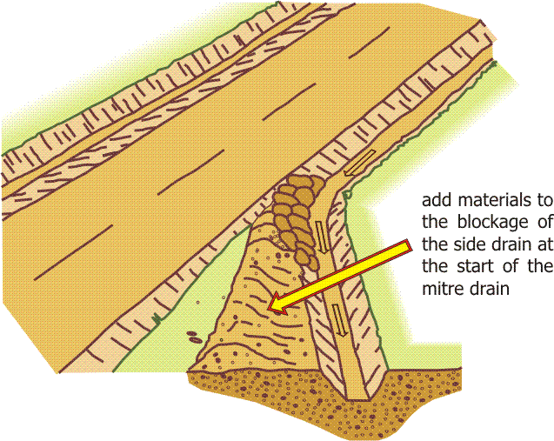
Mitre drains secure the exit of water from the side drains and needs to be kept clean at all times in order for the other components of the drainage system to function properly.
Mitre drains are normally excavated and maintained to the same standards as the side drains. Their capacity should at the least be similar to the side drains. To avoid causing erosion at the discharge point, mitre drains should be provided as often as possible so that the accumulated water volume in each drain is not too high. Wherever possible, they should be located at intervals of 30 metres along the road alignment. Additional mitre drains may be installed where necessary on the direction of the provincial technical agency.
Some of the excavated soils shall be used to block the downhill side of the drain to ensure that the water flows into the mitre drain. The remaining excess soils should be disposed well away from the drainage system, thereby avoiding excavated soils and debris to re-enter the drains.

Patch Potholes in Carriageway

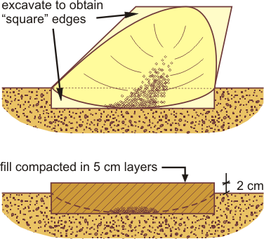
Potholes collect rainwater on the road surface and restrict it from draining off to the side of the road. Combined with traffic, this stagnant water accelerates the wear of the road surface and finally if this water penetrates the road surface layer, it reduces the bearing strength of the road base.

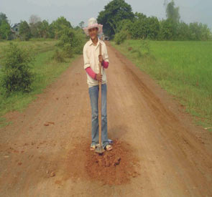

Description of Work

The area to be filled shall be excavated with squared off edges and to a minimum depth equal to the lowest point of the pot hole or until firm and compacted materials are reached. The excavated material together with other approved filling material is mixed together, watered and placed back into the excavated hole and compacted using hand rammers. Make sure that there is no water in the pothole when it is filled. If the pothole is deep the materials should be filled and compacted in layers not thicker than 5 centimetres. Compaction is carried out using hand rammers.

The surface level of the filled hole after compaction should be a minimum of two centimetres higher than the adjacent pavement surface level.

Fill Ruts in Carriageway
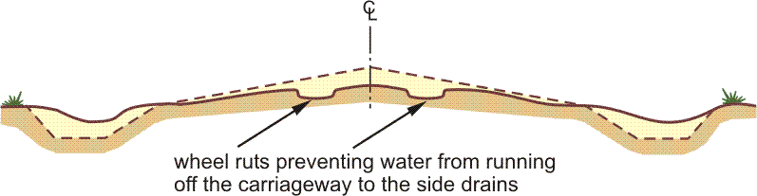
Ruts are caused by vehicles that keep on passing in the same tracks made by vehicles before them. The weight of the vehicles and their speed push surface material to the sides of the road. This process eventually deforms the cross section and the camber of the road surface. The ruts obstruct the water from exiting the surface. The stagnant water accelerates the wear of the surface when subject to passing traffic.

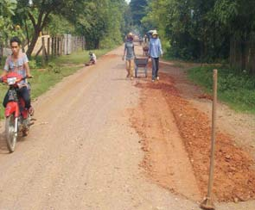
Description of Work
This work normally comprise of raking excess materials from the road shoulder back on to the carriageway where ruts have been formed.

In cases of more severe rutting, it may be necessary to bring in additional soil to compensate for the material loss. In such cases the ruts should be treated using the same work methods as when filling potholes. The ruts should then be excavated to form vertical edges and the fill materials need to be placed, watered and compacted in layers. When using hand rammers for compaction, the thickness of each layer should not exceed 5 centimetres.

Grub Edge of Carriageway

Grass growing on the edge of the carriageway can prevent rainwater from draining off the road surface. It can also start growing into the carriageway.

Description of Work
Grass and roots should be removed from the carriageway. A string line showing the exact position of the start of the side slope provides a good guidance when removing grass and grubbing the shoulders. Debris should be removed well away from the road to avoid the removed material being washed back into the drainage system.

Grass Cutting and Bush Clearing

Description of Work
Clearing consists of the removal of grass, bushes, other vegetation, rubbish and all other superfluous material including the disposal of all material resulting from the works.

The work comprises of cutting all grass and bush on both sides of the roadway and for the entire width between the pavement edge and the top of the back-slope at the outer side of the side drain. The vegetation should be cut to a height not exceeding five centimetres. Where road side drainage exists on only one side of the roadway, grass and bush cutting on the fill slope should extend for a minimum distance of 2.5 metres from the pavement edge adjacent to the embankment slope. Where no road side drains exist, i.e. on road embankments, clearing should extend from the pavement edge to the foot of the embankment or to the paddy water level on both sides of the roadway.

All bush and branches hanging over the road, shoulders, side drains, mitre drains and traffic signs should be cut down and disposed of safely.

When tree seedlings have recently been planted, it is important that they are not damaged when clearing grass and bush around the seedlings. Furthermore, when the seedlings are young, vegetation close to the trees should be removed to allow the trees good growing conditions.

Finally, trimming of planted trees should be included in this activity on a regular basis to ensure that they develop into healthy shapes and which do not interfere with the road traffic.

Grass Planting

Description of Work
This work consists of furnishing turf and sods as required and planting them to give a healthy stable covering of grass which maintains its growth in any weather and prevents erosion of the material in which it is planted.

Turfing should be done by planting sods or turf to give continuous cover over the whole area. Turfs should be planted with their root system substantially undamaged, well buried in firm material, and packed around with moist earth in which they have grown.

Grass should be planted at such a time and done in such a way that at the time of the final inspection all areas to be grassed are substantially covered with healthy, well established, firmly rooted grass and the planted area is free from erosion channels.

Surfaces to be planted should be trimmed in such a way that the ground surface after planting should be as shown on the standard drawings.

Maintenance consists of watering, preserving, protecting and replacing grass and such other work as may be necessary to keep it in a satisfactory condition to prevent erosion and to present a dense and uniform appearance.

Annex 3 Monitoring Indicators

Immediate Objective | Indicator
1.Sustained and predictable income provided through /cash for work projects | - Yearly income of IDPoor 1 and 2 in each commune increased by X%  - Food insecurity in each commune reduced as measured by reduction in food gap  - Employment provided throughout the year  - Indications of physical infrastructure contributing to economic and social development in the commune  - %age of infrastructure completed to relevant standard
2The PWP aligned with component 3 of the National Social Protection Strategy | - 90% of the participants are IDPoor 1&2  - Communes choosing a variety of infrastructure  - Roads as proportion of expenditure reduces from 70% to < 50%
3. RGC takes ownership of the cash for work programme | - By 2016 PWP becomes a government programme as part of an appropriate government agency  - PWP/PIM procedures being used by communes on all projects  - Communes effectively implementing programme of works and disbursing cash and food  - provincial technical agency monitoring visits to each commune in their area > 3 times per month  - Cost per beneficiary reduces year on year  - MEF provide separate budget at Commune level for PWP programme
4. PWP is included in the District and Commune Development Plans | - Number of H/Hs benefiting from PWP increased by 20% through cooperation with other programmes  - By 2016, PALS included in investment plans of 50% of the Districts where PALS operates

Annex 4 Measurement Procedures

The method used to measure PWP projects is called the “1 string method”. The equipment needed includes:
- One string, (50 meters long).
- Three measuring sticks (1.5 metres long).
- One line level or bubble (to make the string exactly horizontal before measuring).
- One measuring tape - steel (7.5 meters long)
- One measuring tape - plastic (50 meters long)
The steps followed for measuring each cross section of road or irrigation (dug) canal is as follows:
- Tie one end of the string to the top of one measuring stick and tie the other end of the string to the top of another measuring stick.
- Place the 1st measuring stick at the reference peg on the left side of the road / canal and the 2nd measuring stick at the reference peg on the right side of the road / canal.
- Tighten the string between the two measuring sticks so the string is straight and level.
- Place the line level or bubble on the string, half way between the two measuring sticks.
- Move the string line up or down the 2nd measuring stick until the line is level.
At each cross section measure the height of the PWP project at five locations using the 3rd measuring stick, starting at the left hand reference peg. The location of each measurement is as follows:
- Measure the height at field level at the left hand reference peg. (Reference Peg – Left). The height is measured from the ground to the level string. Record the height in meters (e.g. 0.82 meters) in the measurement sheet.
- Measure the height of the top edge of the road on the left side (Top Peg – Left). The height is measured from the top edge of the road to the level string. Record the height in meters (e.g. 0.32 meters) in the measurement sheet
- Measure the height of the centre of the road, and highest point on the road (Centre Peg). The height is measured from the top centre of the road to the level string. Record the height in meters (e.g. 0.12 meters) in the measurement sheet
- Measure the height of the top edge of the road on the right side (Top Peg – Right). The height is measured from the top edge of the road to the level string. Record the height in meters (e.g. 0.30 meters) in the measurement sheet
- Measure the height at field level at the right hand reference peg (Reference Peg – Right). The height is measured from the ground to the level string. Record the height in meters (e.g. 0.80 meters) in the measurement sheet.
A diagram showing the location of each of the five measurements is shown below:
HR (m)
HL (m)
WT (m)
HC (m)
WB (m)
1 m
1 m
STRING LINE
RPL (m)
RPR (m)
LEFT
RIGHT
The same five measurements are taken for irrigation (dug canal), only depths are measured instead of heights:

Roads and Dikes (Dams):
- The design of the road will be based on simple cross-section measurements at every 50-meter interval along the road. Additional cross sections, within the 50m interval, also need to be taken when the height of the road varies dramatically.
- The cross-section should be measured to the edge of the planned road. The cross-section must have a reference peg at both ends. Pegs are to be at field level (natural ground level) and mark the edge of the planned road on both sides. The reference pegs will be used as a bench mark (fixed level) for the height measurements. For post-work measurements, the pre-work reference pegs will also be used to measure post-work heights. Reference pegs are not allowed to be removed or moved.
- Measurements will be made at each cross section to calculate pre-existing and post-work earthwork volumes, so that actual earthwork volumes can be calculated.
- The whole length of the road will be divided into work sections which will be numbered in order from start to finish of the project.
- Section lengths may be of varying length according to the terrain. The division of work units should be between and within the provincial technical agency’s measured cross sections and should not cross over into other cross sections.

Irrigation and Drainage Canals (Raised and Dug):
- Cross-section measurements should be taken at 50m intervals. Additional cross sections, within the 50m interval, also need to be taken when the depth of the canal varies dramatically.
- The cross-section should be measured to the edge of the planned canal. The cross-section must have a reference peg at both ends. Pegs are to be at field level (natural ground level) and mark the edge of the planned canal on both sides. The reference pegs will be used as a bench mark (fixed level) for the height measurements. For post-work measurements, the pre-work reference pegs will also be used to measure post-work heights. Reference pegs are not allowed to be removed or moved.
- Measurements will be made at each cross section to calculate pre-existing and post-work earthwork volumes, so that actual earthwork volumes can be calculated.
- The whole length of the canal will be divided into section lengths, which will be numbered in order from start to finish of the project.
- Section lengths may be of varying length according to the terrain. The division of sections should be between and within the provincial technical agency’s measured cross sections and should not cross over into other cross sections.

Village and Family Ponds:
- Three cross section measurements will be taken, one across the middle and one at each end of the bottom of the pond for a one level pond. Two cross section measurements will be taken, at each end of the bottom of the pond for a 3 level pond.
- The volume of digging/cutting needs to be divided into household work units (phlongs), which will be numbered in order from top to bottom of the pond.

Annex 5 Flow Chart of Activities

Planning
Projects identified through consultation with villagers and presented to CC
CDP and CIP formulated through discussion in Commune Council

Project Identification
Some minor works such as road maintenance can be included in the support from WFP.
From each participating commune 5 Projects selected from the DIW approved priority investment projects

Project Feasibility
Pre-assessment conducted Estimate made of ID Poor work days required. Projects prioritised
Provinicial technical agency endorses the selection of projects
Pre-work measurement

Project Implementation
Initial public meeting; information on PWP , Project Management Committee (PMC) formed, IDPoor participants selected

Two day training provided to PMC members, group leaders

Section leaders explain the work process, the terms and conditions of employment and the payment procedures to their section participants
Sections allocated to groups (PMC)

Verification of work output for interim payment

Sections set out
Post work measurement estimate made
Work Starts

Measurement sheets signed PMC chairperson
Post work measurement finalised

Project Supervision

Periodic Supervision provided by Provincial technical agencies
Daily supervision provided by PMC

M&E overall framework

LogFrame designed
Monitoring Indicators defined
Data collected pre project agreement
Data collected post final cash payment

Evaluation report produced

This figure relates to 2013. It will need to be updated on a yearly basis
Ibid
See for example ADB. Tonle Sap Poverty Reduction and Smallholder Development project

