  Government of Jharkand | 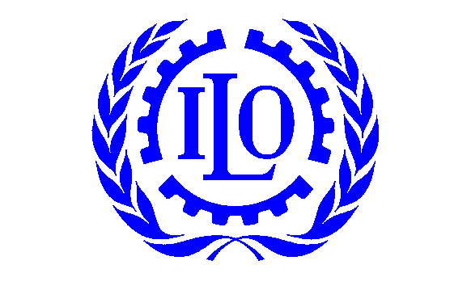

The Organization

Carved out of Bihar, the state of Jharkhand came into existence on November 15th, 2000. Its population has been estimated to be 26.9 million, with some 20 million residing in rural areas. Jharkhand is one of the poorest and most backward states in the country with low per capita income, some 54% of the population living below the poverty line with health indicators lagging way behind the national average.

Jharkhand’s government has recognized health as a state priority and as a result, the Ministry of Health and Family Welfare has taken a strong stand to improve the overall health situation adopting for its mission to “provide quality heathcare services to the last person of the last household of the last village in the state and thus ensuring a healthy Jharkhand and a happy Jharkhand”.

As an appropriate answer strategy, government of Jharkhand developed the “Sarv Swasthya Mission” (SSW) broad concept which aimed at providing quality health care services at all levels, especially for women, children, and under-privileged sections of society. One of the Mission’s objectives was to protect the poor from indebtedness and impoverishment resulting from medical expenditures by spreading the health shocks among the community. The design of a health insurance scheme for the poor marginalized population was also conceived as a new vehicle to enhance public and private investment in remote and left out areas of the state. In August 2005, a delegation from Jharkhand contacted the International Labour Organization and requested its technical support for the design and setting up of a new health insurance schemes that was planned to cover the whole Below Poverty Line population of the state. As a result of the first interactions with all stakeholders concerned, new orientations were adopted as regards the design of the health insurance scheme and further ILO technical assistance was planned. Follow-up activities allowed for the progressive shaping up of the scheme’s implementation process and operational modalities. As compared to other recent state-level initiatives, the integrated health care system to be developed in Jharkhand clearly adopted distinctive innovative features allowing it to pave the way towards a broader programme that could ultimately encompass the whole population

The Partnership

The ILO – Ministry of Health & Family Welfare, Government of Jharkhand partnership covers the following activities:

- Formulate, prepare and plan the health insurance component of the SSW
- Promote and develop active partnerships with social partners and key civil society organizations for the preparation and implementation of the health insurance scheme
- Monitor, evaluate and document the development of the health insurance scheme and its impact on public health

