Thailand Social Protection Joint Team Meeting
Social Protection Floor initiative

August 23, 2011

Venue: ILO Meeting Room, 11th Floor

Time: 14.30 – 16.20

Present:
- UNESCO: Rachel Mc Carthy
- UNRCO: Mrs. Barbara Orlandini
- UNICEF: Mr. Andrew Claypole
- UNFPA: Mrs Viennarat Chuangwiwat
- UNFPA: Mr Adhi Wongkieo
- ILO: Mrs. Valerie Schmitt
- ILO: Ms. Celine Bista
- ILO: Ms. Celine Felix
- ILO : Ms. Diane Taieb

Agenda of the Meeting

I. Introduction by RC

II. Main findings of Consultative Meeting (August 10)

III. UNPAF Action Plan - Outline

a. Program actions and implementation strategies

b. Resources and resource mobilization strategy

IV. UNPAF Action Plan – Matrix
- Introduction of RC

Rebecca Hansen, our new RC coordinator sent her apologies. Being sick, she was not able to join our meeting.
- Main findings of the Consultative Meeting (August 10)
Celine presented the findings of the Consultative Meeting. The report of the meeting should be available soon and will be shared with the Team for review and then all participants.

All presentations as well as the pre-assessment matrix have been put online and are available on the GESS platform: http://www.social-protection.org/gimi/gess/ShowProjectPage.do?pid=1285
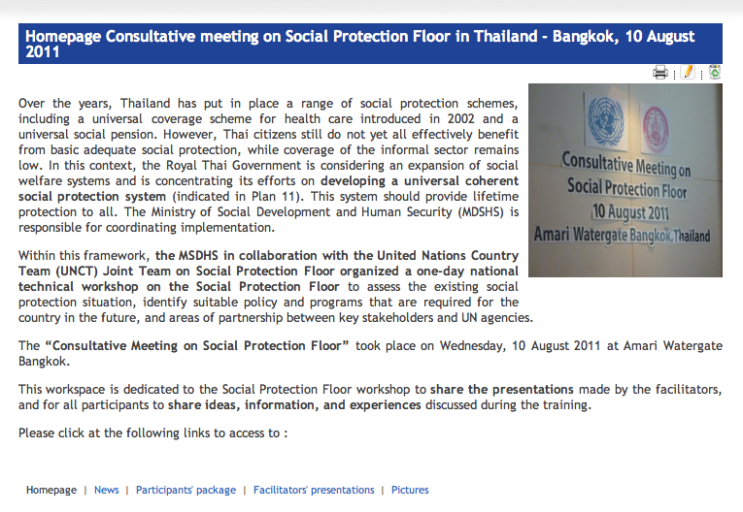

Useful information was obtained and will help to feed the Action Plan, especially in terms of identification of assistance from the UN, as well as information for the M&E framework (indicators, etc.).

The MSDHS who co-organized the meeting expressed its gratitude and was pleased to see the involvement and active participation of the different actors present (including HISRO, SSO, NESDB, Academics and civil society organizations). Putting all actors to be involved in the implementation of the social protection strategy was a key objective for them.

It was clarified that all recommendations from the government are not going to be taken up by the Joint Team for the Joint Team but provide good guidance on the type of assistance the Government expressed. - See recommendations attached
Follow-up:
- Each organization to review recommendations and identified UN assistance and mention if yes or no work will be performed in this area.
Ex 1: HISRO and MoPH identified the need for independent studies to provide evidence-based information on introduction of unified system: any work by WHO and/or ILO?
Ex 2: HISRO and MoPH identified the need for legal review: any work by UNDP?

- Assessment content
  - The TDRI report

- How to present to TDRI report as compared to the assessment?
There may be a political issue around the TDRI report because there may be conflicts between TDRI and the new government. In that prospect, the results of the TDRI survey may just be partly used (not the tax reform chapter). TDRI provided a very good diagnostic of the social security situation, the options provided may not fit the UN social protection floor strategy, and may be not used as such. During the 10th August workshop, we will ask Dr Somchai from TDRI to present the findings of his diagnosis.

A meeting with TDRI will be organized next Monday so as to get more information on their report. UNICEF, UNFPA and the ILO will be part of that meeting, together with Khun Chinchai from MSDHS.

- Should we translate the TDRI report in English?
The TDRI report consists of 6 chapters:
- Explanation of the social security concept, the UCS ambition and the 4 pillars of social security,
- Stocktaking of the system and gaps in the current system,
- Recommendations to improve the current system,
- Estimations of the budget currently dedicated by the Government for the social security scheme,
- Proposal of four alternative programs of the current scheme,
- How to make this system sustainable? Analysis of ways to finance the new scheme, with taxes for example.
The UN agencies agreed in principle that the first 3 chapters should be translated. UN agencies attending the TDRI meeting will check that a translation has not yet been planned by TDRI.

  - Presentation of the pre-assessment

The pre-assessment matrix prepared by Celine was distributed to all participants of the meeting. It is organized by guarantee:
- Guarantee 1 : Health Social Protection,
- Guarantee 2 : Income security for the children, they are organized in 3 issues, minimum income, access to education, nutrition.
- Guarantee 3 : Income security for the working age,
- Guarantee 4 : Income security for the elderly.

  - Key data/info missing
All the agencies were asked to provide their inputs, but many of them did not do it so far. Thus, a few key data is missing, and Celine asked for the agencies to send their inputs as soon as possible. In particular, the following information is missing:
- Guarantee 1 : health
Information expected from WHO
- Guarantee 2 : children
Many inputs were provided, but we may think of reformulating.
- Update on coverage of the informal economy
- Information on community-based programs At that point, a comment was made about the social security schemes that are provisioned at the subnational level. How should we take them into account? After a discussion, the conclusion was that community-based schemes and non-formal systems must be included if they constitute good experiences that could be considered for replication but their limits should be highlighted (if not legislated, not systemic, on demand basis rather than following concrete targeting criteria, etc.)
- Include programs and gaps at decentralized level :
Issues on decentralization need to be captured in the assessment at that point. It may be a good idea to go and see at least one provincial representative.

- Cross-cutting topics :
  - HIV sensitiveness
MSDHS in collaboration with A workshop was organized by this week on HIV sensitive social protection for children. This was a very useful meeting, during which much information was gathered for the pre assessment. ILO and UNICEF met with people from NGOs who ILO might meet during the bilateral consultations.
  - gender sensitiveness
UNWomen committed to send the Joint Team guidance on key questions to ask during the bilateral consultations to ensure that the assessment include gender sensitive issues.

Follow-up:
- Agencies to provide information mentioned above
- ILO (Chayanich and Celine) to meet with UNFPA on July 22

  - Bilateral consultations

They will be scheduled during the next two weeks. The objective of the consultations is to review the legal framework, to identify missing schemes, and to discuss the design gaps and implementation issues.
Beyond that, the goal is also to work on the UNPAF Action Plan by discussing possible outputs with our counterparts.

To do so, the UN agencies are asked to provide by July 22nd a list of people that should be met for the bilateral consultations. The objective is for each specialized agency to guide ILO towards the right persons in their area of specialty, and also come with ILO during the meeting since they are most able to identify the key issues in their area of expertise. ILO is developing a pager to explain briefly what we are trying to do on the assessment. The idea is to contact also organizations that we will not be able to meet so that they provide us with their inputs.
Concerning coverage of migrants, a very complete report has been published lately. Most of the gaps and update on migrations in Thailand may be found on the subject and ILO is in contact with the working group on migration to get further inputs.

  - Assessment in Thailand : Outputs

- Baseline and output for the UNPAF Action Plan :
Seth Broekman made comments on the UNPAF action plan that has been drafted. An important point is that, even though outputs are important to define the overall goals, the focus must be on indicators and M&E framework more than on outputs. Indeed, indicators are crucial because you don’t measure outputs, whereas you do measure indicators to know how successful our efforts are. The question that also need to be risen is : do we have the budget to measure indicators ?

At the end of the process, the action plan will be co-signed by the Ministry of Social Development and Human Security and the ILO as the coordinator of the UN Joint Team.

- AOB/ Tour of the table
- Community based-programs
The question is : to what extent these schemes are to be included ? If all community-based schemes are included, the matrix will be unreadable. At the same time, sometimes central and local governments provide huge funds from its regular budget to that kind of schemes if the groups are qualified. These are the community empowerment programs. The matrix should assess if those schemes are systemic and predictable and it may be identified as complementary programs that can be used as recommendations. A good idea would be to include at least one or two relevant examples of community-schemes that are working.

- The floor methodology
An important point to keep in mind: in the assessment, the four essential guarantees of the floor are used as benchmark. Higher levels of benefits are assessed towards the floor only (not other benchmarks such as ILO Convention 102). The gaps that are identified in that exercise refer to the floor.

Meeting adjourned at 16h15

