1st Social Protection Inter-Agency Cooperation Board Meeting
New York, 2-3 July 2012
United Nations Headquarters

The first meeting of the Social Protection Inter-Agency Cooperation Board (previously called the “Social Protection Inter-Agency Board”) took place on 2-3 July 2012 in New York. The establishment of the Board is based on the recommendations of the G20 Development Working Group presented to the G20 summit in Los Cabos, June 2012.
The Board is jointly chaired by ILO and Word Bank. The work is supported by a secretariat, provided by ILO for the upcoming 2 years.
The very constructive discussions in the first meeting lead to the following outcomes:
- Finalization of the Terms of Reference (TOR) of the Social Protection Inter-Agency Cooperation Board: The members requested clarification on certain issues, such as the relationship of the Board to other initiatives, such as the Social Protection Floor Initiative (SPF-I), and on the rules of membership (the former is clarified below; on the latter, it was clarified that the Board is inclusive but includes only all practitioners working on social protection in developing countries). The secretariat will circulate an updated version of the TORs including these amendments in the near future. Participants are invited to send comments and suggestions related to the TORs to Vinicius Pinheiro (pinheiro@ilo.org) before 31 August 2012.
- There was full agreement to add the word “Cooperation” to the name of the group as this reflects the objective of the group. There was agreement to on the title of “Social Protection Inter-Agency Cooperation Board” (possible acronym could be SPIAC-B). Further suggestions could be discussed on our blog.
- Participating agencies are asked to identify a focal point for the Social Protection Inter-Agency Cooperation Board. A draft list of focal points is available online. Please send corrections/amendments if necessary to Griet Cattaert (cattaert@ilo.org).
- It was agreed that it was important to include middle-income countries, especially G20 partners, to become active members of the SPIAC-B. The Australian Agency for International Development (AUSAID) agreed to contact G20 members.
- It was agreed that the participation of the regional development banks need to be ensured for subsequent meeting.
- It was agreed that it would also be important to include representatives from potential partner countries for implementation of joint actions in future meetings. Some participants mentioned an interest in financially assisting potential developing country representatives’ attendance for future meetings.
- It was agreed that detailed reporting regarding sessions and outcomes of the Board would be provided by secretariat to avoid duplications of discussions and easing the inclusion of new partners.
- The link between the Social Protection Inter-Agency Cooperation Board and the Social Protection Floor Initiative (SPF-I) was discussed and clarified.
- Social Protection Floors are part of comprehensive social protection systems (e.g. as in ILO two-dimensional strategy for the extension of social security);
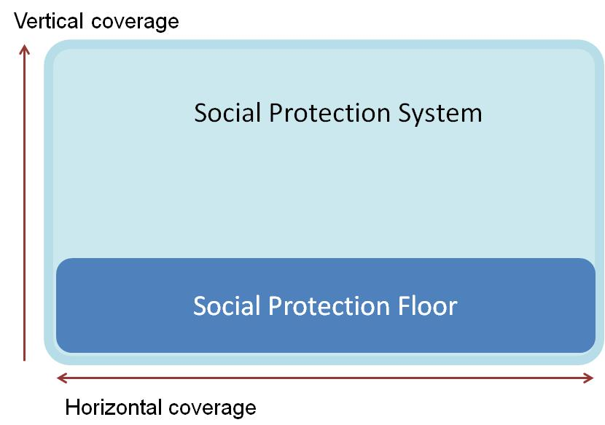
- While the SPF-I addresses the horizontal dimension (basic levels of social protection), the SPIAC-B provides a broader and more inclusive mechanism for sharing of information and coordination between partners, addressing social protection systems as a whole (including the vertical dimension);
- The shared secretariat hosted by ILO will ensure coherence and consistency in the coordination process;
- Existing SPF-I work continue as planned under CEB mandate (UN-Initiative), and its activities would be strengthened within a broader SPIAC-B perspective;
- SPIAC-B work could build on the experience accumulated in the SPF-I, especially at the country level.
The SPIAC-B responds to the request of the G20 Development Working Group. The Board will work autonomously. The priority of the SPIAC-B is to support the coordination of country activities related to social protection, which includes operational and advocacy work.
- Possible activities of the SPIAC-B - Areas of cooperation: SPIAC-B members are invited to complete the discussed action matrix, and to indicate areas where they would like to take leadership and/or take commitments as partner organization. Please send us your comments and suggestions (cattaert@ilo.org) before 31 August.
- Inventory of Country-led cooperation activities (existing and planned partnerships): It is important to have an inventory of ongoing and planned country cooperation activities as a basis for both information-sharing and signaling on cooperation. The German Federal Ministry of Economic Cooperation and Development will provide a draft template for this mapping exercise. The mapping exercise should include the following questions:
- Where is your organization collaborating with at least one other organization in social protection + short description of the project/activity;
- Which coordination mechanisms do you know?
- Studies/Research planned in social protection (to avoid duplicates).
The matrix will be available online and it is the responsibility of all participating agencies to provide the requested information by completing the table.
- Advocacy: There is the need for an agency to volunteer to lead a sub-group on joint social protection advocacy messages. The importance of civil society organizations and evidence based advocacy was underlined.
- Country-based assessments: the World Bank will send out, in September, a note with greater details on the SPARCS initiative on benchmarking social protection systems, and organizations will be invited to indicate their areas of interest/facilitation. The ILO will organize later this year several training sessions at the International Training Centre of the ILO in Turin on the advanced costing tool in selected countries where joint activities will be developed.
- UNDP will send specific questions related to the new developed social protection gateway website: http://www.socialprotection.org/
- Agreement to meet as a Board at least annually (flexible in place and timing). The Board meetings will include the annual Show &Tell meeting. There was interest to meet as a board during regional social protection conferences. The next SPIAC-B meeting could be held on Monday, October 29 2012, in Hyderabad, just before the South-South event organized by World Bank and others (October 30 to November 3).

