ASSESSMENT METHOLOGY ON LONG TERM CARE

Information collected from:
- Conceptual framework and methods for analysis of data sources for long term care expenditures (OECD Dec 2007)
- Regional forum on elderly care service in ASIA and Pacific 2011 UNFPA
- Social Security Programs throughout the world, ISSA 2010

PLAN OF THE PRESENTATION
- LONG TERM CARE DEFINITION
- COUNTRY INDICATORS
- LONG TERM CARE EXPENDITURES
- SOCIAL SECURITY SCHEMES AND LTC
- TOOLS TO IMPLEMENT LTC SCHEME
- WHAT IS LONG TERM CARE:
DEFINITION
Review of classification and data on long-term care expenditure for the purposes of the System of HealthDefinition of Long-term care The term ‘long-term care services” refers to the organization and delivery of a broad range of services and assistance to people who are limited in their ability to function independently on a daily basis over an extended period of time. There are two complementary components of this definition: the care continues over a long time period, and second the care is usually provided as an integrated program across service components. The services may be provided in a variety of settings including institutional, residential or home care.
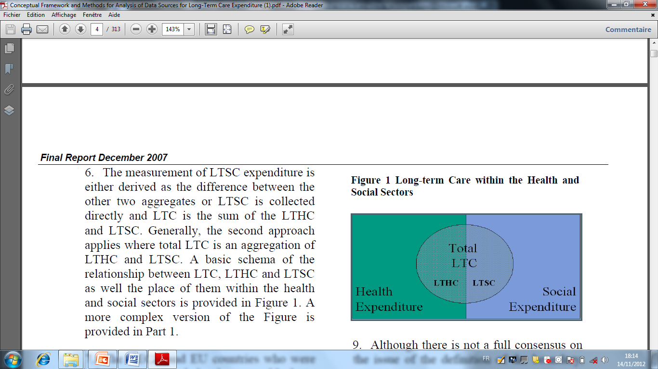

The measurement of LTSC expenditure is either derived as the difference between the other two aggregates or LTSC is collected directly and LTC is the sum of the LTHC and LTSC.
The first type of LTC service is help with activities of daily living (ADL) restrictions. These limit independence through curtailing personal care activities such as washing and eating. Because these restrictions require complex care, often performed by or supervised by nurses, they are considered as health services. The second type of LTC service is help with instrumental activities of daily living (IADL) restrictions which limit the capacity of an aged or disabled person to function normally within their home or community. IADL services provide help with shopping, household finances and cleaning and are considered as social services.
BOUNDARIES BETWEEN HEALTH CARE AND SOCIAL CARE
LONG TERM SOCIAL CARE
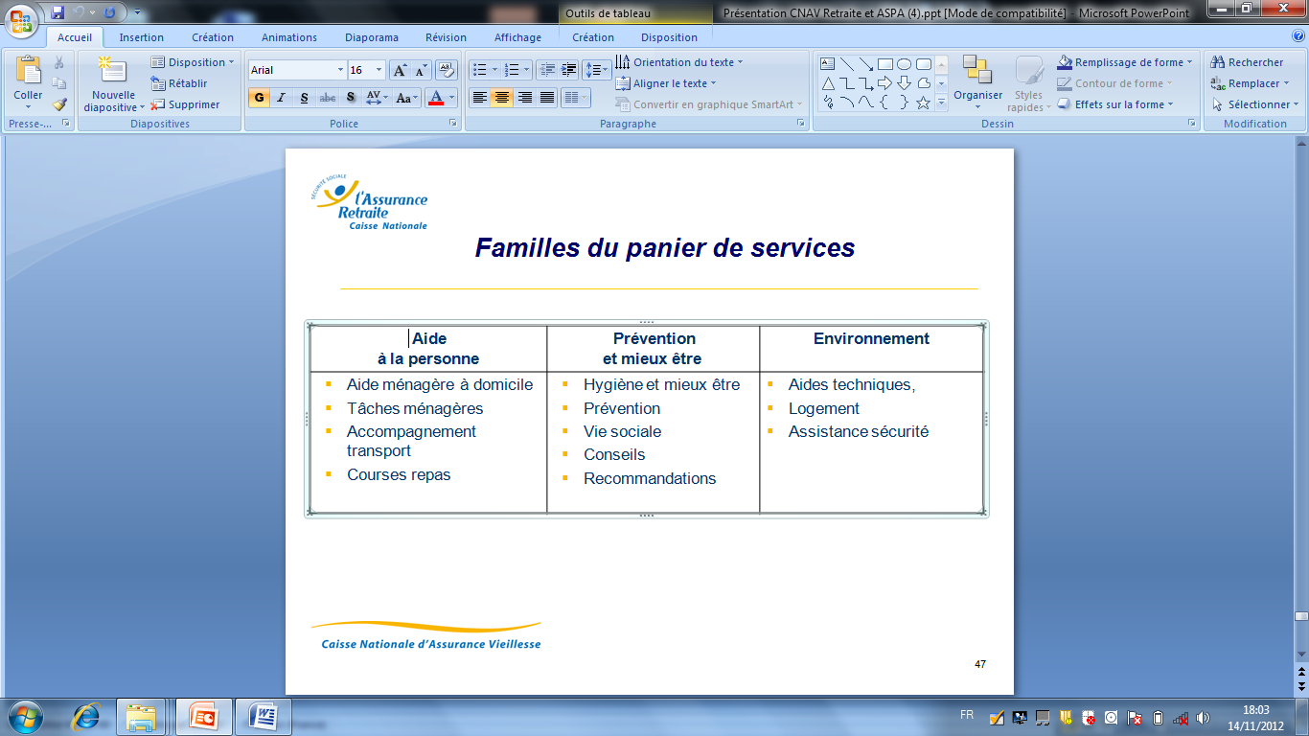

Help for daily personal needs | Prevention and well being | Environnement
- Domestically housing  - Cleaning and tiding  - Transportation and shopping  - Eating and cooking | - Personal care,  - Prevention  - Social life  - advisory | - Technical help  - Home  - Safety

OECD In this analysis is recommending that the definition of the boundary between LTHC and LTSC should be based on types of services received (ADL/IADL distinction)
In essence there are two issues here. One is that government and policy makers would like to know the total costs of providing long-term care to dependent people. The second is that from the perspective of health expenditures, it is desirable to know the proportion of LTC which is health care (in this report called long-term health care or LTHC). If carefully measured, the difference between the LTC and LTHC is long-term social care (LTSC).
More challenging is the choice of the approach to divide total LTC into long-term health care (LTHC) and long-term social care (LTSC), the OECD grid sets out to provide a Conceptual Framework and Methods for Analysis of Data Sources for Long-term Care expenditure. There are 3 major LTC aggregates of interest in this area. They comprise LTC expenditure itself and its two subcomponents of LTHC and LTSC. For government, policy makers and researchers, however, LTC expenditure as a whole and associated comparative analyses are also of interest. Both aggregates of LTC and LTHC expenditures have to be collected.
In practice, the division of LTC into its health and social components is challenging as many services provided to LTC recipients have both a health and social component.

- COUNTRY INDICATORS 2010
DATA/COUNTRIES | THAILAND | JAPAN | AUSTRALIA | CHINA | HONG KONG | TAIWAN | S KOREA | SINGAPORE

Total population | 68.1 | 127 | 21.5 | 1 354.1 | 7.1 | 23 | 48.5 | 4.8
% of older 65 | 7.7 | 22.6 | 13.9 | 8.2 | 12.9 | 10.7 | 11 | 10.2
Dependency ratio | 41.2 | 55.7 | 48.8 | 39.1 | 32.3 | 37.7 | 37.4 | 34.7
Life expectancy  M  W | 67.1  72.8 | 80.1  87.2 | 80.0  84.4 | 72.3  75.9 | 79.9  85.7 | 75.3  81.2 | 76.6  83.2 | 78.5  83.4
Pension age M  Pension age W | 55  55 | 65  65 | 65  64 | 60  55 | 65  65 | 60  60 | 60  60 | 55  55
GDP per capita US/$ | 4043 | 38 455 | 47 370 | 3 267 | 30 863 | 35 100 | 19 115 | 37 597
GINI coeff | 0.420 (20°) | 0.242 | 0.352 | 0.469 |  |  | 0.316 | 0.425

In spite of the huge difference of population the indicators for Thailand and China are closed; life expectancy is slightly higher in China when GDP per capita is higher in Thailand but in the same dimension. This should be compared with the way of life and sanitary behavior in those two countries.
GINI coef (0=equality) remains twice higher than Japan close to Singapore and China! EU 27=0.307

- LONG TERM CARE EXPENDITURES INDICATORS (DATA COLLECTED IN THE OECD TO ANALYSE)
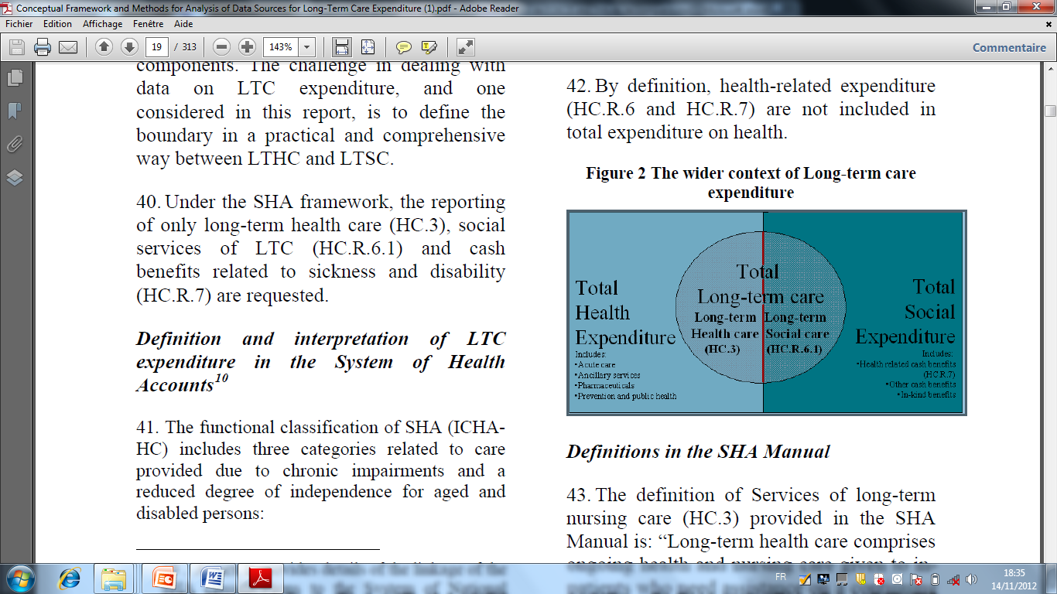
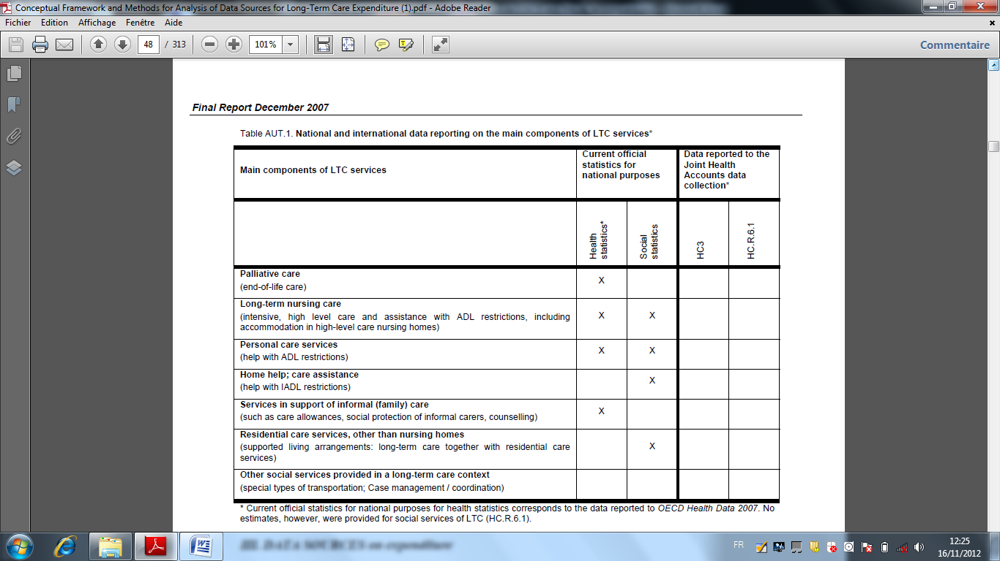

LONG-TERM CARE EXPENDITURE IN OECD AND EU COUNTRIES: A COMPARATIVE ANALYSIS 2008

In both parts of the report, the main purposes are:
• to assess the availability and comparability of the data on LTHC and total LTC expenditure,
• to describe the main characteristics of the spending on LTHC services, and
• to propose and test a core set of indicators for comparative analysis of LTC data
Main indicators proposed for comparative analysis by OECD Methodology
Main requirement for a set of indicators for future analysis of LTC expenditure is to provide adequate, meaningful information for policy analysis, and at the same time to be technically feasible
(1) Per capita expenditure on LTHC to characterize the differences in absolute terms across countries regarding the consumption of long-term health care services.
(2) LTHC as percentage of households' actual final consumption58. This shows how much of households total resources (including social benefits), are devoted to LTHC. This indicator is better for characterizing the impact of long term care spending on the households than the share of GDP59.
(3) LTHC as percentage of current health expenditure, and
(4) LTHC as percentage of personal health care expenditure.
(5) Share of spending by general government and the private sector in LTHC expenditure to show how the burden of financing is shared between government and households.
(6) The share of inpatient and home care within LTHC expenditure to characterise the structure of provision of LTHC.
(7) Per capita expenditure on LTC to characterise the differences in absolute terms across countries in the consumption of long-term care services, including both health and social components of long-term care services.
(8) LTC as a percentage of households' actual final consumption to characterise the impact of total long term care spending on the households.
(9) The share of inpatient care, home care and social services of LTC within total LTC expenditure to characterise the structure of provision of total long term care services.
-SAMPLE OF TABLE

- SOCIAL SECURITY SCHEMES AND EXISTING LTC FRAME

Main services as component of LTC
The LTC guidelines define the following services as components of LTHC: | LTC guidelines define the following services as components of LTSC:
• Palliative care (end-of-life care)  • Long-term nursing care (intensive, high level care and assistance with ADL restrictions), including accommodation in (high-level care) nursing homes  • Personal care services (assistance with ADL restrictions)  • Services in support of informal (family) care (such as care allowances, social protection of informal careers, counseling | • Home help; care assistance (help with IADL restrictions, including housekeeping, meals on wheels)  • Residential (care) services (other than nursing homes): Services of care and social support provided in supported living arrangements: protected housing and the like (including tele-linking to call centres and the like)  • Other social services provided in a long-term care context ( e.g. social services of day care, social activities for dependent older persons etc.)

- EXISTING FRAMES FOR LTC SELECTED COUNTRIES
COUNTRIES/  ITEMS | THAILAND  (NANJING ROUND TABLE 2010) | AUSTRALIA | SINGAPORE | KOREA | CHINA | JAPAN
EXISTING NATIONAL LTC SCHEMES | NATIONAL PLANS FOR OLDER PERSON  1st National Plan 1982-2001  Focused on health, education, social and income security, social and cultural participation, social welfare services  2nd National Plan 2002 2021, Revised 2010  1999 Declaration of Thailand older person’s  -2003 National Commision for the Elderly  -Act on older person’s  -2007/2011 10th National Plan for economical and social development  -2007/2011 National Framework on preparing for ageing society NESBD | Benefits for residential aged care are provided under the Aged Care Act to all eligible Australian residents. |  | Older Person’s Welfare acte  Four principal categories of concern: income maintenance, health care, housing and social services.  Current long-term care services for the elderly are classified into institutional care and home care.  I.C= General nursing homes provide care for the disabled and elderly with minor or no chronic diseases  Special nursing homes for those with chronic conditions such as stroke or dementia. |  | Health service system for the older persons is to supply those in or after the prime of life with comprehensive health and medical services, including disease prevention, treatment and functional training in order to maintain good health in old age and ensure the availability of appropriate medical services to them, while the necessary cost is shared fairly by the whole nation  2000, a Public Long-Term Care Insurance Law,  is a mandatory social insurance operated by municipalities under central government legislation. All residents in Japan aged 40 years and older are insured, 1st category insured person (aged 65 and over),  Under long-term care insurance, beneficiaries pay 10% of the cost of services. The rest of the cost is borne by the insurers
STANDARDS |  |  |  | Uniform standards on the degree of disability for entry to care have been developed. In addition, geriatric hospitals provide services for the elderly with acute health care needs. Only older persons who receive social assistance benefits are entitled to care in nursing homes free of charge  There is a growing supply of home care services including home help, day care and short-stay services. Home help covers domestic support and personal care services. Day care centers provide rehabilitative care services, wheels-on-meals, and bathing and recreation services. |  | Need of care are assessed on application and classified into one of 7 care levels (5 for Care Level and 2 for Support Level). The role of care manager was created with the introduction of long-term care insurance. After determination of care level and before use of care services, a care plan is drawn up with a help of the care manager, reflecting the needs of the recipient. For home care services, each care level has a budget ceiling. Beneficiaries have access to care services up to the ceiling of their care level
CARE GIVERS
FAMILY and informal |  |  |  | In Korea, almost all older persons have their long-term care needs provided by informal caregivers. The reasons for this include, amongst others, a lack of long-term care services, traditional values of filial piety and family responsibility, face-saving cultural attitudes of being reluctant to use services provided by non-familial persons |  | The spouses or children of older persons have traditionally provided long-term care. However, this traditional approach to long-term care is breaking down in response to changes in the social structure and an increase in the number of people in need of care. For example, some 50 percent of care attendants are themselves over 60 years of age and there are a declining percentage
   | spouse | Husband | children
  M | 53,2 |  | 35,2
  F |  | 11,5 | 63,7
PUBLIC INSTITUTIONS  Benefit cash or kind |  |  |  |  |  | A cash benefit is not covered by the public long-term care insurance. However, some municipalities provide a cash benefit as an additional service from the municipalities
ORGANISATION
ELDERLY HEALTH CARE SERVICES | -COMMUNITY BASED CARE NGO, CBO, Local administrative organizations as Rehabilitation centers provided by bhudist temples  -HOME VISIT by health personnel and volunteers (more than 1 Million)  -Health Volonteers under the supervision of community based health center (basic health assessment)  -Temple and elders club health promotion and self care |  |  | The national policies and programs for the welfare of older persons are currently planned and implemented by the Ministry of Health and Welfare. Korea does not currently have a comprehensive long-term care system. The great majority of older persons who need help with activities of daily living are currently cared for informally in families, with only a small number of persons receiving formal long-term care services  It is decided that a system of long-term care insurance will be introduced from 2008 onwards.
LTHC KEY INDICATORS OF expenditures | As percentage of total current expenditure on health and LTC 0.67  Government 0,47  Private 0,19  -Nursing and personal car  total 0,51  Government 0,37  Private 0,14  -Inpatient care 0,49  Government 0,36  Private 0,13  -Homecare  Total 0,02  Government 0,01  Private 0,01  -Social Services Total 0,16  Government 0,10  Private 0,06 | LTC expenditure 7.4 % of health expenditure  0.7% of GDP OECD-EU averages of 9.5%  79.98% of long-term health care was publicly funded  19.8% was funded by out-of-pocket payments. |  | 0.5% of current health expenditure  0.9%. of GDP OECD-EU averages of 9.5%  70.92% of long-term care was publicly funded and 19.16% was funded by out-of-pocket payments. |  | LTC expenditure (HC.3) was 17.6% of current health expenditure and 1.4% of GDP compared with the OECD-EU averages of 9.5% and 0.9%. In 2004, 88.52% of long-term care was publicly funded and 7.8% was funded by out-of-pocket payments
My suggestions are
- To focus on the family links established in those countries to assess the help needed by the beneficiaries and their family. This position suggests that a basic line of the policy is to maintain at home as long as possible the elderly and dependant people. The urbanization and the economic development are changing this family behavior in spite of the constant cultural reference to the intergenerational solidarity .
- To focus on the community organizations (NGO or established by the authorities ), as it is frequently mentioned in the report s. Do they still play a significant role in the elderly policy and could they be a partner for the proposed policy implementation.
- To investigate if the services should be delivered in cash or in kind, many experiences of subsidies for services show a misuse probably relevant to the lake of confidence in the social organizations.
- To realize the inventory of the mankind available in the different contexts (urban and rural) and their capacity to receive training to enhance their professional capacity. What place the prevention takes in this policy?
- OLD AGE AND HEALTH COVERAGE SCHEMES TO SUPPORT LTC IN SEVERAL COUNTRIES AND ITEMS TO PREPARE A LTC LEGISLATION
DATA from ISSA collection SOCIAL SECURITY SCHEMES (all available)
DATA/COUNTRIES | THAILAND | JAPAN | AUSTRALIA | CHINA | HONG KONG | TAIWAN | S KOREA | SINGAPORE
OLD AGE | Social Security Law 1990 implemented in 1998  Social Insurance System | First law 1941  1954-59 Current Law  Social insurance system |  |  |  | 2007 national pensions
COVERAGE | Employees 15 to 60 | National Pension Program Resident in Japan 20 to 59volontary coverage 60 to 64  Employes’pension insurance under 70 industries and commerce |  |  |  | Social insurance and mandatory individual account system -citizens from 25 to 65 who choose to join the program  -Labor pension fund (individual account)
SOURCES OF FUNDS | employees3% of gross monthly earnings minimum to calculate 1650 baht  Employers 3% of monthly pay roll | NPP The employees’pension insurance pay contribution for low income and dependant spouse of insured persons  Emp P I 7.852% of monthly wages Employers contracting out of a portion of the employees’ pension insurance contribute for 5,47  Employers for EPI 7,852 of monthly pay roll  Cost of administration paid by government |  |  |  | NPP 3.9% monthly minimum wages  LPF 6% monthly earnings
QUALIFYING CONDITIONS  old age pension | Age ( with at least 180months of contributions). Employment must cease either pension suspended | NPP age 65 with minimum 25 years of contribution, full pension for 40 years contribution  EPI age 60 rising to 65 in 2025for 25 years of coverage, no requirement to cease employment |  |  |  | NPP age 65 (67 in 2027)  LIP age of 60 and 15 years registered in
Old age benefit  Monthly pension | 20% of the insured average in the last 60 months minimum is 1650 baths to calculate  O A pension increased for 1,5% for each 12 months exceeding 180 months | Flat rate benefit under the national pension program and earning related benefit under employees pension insurance |  |  |  | NPP 1,3% of monthly insured amount multiplied by years of coverage  LIP 0.775% of the monthly average in the 36 months before retirement multiplied by number of years coverage  Labor pension fund LPF the accumulated capital can be used to provide monthly benefit
Administrative organization | Ministry of Labor supervises  Social Security office collects contributions and pays | Pension Bureau of the Ministry of Health Labour and welfare supervises the NPP and EPI  Japan pension services collect contributions and pays benefit |  |  |  | -Labor insurance Department  -Social affairs department of Ministry interior  -Bureaus of labor insurance pay and collect
HEALTH INSURANCE framework | Social Security 1990 implemented in 1998  Social Insurance system | 1922 employees health insurance  1938 National Health Insurance  1982 Medical system for elderly  Social insurance system |  |  |  | National Health Insurance 1998  Social Insurance system
Coverage | Employees 15 to 60  Same as old age pension | NHI All persons residing in Japan non cevbered under the EHI  EHI Employees of firms in industry and commerceare covered by the programmanaged by the Japan Health Insurance Association  Health and medical services program operats for persons aged 75 or older |  |  |  | Cash sickness and maternity benefits employees 15 to 60. Older than 60 if 15 years coverage  Medical benefit 4months resident
Sources of funds | Insured persons1,5% of gross monthly earning  Employers 1,5% of monthly pay roll | Insured  NHI contributions defined by the insurer  EP I 4,67% of the pay roll monthly with minimum and maximum monthly earning to calculate  Employer  NHI none  EHI 4,67% of the monthly pay roll  Govrnment NHI subsidy of 50% of the costs of medical care  EHI 16,4% covered by GVT and administrative costs |  |  |  | Cash sickness same as Old age  Medical benefit contributions according 36 classes of earning
Qualifying conditions | Cash sickness and medical benefit at least 3 months in the last 15 months before treatment. Medical certification | Japan resident  Large extension to the family for eligibility of dependent |  |  |  | Cash benefit incapacity due to non work injury  Medical benefit provided for non work- injury and illness
Benefit | Sickness benefit 50% of the insured average daily wage paid 3 months in the 9 | Allowance 66,7 of the average dailybasic wage after 3 days for 18 months  Clininics hospital pharmacist under contract provide medical care  Cost sharing depending of the age no limit to duration |  |  |  | Sickness and medical benefit
Administrative organization | Ministry of Labor  Social Security Office | Health Insurance Bureau of the Ministry of Health Labor and welfare tosupervise  Japan Health Insurance Association administers the HI societies |  |  |  | Labor Insurance department of the Council  Bureau of Labor Insurance  Medical benefit Bureau of medical insurance

- TOOLS TO SUPPORT THE LTC SCHEME :GRID TO EVALUATE THE LEVEL OF DEPENDENCY AND TO DEFINE THE NEEDS OF SERVICES
FUNCTION | INDEPENDANTS | NEEDS HELP | DEPENDANT | DOES NOT DO
Bathing
Dressing
Grooming
Oral Care
Toileting
Transferring
Walking
Climbing stairs
Eating
Shopping
Cooking
Managing Medic.
Etc…

FIGURES TO PREPARE THE COMPARAISONS (THAILAND DETAILED DATA)
POPULATION.  AGEING POP.  RATIO GRAPH 1 | 201O:  70 OOO OOO  7 200 000  10,3 %
The share of older population +60 | 10.1% in 2000  21.5% in2025  29.8% in2050  fast ageing country (3.7% per year),  2nd (S. E. Asia)
Fertility rate  GRAPH 2 | Rapid declines in fertility due to successful Family Planning from  1960:6+children per wom.  2010: 1.5 child per wom.
Life  expectancy | 2010;  Male = 67.8 yrs;  Female = 72.8 yrs) thanks to improved public health care policy
Demographic  Trend | Demographic Dividend end in 2010  • Decreasing potential support ratio  • Family structure change/ smaller size
INCIDENCES  FOR ELDERLY | -Continuing decline in the  percentage of older persons who co-reside with their adult child(ren)  - Decreasing number of family caregivers  -Increasing demand in Long-term Care  - Increased health expenditures

LIVING ARRANGEMENT

Expanded family  Nucleus family  Other  Total CORESIDENCE  ALONE | 58,3  31  3,1  92,5  7.5
Living Alone Assessment | No problem 56,7  Feel lonely 21,8  No career when ill 12,2  Economic problem 7,0  No one to help 2,3 | INCOMES + 60 | Pension + elderly allowance are for all below 10%
   | WORK | CHILDREN
  60+ | 29 | 52,5
  60-69 | 39,7 | 41,9
  70+ | 13,7 | 67,8

